ANL 488 FINAL PROJECT REPORT

## Optimization of production portfolios in the

## upstream oil and gas industry

## to minimize emissions

## using Python



Submitted by

## KHOO WAN TING

SCHOOL OF BUSINESS

Singapore University of

Social Sciences

Presented to Singapore University of

Sciences in partial fulfillment of the

requirements for the

Degree of Bachelor of Science

in Business Analytics

## 2023

ABSTRACT

This analysis used optimization techniques on oil and gas (O&G) companies’ fields to optimize their portfolio mix. With climate change having a negative impact in the long run and the contribution of greenhouse gas (GHG) emissions from the O&G industry, various companies and countries have committed to reducing their GHG emissions. Cleaned using Microsoft Excel’s Power Query and Python’s pandas library, the dataset focuses on fields in Southern Asia, South-Eastern Asia, and Eastern Asia and ten companies, consisting of five international and national oil companies each, chosen by the highest market capitalization and five unique countries, to construct the Mixed-Integer Programming (MIP) models. With the investment or divestment of the fields set as the binary decision variables, the objective of this analysis is to maximize production volume while keeping the emissions within target by finding the optimal portfolio mix of each of the ten companies. The model was then applied to the companies’ latest accurate data in 2021 and forecasted data in 2030, the target year, optimizing the portfolio mix based on O&G production and field’s development type, offshore or onshore.

The MIP models constructed successfully achieved the objective for all 20 models with no constraint violated. While the results of some models were not as useful in reducing emissions by optimizing the portfolio mix due to the lack of production of one of the two hydrocarbon types or in one of the two field development types, they would still be useful in identifying the fields to be invested to maximize production volume and keep emissions within target. Another notable limitation of the model includes not taking other factors into consideration, such as each company’s own objective and the environmental, societal, and economic factors in each country to know whether the recommended optimized results are feasible and suitable for each company.

TABLE OF CONTENTS

|  |  |  |
| --- | --- | --- |
| Abstract |  | i |
| Chapter 1 | Introduction | 1 |
| Chapter 2 | Literature review | 2 – 5 |
| Chapter 2.1 Chapter 2.2  Chapter 2.3 | Project Portfolio Optimization in a Changing Energy Landscape  An improved portfolio optimization model for oil and gas investment selection  A portfolio optimization model for a large number of hydrocarbon exploration projects |  |
| Chapter 3 | Data understanding and preparation | 6 - 13 |
| Chapter 3.1  Chapter 3.2  Chapter 3.3 | Microsoft Excel Power Query  Python (emissions and intensities)  Python (targets) |  |
| Chapter 4 | Modelling and evaluation | 14 - 43 |
| Chapter 4.1  Chapter 4.2  Chapter 4.3  Chapter 4.4  Chapter 4.5 | Modelling software  Model construction  Model evaluation  Results evaluation – IOC vs NOC  Results evaluation – by company |  |
| Chapter 4.5.1  Chapter 4.5.2  Chapter 4.5.3  Chapter 4.5.4  Chapter 4.5.5 Chapter 4.5.6  Chapter 4.5.7  Chapter 4.5.8  Chapter 4.5.9  Chapter 4.5.10 | Cenovus  Chevron  Eni  ExxonMobil  Shell  ONGC  Pertamina  Petronas  PTTEP  Sinopec |  |
| Chapter 5 | Recommendations and conclusion | 44 – 49 |
| Chapter 5.1 | IOCs |  |
| Chapter 5.1.1  Chapter 5.1.2  Chapter 5.1.3  Chapter 5.1.4  Chapter 5.1.5 | Cenovus  Chevron  Eni  ExxonMobil  Shell |  |
| Chapter 5.2 | NOCs |  |
| Chapter 5.2.1  Chapter 5.2.2  Chapter 5.2.3  Chapter 5.2.4  Chapter 5.2.5 | ONGC  Pertamina  Petronas  PTTEP  Sinopec |  |
| Chapter 5.3 | Conclusion |  |
| References |  | 50 – 52 |
| Appendices |  | 53 - 112 |

1. Introduction

This study focuses on the optimization of production portfolios in the upstream oil and gas (O&G) industry to minimize emissions using Python. The upstream O&G industry includes activities such as finding reservoirs, acquiring land rights, and onshore and offshore drilling of O&G wells for production. Around 15% of all energy-related emissions worldwide, or 5.1bn tons of greenhouse gas (GHG) emissions, are attributable to the operations of the O&G industry (International Energy Agency, 2023). Butterfield et al. (2005) researched that while the impacts of climate change could be positive in the short term, they would eventually turn negative once it gets severe. Climate change affects everyone and everywhere in various ways, such as frequent changes in rainfall and temperature negatively impacting agriculture cultivation and water resources, health issues arising from thermal stress and disease burden, and ecological productivity and biodiversity due to sea-level rises leading to the extinction of some species.

Therefore, to minimize the large emissions speeding up climate change, the business and data mining objective is to utilize optimization techniques to identify assets within the portfolio to divest. Optimization of the production portfolio can help to minimize emissions by divesting assets releasing the highest emissions per production unit. The solution would thus include converting the objective into a mathematical equation, identifying the decision variables, and setting the constraints and parameters using optimization packages in Python.

1. Literature review

# 2.1 - Project Portfolio Optimization in a Changing Energy Landscape

Moubarak (2021) conducted a study to identify assets to divest and the time to divest them, wanting to reduce carbon emissions while comparing the oil and gas (O&G) assets with the wind farms in a portfolio context. The dataset used was hypothetically created, consisting of a portfolio of sixteen assets, “ten hydrocarbons, five wind farms, and one carbon capture and storage (CCS)”.

Using time-dependent stochastic aggregations in Python, the objective was to minimize the carbon emissions by selecting the optimal combination of its sixteen assets, with the primary constraint being annual expected Capital Expenditures (CapEx). Two scenarios were then considered for modelling. Firstly, by investing a 100% working interest in CCS, the O&G production targets would be maintained. Secondly, as it mentioned wind energy production would release less emissions than oil production, changing the production portfolio by increasing the percentage of renewables, wind farms, with less working interest in CCS (Moubarak, 2021).

The optimization model for Scenario 1 was constructed with a constraint pre-setting 100% working interest in CCS and other constraints. A further detailed analysis was then conducted for Portfolio C which had the highest Net Present Value (NPV) value. The optimization model for Scenario 2 was constructed with constraints set for 100% participation in all five wind farms and a pre-set percentage of working interest in CCS, 50%, 35%, and 10, resulting in two of the portfolios (E and F) performing well. Since Portfolio E does better than Portfolio F in both NPV and carbon emissions with the addition of around $3 billion CapEx, a further detailed analysis was conducted for it.

By comparing Portfolios C and E, both have a 100% participation in the five wind farms but a 100% and 50% working interest in CCS respectively. The detailed analysis conducted for both portfolios looked at the probability of each meeting the goals for annual oil production, annual gas production, annual carbon emissions, annual CapEx, and Net Cash Flow (NCF) for the next 30 years. Since Portfolio E had a higher NPV and lower ownership of CCS assets, it had a higher probability of meeting the NCF targets at the expense of its emission targets during the first 15 years. Portfolio C, on the other hand, would meet most of the emissions and oil production targets but at the expense of its NPV (Moubarak, 2021).

The CCS solution would likely be unprofitable, especially if it does not receive additional governmental financial aid or produce new revenue streams in the future. However, as this analysis pre-set the percentages of working interest invested into the CCS assets, it would not be able to identify the optimal combination for all sixteen assets but only identify the best portfolio among those constructed. The research was concluded with the evaluation of portfolios C, D, and E’s performances by assessing the expected payoffs and applying weights to the objectives. Portfolio C would be optimal regardless of the weights on the emission and oil production targets, Portfolio D would be optimal if the weights on the gas production target increase, and Portfolio E would be optimal if the weight on the NPV is “high enough” (Moubarak, 2021).

This literature review is thus relevant to the study as it aims to minimize the carbon emissions depending on the optimal portfolio mix of its sixteen hydrocarbons and CCS assets by applying weights to the various objectives that the company could want to focus on and investing only in the assets with less emissions and divesting the assets with higher emissions.

# 2.2 - An improved portfolio optimization model for oil and gas investment selection

Dong et al. (2014) conducted a simulation using “19 overseas upstream assets owned by a large oil company in China” with the objective of maximizing expected utility at a pre-set level of risk under budget constraints.

The input-output ratio, return on investment that a project will bring, was used to measure operating efficiency. With an asset’s output being affected depending on the percentage of ownership interest, based on management experience, the operating efficiency was expressed in a nonlinear form of ownership interest, *wa*, where weights (*w*) indicate the ownership interest of each asset and “*a* indicates how much the ownership interest of the underlying asset affects the elasticity of output efficiency”. The convexity between the operating efficiency and ownership interest was matched to the assumption that the control powers of the major and minor shareholders on the same project do not follow their equity allocation’s proportion (Dong et al, 2014).

Even though this study uses a different optimization technique, simulation, it still focuses on optimizing assets within an upstream O&G industry capital budgeter’s portfolio. The constraints and assumptions set and how the objectives and constraints were converted into mathematical equations would still be relevant to this study.

# 2.3 – A portfolio optimization model for a large number of hydrocarbon exploration projects

Bulai & Horobet (2018) used a fictional dataset consisting of “40 currently producing fields, 40 production enhancement projects, and 20 exploration projects” with the objective of increasing production in those fields. They made use of expected NPV calculations for each portfolio item for the different scenarios created before applying the Markowitz portfolio optimization theory. The objective was to find the optimal vector of weights for each portfolio item, minimizing the portfolio variance, subject to the expected portfolio return and CapEx constraints.

This study not only reiterates the importance of weights as they mentioned that “assignment of a zero weight for a currently producing field could indicate the need for divestment”, but also provides another angle to look at the assets while specifying the use of the model to support management decisions. While they used “currently producing”, “production enhancement”, and “exploration” to categorize their projects, it is similar to the “field_maturity” field in the dataset used for this study (Bulai & Horobet, 2018).

1. Data understanding and preparation

# 3.1 Microsoft Excel Power Query

The dataset used is a Microsoft Excel CSV file on the upstream oil and gas industry with a continuous field for the production volume and categorical fields such as but not limited to company names, hydrocarbon types, and field characteristics within Southern Asia, South-Eastern Asia, and Eastern Asia.

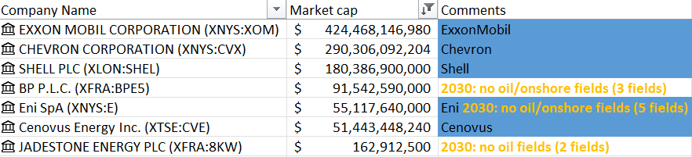

Figure 1: Filtered and sorted company results from Microsoft Excel’s Stock function

The study focuses on five international oil companies (IOC) and five national oil companies (NOC). Using Microsoft Excel’s built-in Stock function, as seen in Figure 1 above, the market capitalization of each company was shown and sorted from the largest to smallest. The five IOCs were then selected from there, namely, ExxonMobil, Chevron, Shell, Eni, and Cenovus. The five NOCs were selected based on five unique countries, namely, Oil and Natural Gas Corporation (ONGC) from India, Sinopec from China, PTT Exploration and Production (PTTEP) from Thailand, Petronas from Malaysia, and Pertamina from Indonesia.

Table 1: Data preparation steps completed in Power Query on the raw dataset

|  |  |  |  |
| --- | --- | --- | --- |
| Step | Description | Action | Example/Explanation |
| 1 | Standardize company and subsidiary names. | Renamed values in “company_name” and “subsidiary_name”. | “Petronas Carigali” to “Petronas” and “PERTAMINA EP” to “Pertamina” |
| 2 | Shrink dataset size. | Filtered for years 2021 to 2030 and the 10 focus companies and then removed unnecessary columns. | 2021 because that is the latest actual data in the dataset and 2030 because targets are commonly set to 2030.  Unnecessary columns are columns with only empty or null values and identification numbers. |
| 3 | Changed the metric values’ unit. | All values in “metric_value” * 1000 and extract text after delimiter “k” in “unit” | Changed the unit of measurement from kboe/d to boe/d for ease in subsequent calculations. |
| 4 | Combine Condensate and NGL values as Condensate_ngl then pivoting columns by Condensate_ngl and Oil. | Rename values “Condensate” and “NGL” to “Condensate_ngl” under “liquid_gas_breakdown” field then pivot columns with “metric_value” as the values. | To obtain continuous fields of production volume categorized by the hydrocarbon types. |
| 5 | Add a new column for total production volume values then pivoting columns by Offshore and Onshore. | Add “total_production” column by summing each “Condensate_ngl” with “Oil” then pivot columns using “field_onshore_offshore” with “total_production” as the values | To obtain continuous fields of production volume categorized by the onshore and offshore breakdown. |
| 6 | Filled null values for the “Offshore” and “Onshore” production fields. | Changed “Offshore” and “Onshore” fields’ types to number then replaced values from null to 0. | To make mathematical calculations with the 2 fields. |

Data preparation was first done to the raw dataset “upstream-country_company_net_annual_production_kbd.csv” using Microsoft Excel’s Power Query, as seen in Table 1 above, and renamed to “Production”. The Production dataset was then duplicated ten times and filtered for each focus company to obtain separate datasets for the focus companies. While no further action was completed in Power Query for nine of the new datasets, one additional action was completed for Sinopec’s dataset where empty values in the columns “sector_name”, “sector_country”, and “country_region” were replaced with their corresponding values from the “field_onshore_offshore_break” column as it was observed that there were various non-empty records with the same values. Concluding the data cleaning in the Production dataset, the dataset now has a total of 35 fields and 1,551 records.

Refer to Appendix A for the Power Query codes used on the raw dataset.

# 3.2 Python (emissions and intensities)

The next data preparation steps were done in Python for each dataset used per model. If the intensities or emissions data is available on the company’s sustainability report or annual report, they were assigned directly. If the data is not available, a ratio of 1:0.73 for “Oil” to “Condensate_ngl” and 1:0.33 for “Offshore” to “Onshore” was used based on the total emissions. After importing the pandas library and each company’s DataFrame and the assignments and/or calculations of the intensities and emissions, a field index column was added. The field index was added to differentiate the different field assets each company has as the dataset received did not include “field_name” nor “id_field” columns. Four new DataFrames for the O&G or offshore and onshore’s productions and emissions were then created for usage in each optimization model.

Research conducted by EPA (2023) has stated that coal releases the largest amount of emissions per unit of useful energy, with oil releasing approximately 75% of coal’s, and natural gas releasing 55% of coal’s. The ratio was thus set at 1:0.73 for oil production’s emissions to condensate and gas production’s emissions, assuming that condensate’s emissions would be close to gases’ emissions.

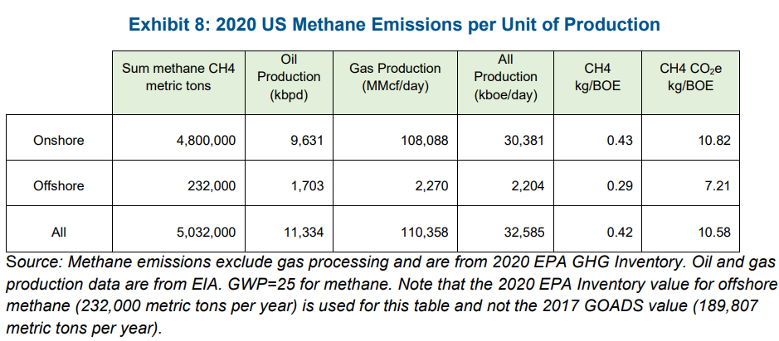

Figure 2: US methane emissions per unit of production in 2020 (ICF, 2023)

Another angle to identify the assets to divest would be whether the field is onshore or offshore. Research conducted by ICF (2023) mentioned that the emissions released from onshore production facilities could add up to around 3k tons of CO2e, equivalent to 200kg/ft of the measured well depth and around 9.7k tons of CO2e, equivalent to 600kg/ft of the measured well depth for offshore production facilities. The ratio was thus set at 1:0.33 for offshore production’s emissions to onshore production’s emissions. Even though the emissions from offshore facilities are around 3 times more than onshore facilities, due to their higher well productivity, the emissions per production unit should be examined instead of just the total emissions released. As per the example in Figure 2 above, ICF could divest more of their onshore facilities and invest more in their offshore facilities to minimize their emissions per production unit.

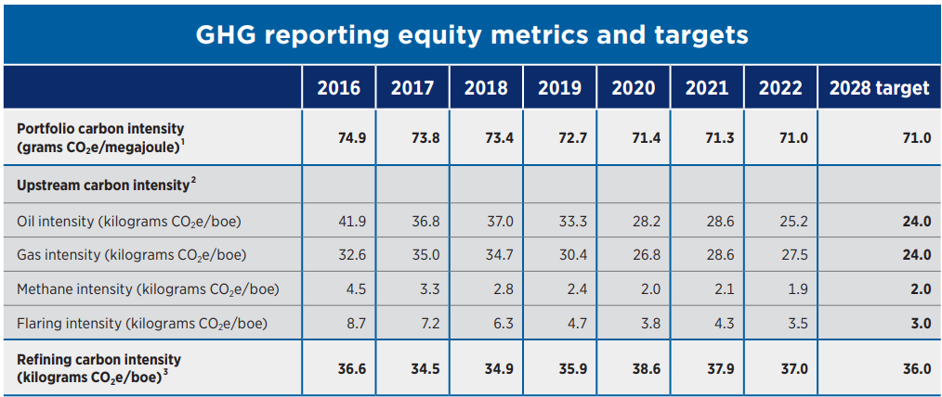

Figure 3: Chevron intensity metrics (Chevron, 2023)

Using Chevron as an example for this study, Figure 3 above is from Chevron’s 2022 sustainability report, showing its upstream oil intensity and upstream gas intensity both at 28.6 kgCO2e/boe in 2021 (Chevron, 2023). With these intensities assigned, the emissions were calculated by multiplying the production volumes with their respective intensities. Four new DataFrames were then created for the O&G production and emissions to be used in the modelling.

Table 2: 2021 Intensities and emissions calculations – Chevron

|  |  |  |  |  |
| --- | --- | --- | --- | --- |
| Step | Assignment/Calculation | Oil | Gas | Total |
| 1 | Production (boe/d) | 75,571.7 | 25,220.5 | 100,792.2 |
| 2 | Intensity (kgCO2e/boe) | 28.6 | 28.6 | - |
| 3 | Emissions (kgCO2e/d) | 2,161,350.5 | 721,306.3 | 2,882,656.8 |
|  |  | Offshore | Onshore | Total |
| 4 | Production (boe/d) | 31,717.1 | 69,075.1 | 100,792.2 |
| 5 | Emissions (kgCO2e/d) | 1,677,238.8 | 1,205,418.0 | 2,882,656.8 |
| 6 | Intensity (kgCO2e/boe) | 52.9 | 17.5 | - |

Since the reports did not state the intensities nor emissions based on the field development type, the ratio 1:0.33 was used for its modelling. As seen in Table 2 above, the O&G production volumes were first summed, intensities assigned, and emissions calculated. The offshore and onshore emissions were then calculated using the 1:0.33 ratio on the total emissions calculated from the O&G emissions, where the workings for offshore emissions is as follows 2,882,656.8 / (31,717.1 × 1 + 69,075.1 × 0.33) × (31,717.1 × 1) ≈ 1,677,238.8 kgCO2e/d and offshore intensity is 1,677,238.8 / 31,717.1 ≈ 52.9 kgCO2e/boe. The calculations for the onshore emissions and intensity followed the same method.

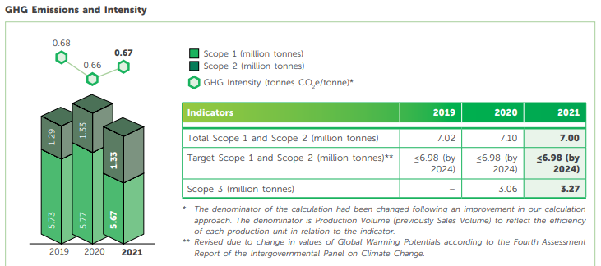

Figure 4: Petronas GHG emissions and intensities (Petronas, 2022)

Table 3: 2021 Intensities and emissions calculations – Petronas

|  |  |  |  |  |
| --- | --- | --- | --- | --- |
| Step | Assignment/Calculation | Oil | Gas | Total |
| 1 | Production (boe/d) | 210,828.0 | 50,289.1 | 261,117.1 |
| 2 | Emissions (kgCO2e/d) | 16,333,893.6 | 2,844,188.6 | 19,178,082.2 |
| 3 | Intensity (kgCO2e/boe) | 77.5 | 56.6 | - |
|  |  | Offshore | Onshore | Total |
| 4 | Production (boe/d) | 261,117.1 | 0 | 261,117.1 |
| 5 | Emissions (kgCO2e/d) | 19,178,082.2 | 0 | 19,178,082.2 |
| 6 | Intensity (kgCO2e/boe) | 73.4 | 24.2 | - |

Petronas, an example where the emissions were given instead of the intensities, mentioned in its sustainability report that its 2021 emissions were 7.0 million tons CO2e. Assuming that the emissions are fully from the total production volume given from the dataset, it was converted to 19,178,082.2 kgCO2e/d as seen in Figure 4 above (Petronas, 2022). The O&G emissions were then calculated using the 1:0.73 ratio on the total emissions, where the workings for oil emissions are as follows 19,178,082.2 / (210,828.0 × 1 + 50,289.1 × 0.73) × (210,828.0 × 1) ≈ 16,333,893.6 kgCO2e/d and oil intensity is 16,333,893.6 / 210,828.0 ≈ 77.5 kgCO2e/boe. The calculations for the gas intensity and emissions followed the same method. For the offshore and onshore calculations, the total emissions were assumed to be fully from offshore production since there was no onshore production. The onshore intensity was then calculated using the 1:0.33 ratio.

Refer to Appendices B to K for the intensities and/or emissions data retrieved from the other focus companies’ reports and the Python codes used on each focus company’s dataset for both O&G and offshore and onshore models.

# 3.3 Python (targets)

Table 4: Target calculations – Chevron

|  |  |  |  |
| --- | --- | --- | --- |
|  | Oil | Gas | Total |
| 2021 Production (boe/d) | 75,571.7 | 25,220.5 | 100,792.2 |
| 2030 Intensity (kgCO2e/boe) | 24.0 | 24.0 | - |
| 2030 Emissions (kgCO2e/d) | 1,813,720.7 | 605,292.0 | 2,419,012.7 |
| 2030 Forecasted production (boe/d) | 0 | 19,604.1 | 19,604.1 |
| 2030 Proportioned emissions target (kgCO2e/d) |  |  | 470,498.4 |

Referring to Figure 3 above and for simplicity, Chevron’s intensities targets were assumed to be 24.0 kgCO2e/boe in 2030 even though it is set to 2028 in the report. Assuming Chevron wants to produce a similar total 2021 production of 100,792.2 boe/d in 2030, with intensities targets of 24.0 kgCO2e/boe each, the total emissions for 2030 would be 2,419,012.7 kgCO2e/d. Since intensities can only be reduced using strategies such as combustion through CCS technology, this optimization model focuses on the portfolio of O&G production and offshore and onshore production to minimize the total emissions. However, by looking at the total production volume Chevron produced each year, it could be seen that Chevron has already been divesting assets with a huge drop in volume every year since 2017. Therefore, to alleviate the differences resulting from the companies’ divestments, the 2030 emissions target was further proportioned according to the ratio of the total 2021 production to the total 2030 production, 2,419,012.7 / (100,792.2 / 19,604.1) ≈ 470,498.4 kgCO2e/d ≈ 0.47M kgCO2e/d.

Table 5: Target calculations – Petronas

|  |  |  |  |
| --- | --- | --- | --- |
|  | Oil | Gas | Total |
| 2021 Production (boe/d) | 210,828.0 | 50,289.1 | 261,117.1 |
| 2030 Emissions (kgCO2e/d) |  |  | 19,123,287.7 |
| 2030 Forecasted production (boe/d) | 140,225.7 | 10,542.2 | 150,767.9 |
| 2030 Proportioned emissions target (kgCO2e/d) |  |  | 11,041,703.6 |

Similarly, referring to Figure 4 above and for simplicity, Petronas’ emissions target for 2030 was assumed to be 6.98 million tons CO2e in 2030 even though it is set to 2024 in the report. As seen in Table 5 above, the 2030 emissions target was converted to 19,123,287.7 kgCO2e/d. The 2030 emissions target was then further proportioned according to the ratio of the total 2021 production to the total 2030 production, 19,123,287.7 / (261,117.1 / 150,767.9) ≈ 11,041,703.6 kgCO2e/d ≈ 11.0M kgCO2e/d.

Refer to Appendices B to K for the target data retrieved from the other focus companies’ reports and the Python codes used on each focus company’s dataset for both O&G and offshore and onshore models.

1. Modelling and evaluation

# 4.1 Modelling software

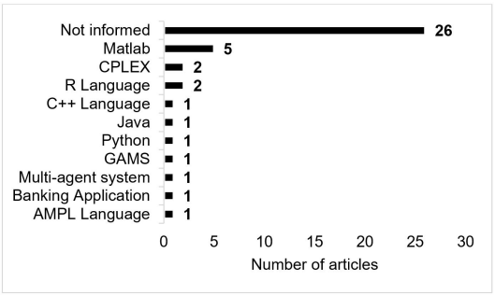

Figure 5: Software or programming language used for portfolio optimization (Milhomem & Dantas, 2020)

As mentioned in the introduction and project title, Python was used to formulate parametric equations as the objective and constraints, assign the decision variables, and solve the optimization problem. There are many libraries and packages available in Python for optimization but there are not many projects that make use of Python for their business portfolio optimization, as seen in Figure 5 above (Milhomem & Dantas, 2020). The Gurobi library was selected for the modelling since it was easy to pick up, has a high performance in terms of being able to find optimal/near-optimal solutions quickly, versatility by supporting a wide range of optimization problems that allow ease in switching modes if necessary, and having a Python Application Programming Interface (API), allowing it to be easily integrated with various Python libraries such as the NumPy library used for the data preparation.

# 4.2 Model construction

Two models were then created for each focus company optimizing the oil to gas production ratio and the offshore to onshore production ratio. With the two angles available to look at the assets to divest, it can serve as a comparison for the company to have the final decision on which assets they would prefer to divest, due to other possible limitations such as the country’s political instability that would not be reflected in the optimization model and results.

The decision variables were set to be binary and as each company’s oil or offshore production DataFrame’s index. Since all four DataFrames (oil/offshore and gas/onshore’s production and emissions) are aligned, the indices are the same. The objective function was set to maximize the target year 2030’s total production volume, which would automatically minimize the ratio of oil/offshore production to gas/onshore production. The first constraint was set to ensure that the total emissions from the solution would be less than or equal to the company’s 2030 emissions target. An assumption was made that money is being spent keeping fields available for use even when they no longer produce anything and thus, should already be divested. This assumption leads to the second constraint that if a field exists in 2030 but is not producing anything, it will be set to 0 to recommend it being divested in the optimized solution found since they were not functioning anymore.

Refer to Appendices L to U for the Python codes used to construct the models for each focus company’s dataset for both O&G and offshore and onshore.

# 4.3 Model evaluation

The models constructed were Mixed-Integer Programming (MIP) models with fast runtimes, at less than 0.02s, with no constraints violated.

Refer to Appendices L to U for the Python codes used to evaluate the models for each focus company’s dataset for both O&G and offshore and onshore.

# 4.4 Results evaluation – IOC vs NOC

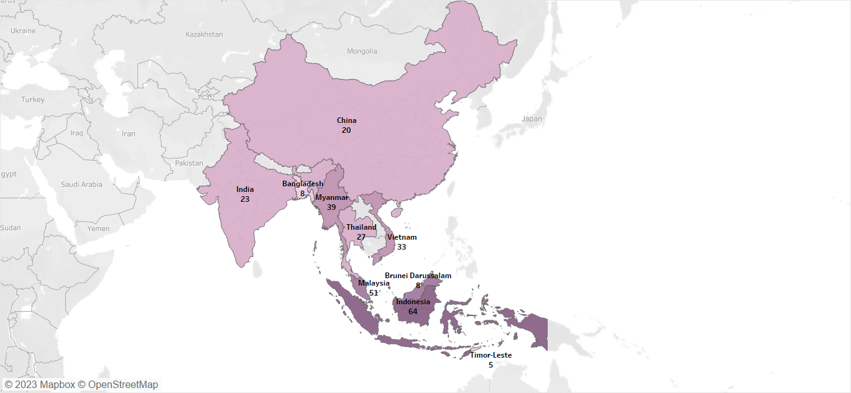

Figure 6: Map chart of the total number of fields in each country

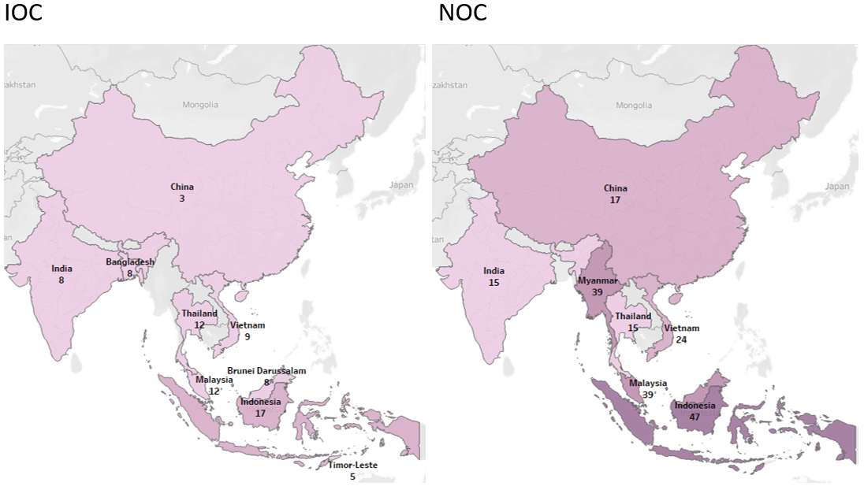

Figure 7: Map chart of the total number of IOC and NOC fields in each country

The ten companies were grouped into IOC and NOC respectively using Tableau, to construct charts and interactive dashboards of the optimized models’ 2030 recommended results. The color schemes used in the map charts in Figures 6 and 7 above are in steps of 5, from 5 fields to 65 fields. From the figures, it can be seen at a glance which countries have more and fewer fields currently. Indonesia has the most fields at 64 while Timor-Leste has the least at 5 fields in total. Indonesia has 47 NOC fields and 17 IOC fields. Malaysia is next with 39 NOC fields and 12 IOC fields. The countries with the third highest number of fields for IOCs and NOCs differ where Myanmar has 39 NOC fields, but 0 IOC fields and Thailand has 12 IOC fields but only 15 NOC fields, the least number of NOC fields in all the countries. These could imply that fields in Indonesia and Malaysia are attractive and ideal for the O&G companies to invest in.

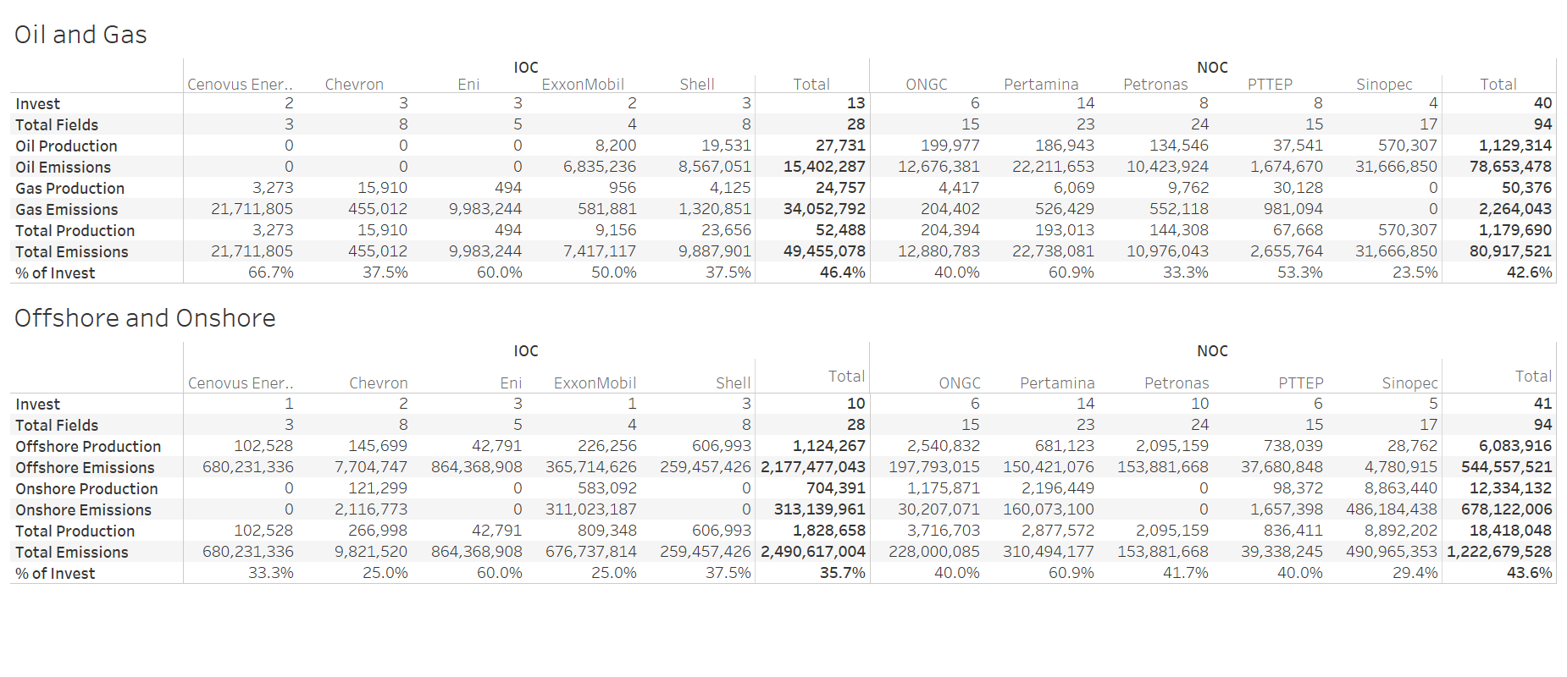

Figure 8: Comparison dashboard of each IOC and NOC

The dashboard in Figure 8 above allows a comparison of the IOC and NOC’s subtotals. However, since the dataset only consists of fields in Southern Asia, South-Eastern Asia, and Eastern Asia, where all the NOCs are based, the total number of NOC fields would reasonably be way more than the number of IOC fields where each company has fields in various countries around the world. The comparison dashboard also allows a quick glance at the difference between the recommendations from the O&G model and the offshore and onshore model for each company and the subtotals.

# 4.5 Results evaluation – by company

# 4.5.1 Cenovus



Figure 9: Cenovus optimized O&G model results for 2030

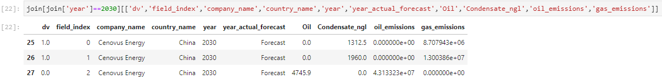

Figure 10: Cenovus optimized O&G DataFrame for 2030

The results of each company’s optimized model were displayed through Python, as seen in Figures 9 and 10 above. For Cenovus’ O&G model, the optimized result recommended investing in field indices 0 and 1 while divesting in field index 2, producing a total of 3,272 boe/d with emissions of 21,711,805 kgCO2e/d, below the target of 34,500,000 kgCO2e/d.



Figure 11: Cenovus optimized offshore and onshore model results for 2030

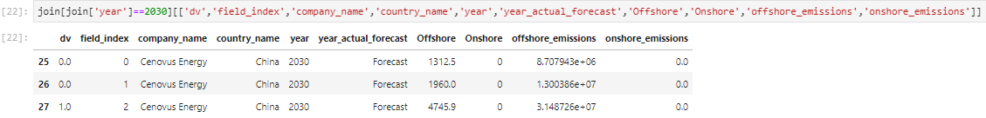

Figure 12: Cenovus optimized offshore and onshore DataFrame for 2030

The optimization results for Cenovus’ offshore and onshore fields, on the other hand, gave the opposite result. As seen in Figures 11 and 12 above, recommending only investing in field index 2 and divesting field indices 0 and 1, producing a total of 4,746 boe/d and emissions of 31,487,259 kgCO2e/d, below the target of 34,500,000 kgCO2e/d. However, Cenovus does not have any onshore fields producing in 2030, thus making the optimization of the offshore and onshore portfolio mix not as useful in reducing the total emissions.

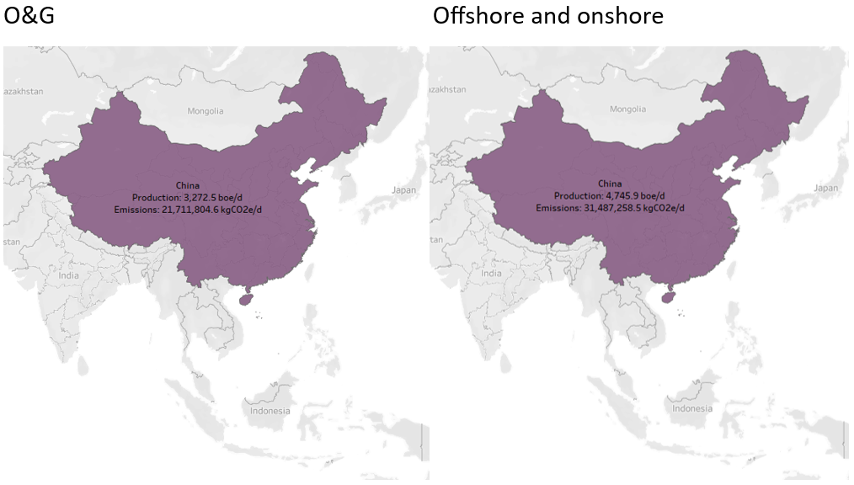

Figure 13: Map chart on production volume in each country – Cenovus

It can be seen clearly from Figure 13 above that Cenovus is recommended to only invest in fields in China. However, looking at all Cenovus field indices from Figures 10 and 12, it can also be seen that there are only China fields. Since Cenovus is an IOC, it would likely have fields outside of the Asian regions that the dataset consists, thus being unable to verify that it is being over-reliant on its production in China. It would, however, show that Cenovus’ presence is low in these Asian regions.

# 4.5.2 Chevron



Figure 14: Chevron optimized O&G model results for 2030

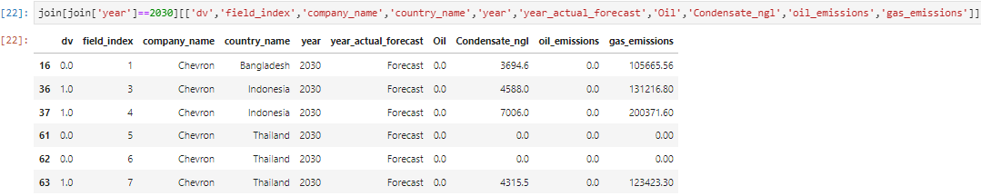

Figure 15: Chevron optimized O&G DataFrame for 2030

For Chevron’s O&G model, the optimized result recommended investing in field indices 3, 4, and 7 while divesting in field indices 1, 5, and 6, producing a total of 15,910 boe/d with emissions of 455,012 kgCO2e/d, below the target of 470,000 kgCO2e/d. However, Chevron does not have any oil-producing fields in 2030 and its O&G intensities are already known to be the same at 28.6 kgCO2e/boe thus, making the optimization of the O&G portfolio mix not useful in reducing the total emissions.



Figure 16: Chevron optimized offshore and onshore model results for 2030

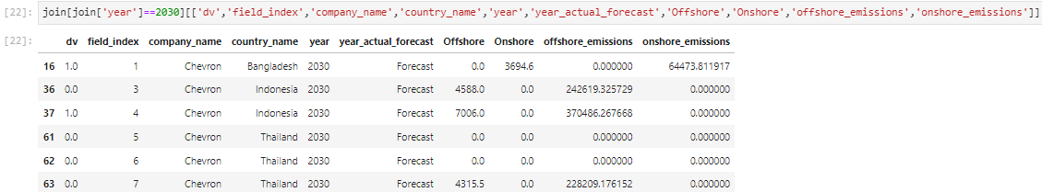

Figure 17: Chevron optimized offshore and onshore DataFrame for 2030

The optimization results for Chevron’s offshore and onshore fields on the other hand could be useful as Chevron has both types of fields forecasted to be producing in 2030. As seen in Figure 17 above, the results recommended only investing in field index 1 and 4 while divesting field indices 3, 5, 6, and 7, leaving one offshore field and one onshore field each, producing a total of 10,701 boe/d and emissions of 434,960 kgCO2e/d, below the target of 470,000 kgCO2e/d.

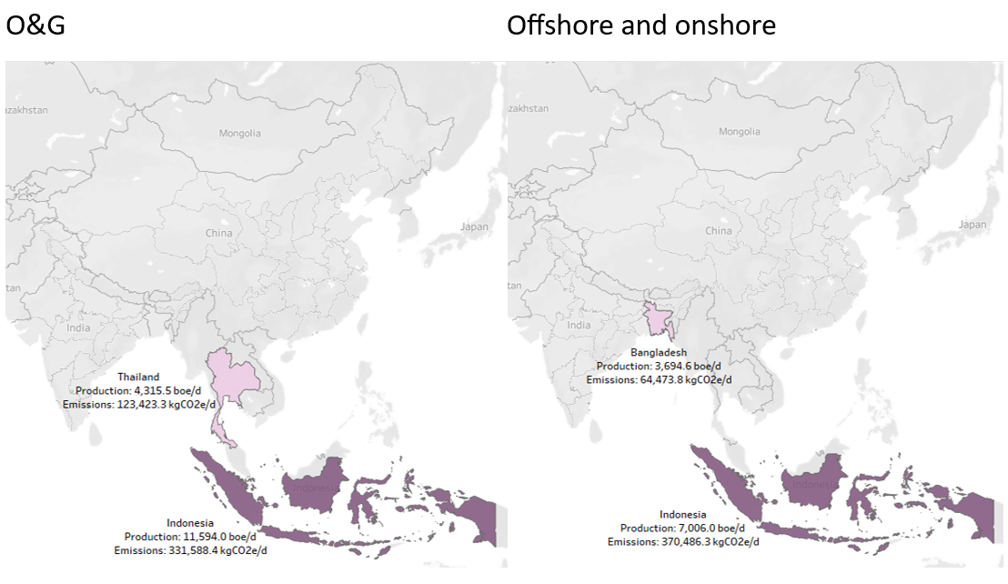

Figure 18: Map chart on production volume in each country – Chevron

It can be seen from Figure 18 above, the country that Chevron produces the most in, in 2030. This analysis could help to see if Chevron could be over-reliant on just one country to decide if it should diversify its fields more. Since Chevron is an IOC, with the available data, it is hard to determine whether producing 7 kboe/d in Indonesia could be considered an over-reliance.

# 4.5.3 Eni



Figure 19: Eni optimized O&G model results for 2030

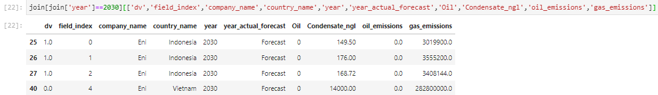

Figure 20: Eni optimized O&G DataFrame for 2030

For Eni’s O&G model, the optimized result recommended investing in field indices 0, 1, and 2 while divesting in field index 4, producing a total of 494 boe/d with emissions of 9,983,244 kgCO2e/d, below the target of 195,200,000 kgCO2e/d. However, Eni does not have any oil-producing fields, making the optimization of the O&G portfolio mix not as useful in reducing the total emissions.



Figure 21: Eni offshore and onshore optimized model results for 2030

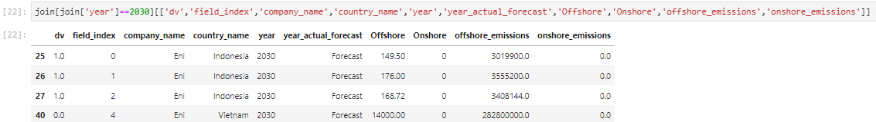

Figure 22: Eni optimized offshore and onshore DataFrame for 2030

For Eni’s offshore and onshore model, the optimized result has the same recommendations as the O&G model, with the same intensities, production, and emissions. However, Eni does not have any onshore fields producing in 2030, making the optimization of the offshore and onshore portfolio mix not as useful in reducing the total emissions.

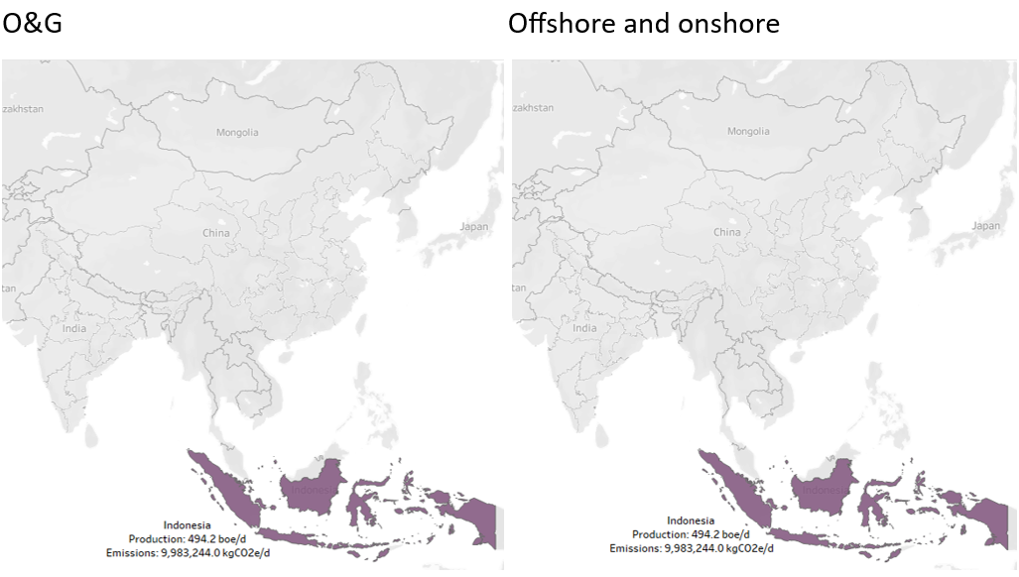

Figure 23: Map chart on production volume in each country – Eni

It can be seen from Figure 23 above, that Eni is recommended to only produce in Indonesia in 2030. This analysis could help to determine if Eni is over-reliant on just one country to decide if it should diversify its fields more. Since Eni is an IOC, with the available data, it is hard to determine whether producing 494.2 boe/d in Indonesia could be considered an over-reliance.

# 4.5.4 ExxonMobil



Figure 24: ExxonMobil optimized O&G model results for 2030

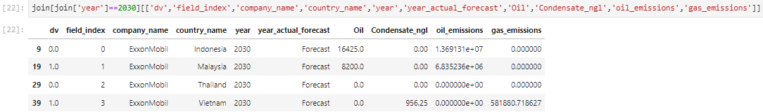

Figure 25: ExxonMobil optimized O&G DataFrame for 2030

For ExxonMobil’s O&G model, the optimized result recommended investing in field indices 1 and 3 while divesting in field indices 0 and 2, producing a total of 9,156 boe/d with emissions of 7,417,117 kgCO2e/d, below the target of 8,300,000 kgCO2e/d.



Figure 26: ExxonMobil offshore and onshore optimized model results for 2030

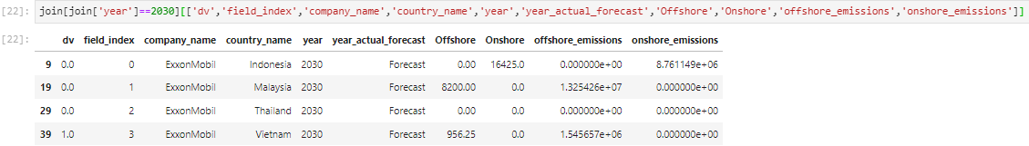

Figure 27: ExxonMobil optimized offshore and onshore DataFrame for 2030

For ExxonMobil’s offshore and onshore model, the optimized result has a slight difference. Field index 3 is still recommended to be invested, but field index 1 is recommended to be divested as well, producing a total of 956 boe/d with emissions of 1,545,657 kgCO2e/d, below the target of 8,300,000 kgCO2e/d.

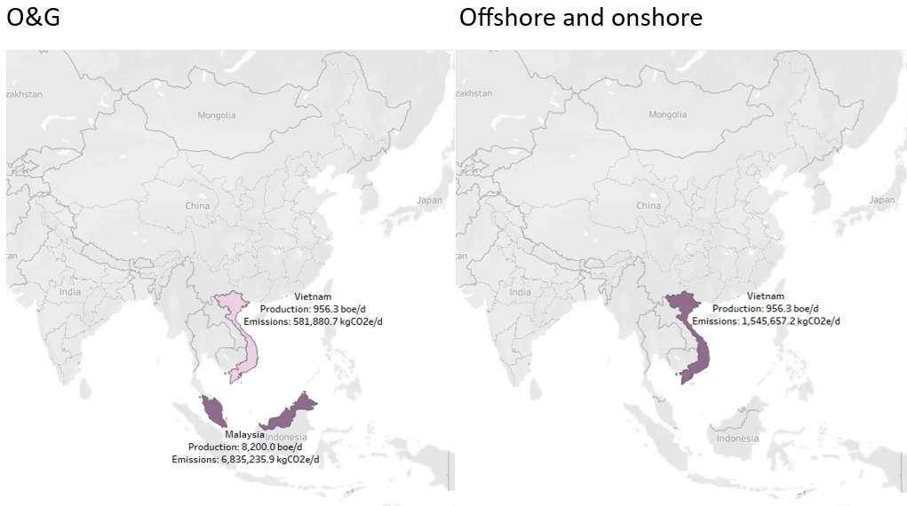

Figure 28: Map chart on production volume in each country – ExxonMobil

It can be seen from Figure 28 above that ExxonMobil was recommended to produce either only in Indonesia or in Vietnam as well in 2030. This analysis could help to determine if ExxonMobil is over-reliant on just one country to decide if it should diversify its fields more. It is important to note here that the emissions are calculated using ratioed intensities therefore resulting in different emissions despite producing the same amount in the same field.

# 4.5.5 Shell



Figure 29: Shell optimized O&G model results for 2030

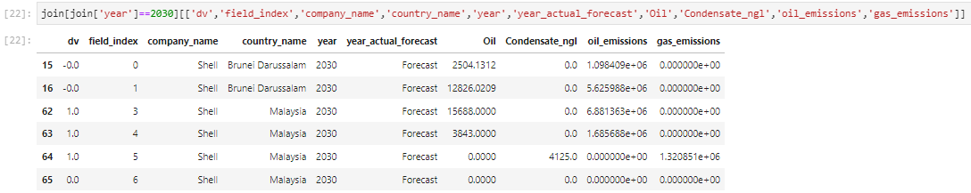

Figure 30: Shell optimized O&G DataFrame for 2030

For Shell’s O&G model, the optimized result recommended investing in field indices 3, 4, and 5 while divesting in field indices 0, 1, and 6, producing a total of 23,656 boe/d with emissions of 9,887,902 kgCO2e/d, below the target of 10,200,000 kgCO2e/d. It can be seen from Figure 30 that field index 6 has no oil or gas production in 2030. Following the constraint set, it was purposefully set to be divested due to the assumption that money is still being invested to keep the field even though there is no longer any production there.



Figure 31: Shell offshore and onshore optimized model results for 2030

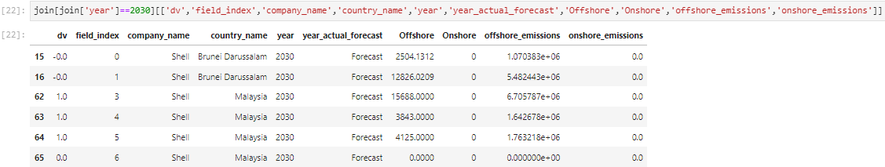

Figure 32: Shell optimized offshore and onshore DataFrame for 2030

For Shell’s offshore and onshore model, the optimized result has the same recommendations as the O&G model, with the same total production volume but different emissions due to the different ratioed intensities. However, Shell does not have any onshore fields producing in 2030, making the optimization of the offshore and onshore portfolio mix not as useful in reducing the total emissions.

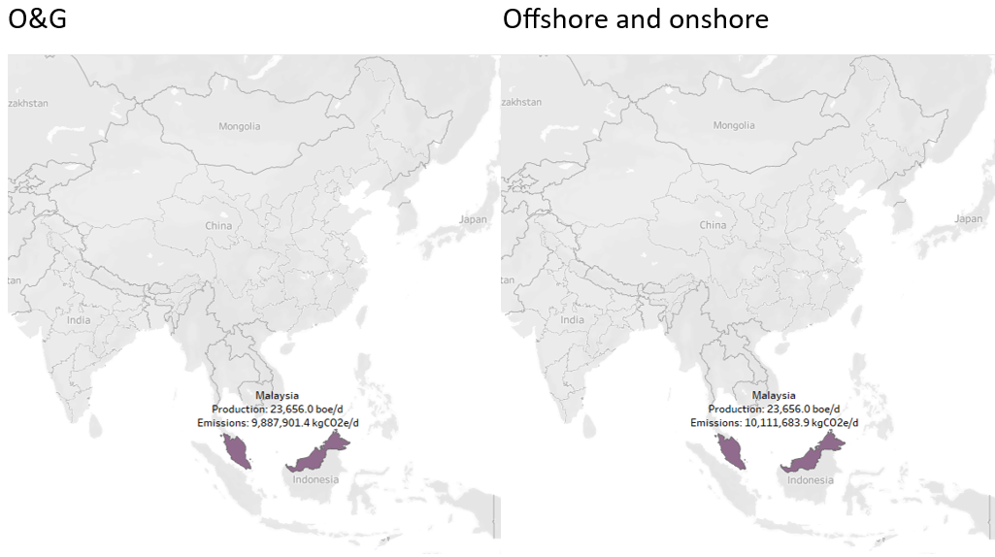

Figure 33: Map chart on production volume in each country – Shell

It can be seen from Figure 33 above that Shell was recommended to only produce in Malaysia in 2030 with the same total production volume. This analysis could help to determine if Shell is over-reliant on Malaysia to decide if it should diversify its fields more. However, since Shell is an IOC, with the available data, it is hard to determine whether producing 23,656 boe/d in Malaysia could be considered an over-reliance.

# 4.5.6 ONGC



Figure 34: ONGC optimized O&G model results for 2030

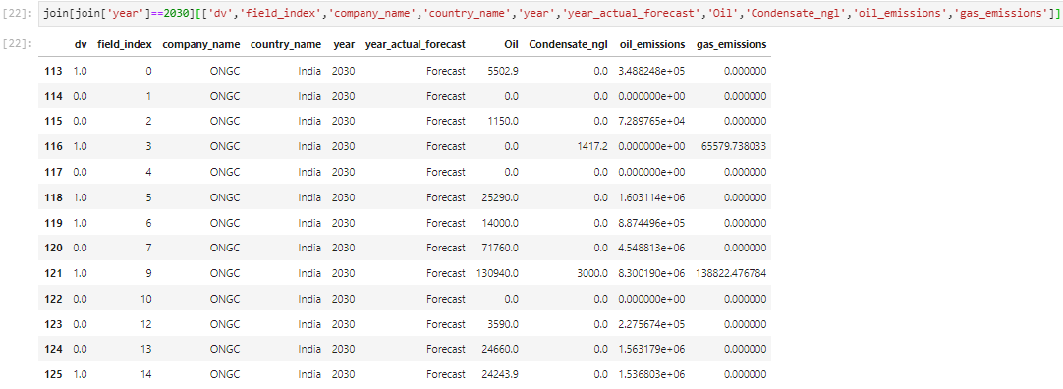

Figure 35: ONGC optimized O&G DataFrame for 2030

For ONGC’s O&G model, the optimized result recommended investing in 6 fields (field indices 0, 3, 5, 6, 9, and 14) while divesting 7 fields (field indices 1, 2, 4, 7, 10, 12, and 13), producing a total of 204,394 boe/d with emissions of 12,880,783 kgCO2e/d, below the target of 13,000,000 kgCO2e/d. It can be seen from Figure 35 that field index 10 has no oil or gas production in 2030. Following the constraint set, it was purposefully set to be divested due to the assumption that money is still being invested to keep the field even though there is no longer any production.



Figure 36: ONGC offshore and onshore optimized model results for 2030

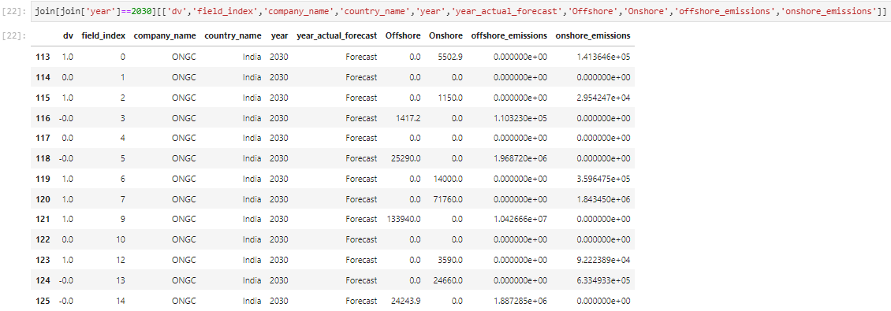

Figure 37: ONGC optimized offshore and onshore DataFrame for 2030

For ONGC’s offshore and onshore model, the optimized result recommended investing in 6 fields (field indices 0, 2, 6, 7, 9, and 12) while divesting 7 fields (field indices 1, 3, 4, 5, 10, 13, and 14), producing a total of 229,943 boe/d with emissions of 12,892,892 kgCO2e/d, below the target of 13,000,000 kgCO2e/d. It can be seen from Figure 37 that field index 10 has no offshore or onshore production in 2030. Following the constraint set, it was purposefully set to be divested due to the assumption that money is still being invested to keep the field even though there is no longer any production there.

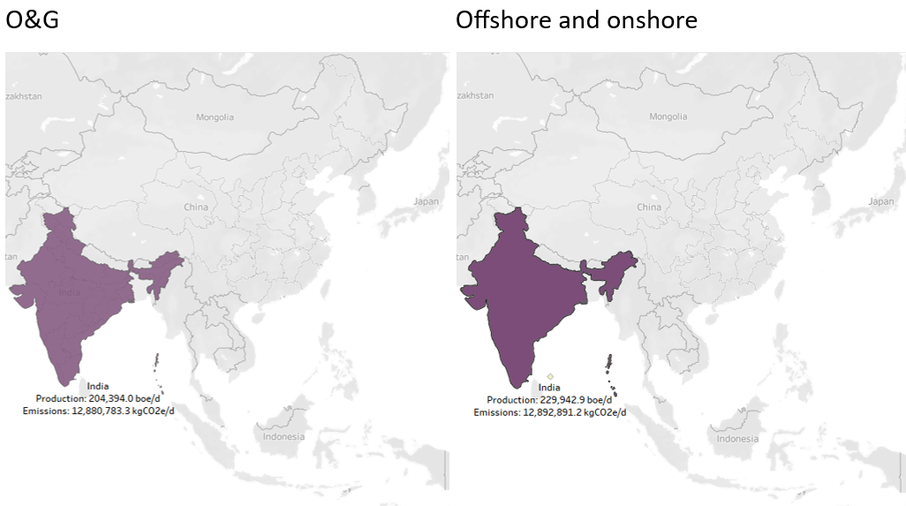

Figure 38: Map chart on production volume in each country – ONGC

It can be seen from Figure 38 above that ONGC was recommended to only produce in India in 2030 with a different portfolio mix. This analysis could help to determine if ONGC is over-reliant on a country to decide if it should diversify its fields more but since ONGC is India state-owned, it is logical for it to produce only/more in India.

# 4.5.7 Pertamina



Figure 39: Pertamina optimized O&G model results for 2030

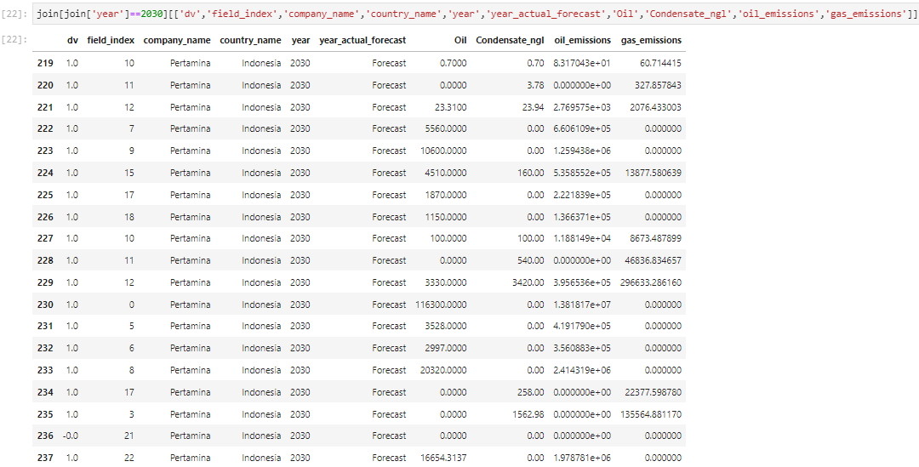

Figure 40: Pertamina optimized O&G DataFrame for 2030

For Pertamina’s O&G model, the optimized result recommended investing in 14 fields (field indices 10, 11, 12, 7, 9, 15, 17, 18, 0, 5, 6, 8, 3, and 22) while divesting 1 field (field index 21), producing a total of 193,012 boe/d with emissions of 22,738,082 kgCO2e/d, below the target of 33,200,000 kgCO2e/d. It can be seen from Figure 40 that field index 21 has no oil or gas production in 2030. Following the constraint set, it was purposefully set to be divested due to the assumption that money is still being invested to keep the field even though there is no longer any production there. This thus shows that all active fields were recommended to be invested while still being approximately 10M kgCO2e/d below the proportioned 2030 emissions target.



Figure 41: Pertamina offshore and onshore optimized model results for 2030

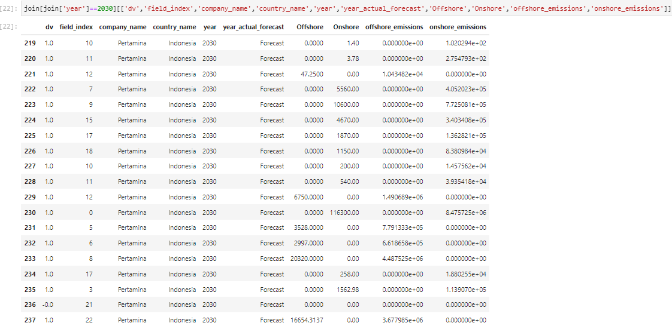

Figure 42: Pertamina optimized offshore and onshore DataFrame for 2030

For Pertamina’s offshore and onshore model, the optimized result recommended the same portfolio mix as the O&G model, with the same production volume and different emissions at 21,508,518 kgCO2e/d due to the ratioed intensities.

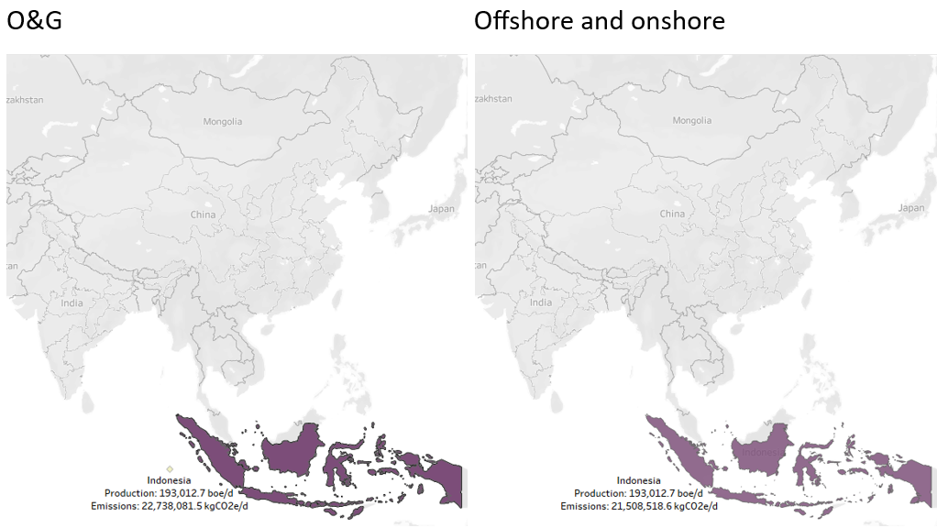

Figure 43: Map chart on production volume in each country – Pertamina

It can be seen from Figure 43 above that Pertamina was recommended to only produce in Indonesia in 2030 with the same portfolio mix. This analysis could help to determine if Pertamina is over-reliant on a country to decide if it should diversify its fields more but since Pertamina is Indonesia state-owned, it is logical for it to produce only in Indonesia.

# 4.5.8 Petronas



Figure 44: Petronas optimized O&G model results for 2030

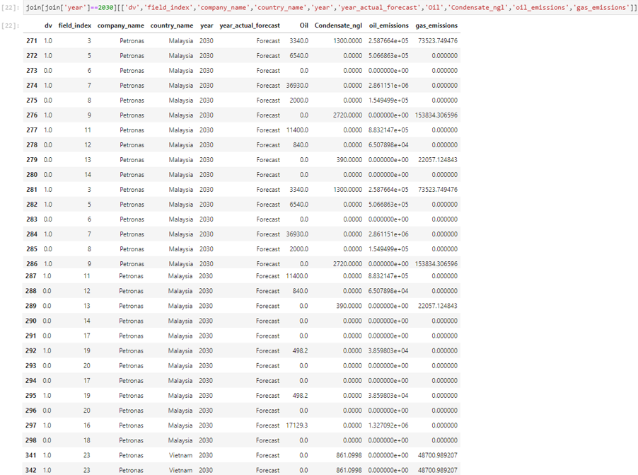

Figure 45: Petronas optimized O&G DataFrame for 2030

For Petronas’ O&G model, the optimized result recommended investing in 8 fields (field indices 3, 5, 7, 9, 11, 19, 16, and 23) while divesting 8 fields (field indices 6, 8, 12, 13, 14, 17, 20, and 18), producing a total of 144,308 boe/d with emissions of 10,976,042 kgCO2e/d, below the target of 11,000,000 kgCO2e/d. It can be seen from Figure 45 that field indices 6, 14, 17, 18, and 20 have no oil or gas production in 2030. Following the constraint set, it was purposefully set to be divested due to the assumption that money is still being invested to keep the field even though there is no longer any production there.



Figure 46: Petronas offshore and onshore optimized model results for 2030

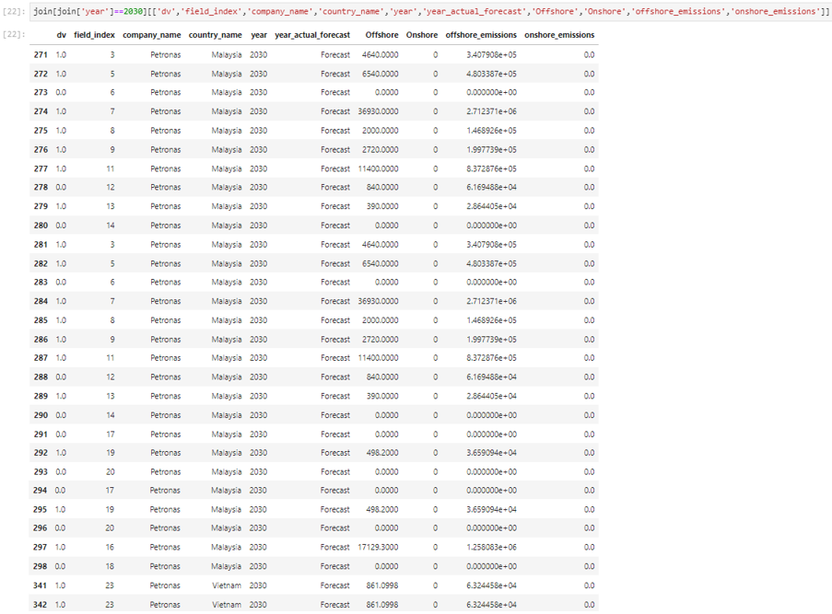

Figure 47: Petronas optimized offshore and onshore DataFrame for 2030

For Petronas’ offshore and onshore model, the optimized result recommended investing in 10 fields (field indices 3, 5, 7, 8, 9, 11, 13, 19, 16, and 23) while divesting 6 fields (field indices 6, 12, 14, 17, 20, and 18), producing a total of 149,088 boe/d with emissions of 10,949,952 kgCO2e/d, below the target of 11,000,000 kgCO2e/d. It can be seen from Figure 47 that field indices 6, 14, 17, 18, and 20 have no offshore or onshore production in 2030. Following the constraint set, it was purposefully set to be divested due to the assumption that money is still being invested to keep the field even though there is no longer any production there. However, Petronas does not have any onshore fields producing in 2030 thus, making the optimization of the offshore and onshore portfolio mix not as useful in reducing the total emissions.

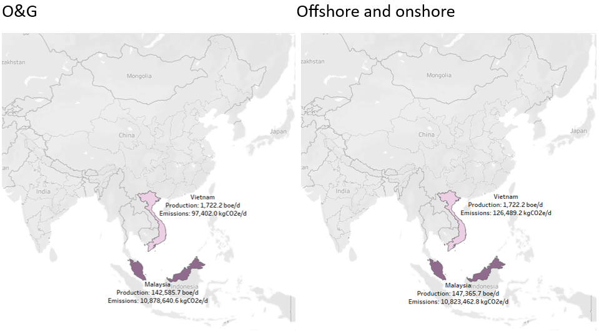

Figure 48: Map chart on production volume in each country – Petronas

It can be seen from Figure 48 above that Petronas was recommended to produce in Malaysia and Vietnam in 2030 with a different portfolio mix. This analysis could help to determine if Petronas is over-reliant on a country to decide if it should diversify its fields more but since Petronas is Malaysia state-owned, it is logical for it to produce more in Malaysia.

# 4.5.9 PTTEP



Figure 49: PTTEP optimized O&G model results for 2030

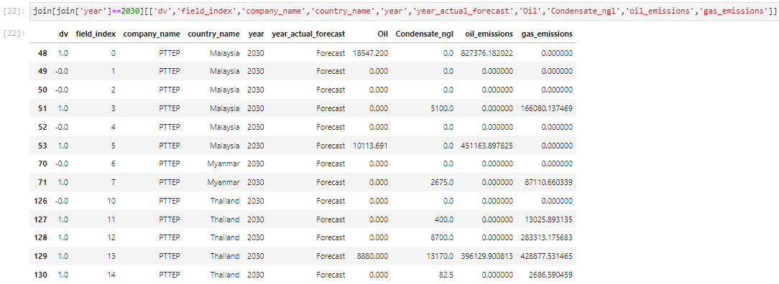

Figure 50: PTTEP optimized O&G DataFrame for 2030

For PTTEP’s O&G model, the optimized result recommended investing in 8 fields (field indices 0, 3, 5, 7, 11, 12, 13, and 14) while divesting 5 fields (field indices 1, 2, 4, 6, and 10), producing a total of 67,669 boe/d with emissions of 2,655,764 kgCO2e/d, below the target of 2,700,000 kgCO2e/d. It can be seen from Figure 50 that field indices 1, 2, 4, 6, and 10 have no oil or gas production in 2030. Following the constraint set, it was purposefully set to be divested due to the assumption that money is still being invested to keep the field even though there is no longer any production there. This thus shows that all active fields were recommended to be invested while being slightly below the proportioned 2030 emissions target.



Figure 51: PTTEP offshore and onshore optimized model results for 2030

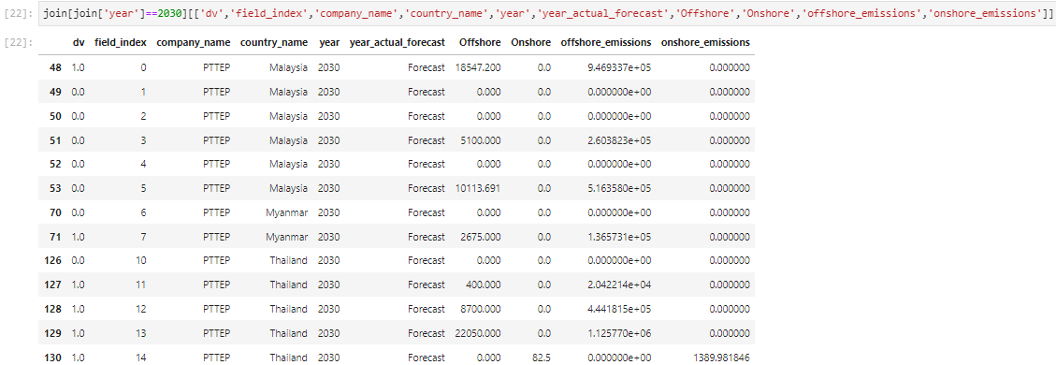

Figure 52: PTTEP optimized offshore and onshore DataFrame for 2030

For PTTEP’s offshore and onshore model, the optimized result recommended investing in 6 fields (field indices 0, 7, 11, 12, 13, and 14) while divesting 7 fields (field indices 1, 2, 3, 4, 5, 6, and 10), producing a total of 52,454 boe/d with emissions of 2,675,271 kgCO2e/d, below the target of 2,700,000 kgCO2e/d. It can be seen from Figure 52 that field indices 1, 2, 4, 6, and 10 have no oil or gas production in 2030. Following the constraint set, it was purposefully set to be divested due to the assumption that money is still being invested to keep the field even though there is no longer any production there. It is important to note here that the emissions are calculated using ratioed intensities thus, having higher emissions despite producing less compared to the O&G model’s results.

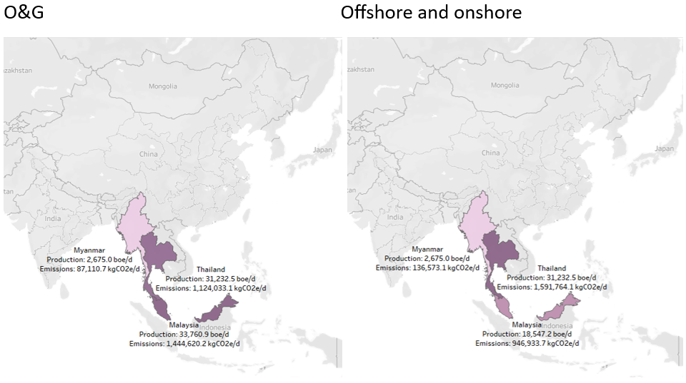

Figure 53: Map chart on production volume in each country – PTTEP

It can be seen from Figure 53 above that PTTEP was recommended to produce in Malaysia, Myanmar, and Thailand in 2030 with a different portfolio mix. This analysis could help to determine if PTTEP is over-reliant on a country to decide if it should diversify its fields more. Despite PTTEP being Thailand state-owned, its recommended production volumes in Thailand and Malaysia are similar for the O&G model. For the offshore and onshore model, since PTTEP is Thailand state-owned, it is logical for it to produce more in Thailand.

# 4.5.10 Sinopec



Figure 54: Sinopec optimized O&G model results for 2030

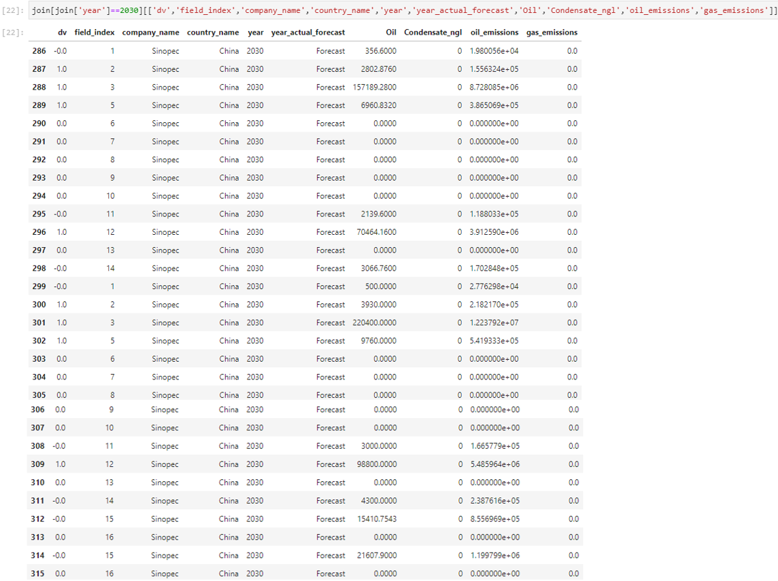

Figure 55: Sinopec optimized O&G DataFrame for 2030

For Sinopec’s O&G model, the optimized result recommended investing in 4 fields (field indices 2, 3, 5, and 12) while divesting 11 fields (field indices 1, 6, 7, 8, 9, 10, 11, 13, 14, 15, and 16), producing a total of 570,307 boe/d with emissions of 31,666,850 kgCO2e/d, below the target of 31,700,000 kgCO2e/d. It can be seen from Figure 55 that field indices 6, 7, 8, 9, 10, 13, and 16 have no oil or gas production in 2030. Following the constraint set, it was purposefully set to be divested due to the assumption that money is still being invested to keep the field even though there is no longer any production there. However, Sinopec does not have any gas-producing fields, making the optimization of the O&G portfolio mix not as useful in reducing the total emissions.



Figure 56: Sinopec offshore and onshore optimized model results for 2030

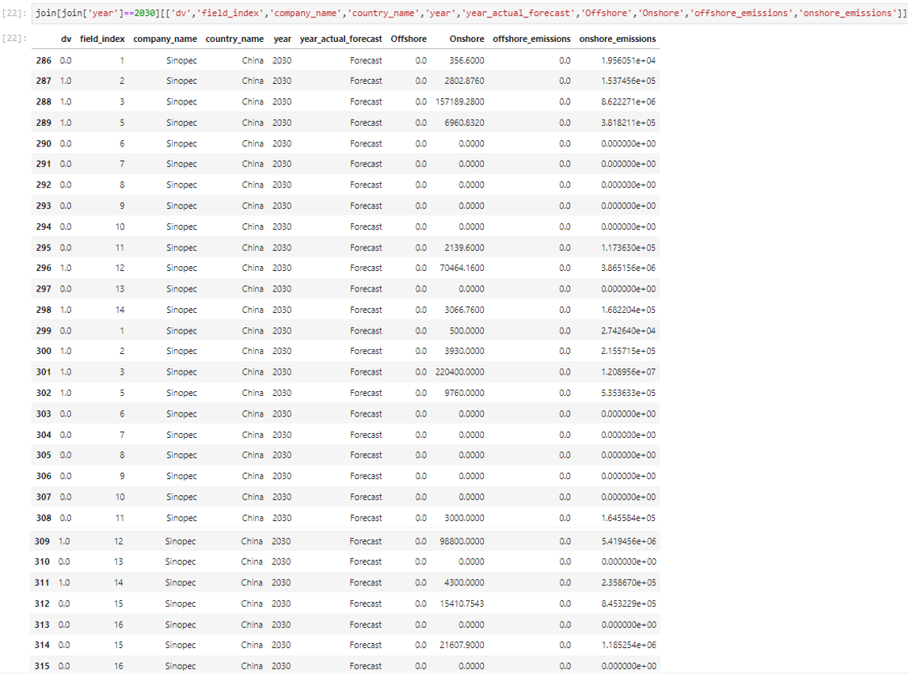

Figure 57: Sinopec optimized offshore and onshore DataFrame for 2030

For Sinopec’s O&G model, the optimized result recommended investing in 5 fields (field indices 2, 3, 5, 12, and 14) while divesting 10 fields (field indices 1, 6, 7, 8, 9, 10, 11, 13, 15, and 16), producing a total of 577,674 boe/d with emissions of 31,687,028 kgCO2e/d, below the target of 31,700,000 kgCO2e/d. It can be seen from Figure 57 that field indices 6, 7, 8, 9, 10, 13, and 16 have no oil or gas production in 2030. Following the constraint set, it was purposefully set to be divested due to the assumption that money is still being invested to keep the field even though there is no longer any production there. However, Sinopec does not have any offshore fields producing thus, making the optimization of the offshore and onshore portfolio mix not as useful in reducing the total emissions.

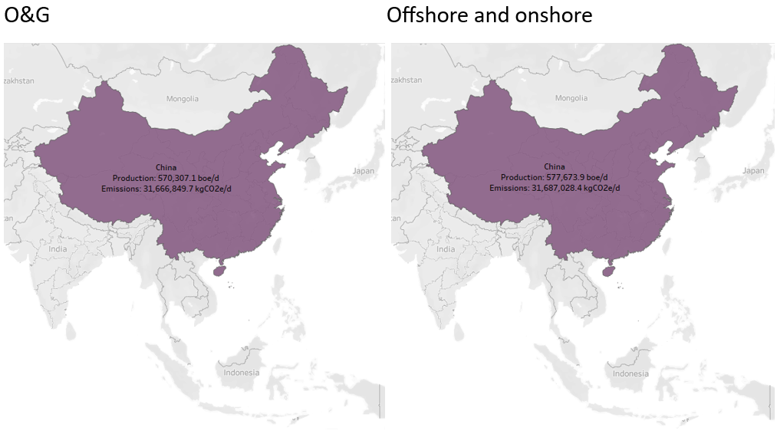

Figure 58: Map chart on production volume in each country – Sinopec

It can be seen from Figure 58 above that Sinopec was recommended to only produce in China in 2030 with a different portfolio mix. This analysis could help to determine if Sinopec is over-reliant on a country to decide if it should diversify its fields more but since Sinopec is China state-owned, it is logical for it to produce only in China.

1. Recommendations and conclusion

Since the optimization model does not take other factors, such as each company’s own objective and the environmental, societal, and economic factors into consideration, further research needs to be done to know whether the optimized results are feasible and suitable.

Table 6: Country ranking by Sustainable Trade Index (STI) ranks (Hinrich Foundation, 2023)

|  |  |  |
| --- | --- | --- |
| Rank | Country | Overall STI rank |
| 1 | Vietnam | 13 |
| 2 | Malaysia | 14 |
| 3 | China | 16 |
| 4 | Thailand | 17 |
| 5 | Indonesia | 19 |
| 6 | Bangladesh | 23 |
| 7 | India | 24 |
| 8 | Brunei | 26 |
| 9 | Myanmar | 29 |

Hinrich Foundation (2023) researched 30 major global economies using 71 indicators under three categories, environmental, societal, and economic, the relevant results are summarized in Table 6 above. Based on this result, it would be easier to identify whether it is practical for the companies to follow the optimized model’s results.

# 5.1 IOCs

As IOCs, companies would likely want to maximize their production as much as possible to increase sales.

# 5.1.1 Cenovus

By 2030, Cenovus only have three fields in China where the O&G model recommended divesting the first two fields while the offshore and onshore model recommended only divesting the 3rd field. Since all three fields are located in the same region, Cenovus can decide to follow the model with the higher production volume, the offshore and onshore model with a production volume of 4,746 boe/d compared to O&G’s model at 3,272 boe/d.

# 5.1.2 Chevron

By 2030, Chevron would still have one field in Bangladesh, two fields in Indonesia, and three fields in Thailand. The optimized offshore and onshore model recommended Chevron to divest all three Thailand fields and one of its two Indonesia fields. Looking at Table 6, while Thailand ranks the highest, Indonesia and Bangladesh are right behind. Since the relative difference is not much, Chevron could decide to follow the recommendations to divest all fields in Thailand to maximize its production volume.

# 5.1.3 Eni

By 2030, Eni would still have three fields in Indonesia and one field in Vietnam. Both models recommend Eni to invest in the three Indonesia fields while divesting the Vietnam field. Even though the minimization of emissions through portfolio mixes was not particularly useful for Eni, as mentioned in the results evaluation, the optimization model can still be used to identify the fields that should be divested to keep emissions within target. Looking at Table 6, since Vietnam ranks 1st and Indonesia ranks 5th, Eni could either follow the model’s recommendations because the Vietnam field’s production volume is too large, exceeding the targeted emissions, or only invest in the Vietnam field but reduce the volume to be produced even though more can be produced, to keep within the emissions target constraint.

# 5.1.4 ExxonMobil

By 2030, ExxonMobil would still have one field each in Indonesia, Malaysia, Thailand, and Vietnam. The optimized O&G model recommended ExxonMobil invest in the Vietnam and Malaysia fields while the offshore and onshore model recommended only investing in the Vietnam field. Looking at Table 6, since Vietnam and Malaysia are ranked 1st and 2nd respectively, ExxonMobil could easily follow the recommendation to maximize production with minimal risks.

# 5.1.5 Shell

By 2030, Shell would still have two fields in Brunei and four fields in Malaysia. Both models recommend Shell to divest both Brunei fields and one of the four Malaysia fields. Looking at Table 6, Malaysia ranks much higher than Brunei therefore, Shell should follow the recommendation to only invest in the 3 Malaysia fields to maximize production volume while minimizing emissions and risk.

# 5.2 NOCs

As NOCs, while companies would want to maximize their production as much as possible to increase sales, they would also be more willing to divest overseas assets as compared to their local assets.

# 5.2.1 ONGC

By 2030, ONGC only have thirteen fields in India and the models recommend different portfolio mixes. Since all fields are located in the same region, ONGC can decide to follow the model with the higher production volume, the offshore and onshore model with a production volume of 229,943 boe/d compared to O&G’s model at 204,394 boe/d. For the divestment of the seven fields, ONGC can sell them to smaller Indian companies with better economies of scale allowing them to operate the fields better and minimizing the revenue gap from the reduced production volume. While it is logical for ONGC to only produce in India since it is India state-owned, it could also consider producing in other countries to broaden its coverage and be open to different possibilities.

# 5.2.2 Pertamina

By 2030, Pertamina only has fifteen fields in Indonesia and both models recommend the same portfolio mix of only divesting field index 21. Pertamina can thus follow the recommendation directly as it already maximizes the production volume while keeping within the emissions target. However, since the total emissions is still approximately 10M kgCO2e/d below the target, Pertamina could look into expanding its production by investing in more fields.

# 5.2.3 Petronas

By 2030, Petronas has twenty-eight fields in Malaysia and two fields in Vietnam. Both models recommend investing in the 2 Vietnam fields with a different portfolio mix of Malaysian fields. Looking at Table 6, even though Vietnam ranks 1st, Malaysia follows close at 2nd. Since Petronas is a Malaysia state-owned company, Petronas might choose to not follow the recommendations and divest the two Vietnam fields to invest in more Malaysia fields instead. Another recommendation could be following the offshore and onshore model’s recommendation since it has a higher production volume, and then selling the divested fields to smaller Malaysian companies with better economies of scale allowing them to operate the fields better.

# 5.2.4 PTTEP

By 2030, PTTEP has six fields in Malaysia, two fields in Myanmar, and five fields in Thailand. The models recommend a similar portfolio mix, with the investment of the same fields but two additional Malaysia fields to be invested in for the O&G model. Since PTTEP is a Thailand state-owned company, it makes sense for it to invest in more Thailand fields (four out of five fields) than Malaysia fields (one or three out of six fields) even though it ranks lower according to Table 6. The one Thailand field to be divested is forecasted to have 0 production volume since 2030. With its “field_maturity” being “mature”, it indicates that only has less than or equal to 33% of its reserves remaining. PTTEP could thus sell the field to smaller Thailand companies with better economies of scale allowing them to operate the field better. Next, PTTEP could decide to follow the O&G model’s recommendation to invest in three Malaysia fields and one Myanmar field or to minimize the risk further by investing in one more Malaysia field without producing its full potential since Myanmar ranks last according to Table 6.

# 5.2.5 Sinopec

By 2030, Sinopec only has thirty fields, all in China. Both models recommend investing in field indices 2, 3, 5, and 12, while the offshore and onshore model also recommended investing in field index 14. Sinopec can thus decide to follow the offshore and onshore model’s recommendation, maximizing the production volume while being within the emissions target.

# 5.3 Conclusion

Since each company could have its own different objectives such as IOCs possibly prioritizing maximizing production volume to boost revenue while NOCs possibly prioritizing maximizing production volume within their home countries to boost their respective country, the recommendations and actual deployment could differ.

With production volume decreased, companies’ revenues would be affected. The companies can thus divest the fields by selling them to other smaller companies with better economies of scale to minimize their gaps in revenues. It is also important to note the fields’ maturity status as brought up by Bulai & Horobet (2018) in the literature review since the remaining reserves in each field would affect the company’s production in the long run.

In addition, since the dataset only consists of hydrocarbon fields, it would be recommended for companies to invest in renewable energy fields and CCS technology as well. Since the former releases less emissions and the latter reduces the emissions released, by investing in them, the companies could reduce their production volume by a smaller amount while keeping their emissions below their targets, leading to less impact on their revenues.

(Word count: 8,194 words)

References

Bulai, V. & Horobet, A. (2018). A portfolio optimization model for a large number of hydrocarbon exploration projects. *Proceedings of the International Conference on Business Excellence, 12(1),* 171-181. doi: 10.2478/picbe-2018-0017

Butterfield, R., Downing, T. Handley, C., & Watkiss, P. (2005). *The Impacts and Costs of Climate Change*. Retrieved from: <https://climate.ec.europa.eu/system/files/2016-11/final_report2_en.pdf>

Cenovus Energy. (2022). *2021 Environmental, Social & Governance Report.* Retrieved from: <https://mc-ced23ebb-4707-4c95-9c94-3171-cdn-endpoint.azureedge.net/-/media/Project/WWW/docs/sustainability/2021/2021-esg-report.pdf?rev=45bf1a4e20464dd0bd82154411fff1db&sc_lang=en&hash=B2241BE6D75EB7F4CD0A30297BD58690>

Chevron. (2023). *2022 Corporate Sustainability Report.* Retrieved from: <https://www.chevron.com/-/media/shared-media/documents/chevron-sustainability-report-2022.pdf>

Dong, Z., Liu, S., Qing, X., & Zhen, W. (2014). An improved portfolio optimization model for oil and gas investment selection. *Petroleum Science, 11,* 181-188. doi: 10.1007/s12182-014-0331-8

Eni. (2022). *Eni for 2021 Sustainability performance.* Retrieved from: <https://www.eni.com/assets/documents/eng/just-transition/2021/eni-for-2021-sustainability-performance-eng.pdf>

EPA. (2023). *Inventory of U.S. Greenhouse Gas Emissions and Sinks.* Retrieved from: <https://www.epa.gov/system/files/documents/2023-04/US-GHG-Inventory-2023-Main-Text.pdf>

ExxonMobil. (2023). *2023 Advancing Climate Solutions Progress Report.* Retrieved from: <https://corporate.exxonmobil.com/-/media/global/files/advancing-climate-solutions-progress-report/2023/2023-advancing-climate-solutions-progress-report.pdf>

Hinrich Foundation. (2023). *Sustainable Trade Index 2023.* Retrieved from: <https://www.hinrichfoundation.com/research/wp/sustainable/sustainable-trade-index-2023/>

ICF. (2023). *GHG Emission Intensity of Crude Oil and Condensate Production.* Retrieved from: <https://www.noia.org/wp-content/uploads/2023/05/NOIA-Study-GHG-Emission-Intensity-of-Crude-Oil-and-Condensate-Production.pdf>

International Energy Agency. (2023). *Emissions from Oil and Gas Operations in Net Zero Transitions.* Retrieved from: <https://iea.blob.core.windows.net/assets/2f65984e-73ee-40ba-a4d5-bb2e2c94cecb/EmissionsfromOilandGasOperationinNetZeroTransitions.pdf>

Milhomem, D. A. & Dantas, M. J. P. (2020). Analysis of new approaches used in portfolio optimization: a systematic literature review. *Production*, 30, e20190144. doi: 10.1590/0103-6513.20190144

Moubarak, R. (2021). *Project Portfolio Optimization in a Changing Energy Landscape.* Retrieved from: <https://uis.brage.unit.no/uis-xmlui/bitstream/handle/11250/3038485/Project%20Portfolios%20Optimization%20in%20a%20Changing%20Energy%20Landscape_Racha%20Moubarak.pdf?sequence=2&isAllowed=y>

ONGC. (2022). *Integrated Annual Report 2021-22.* Retrieved from: <https://ongcindia.com/documents/77751/4210481/annualreport2022_New.pdf/a7abf192-1430-ee78-432f-1dba9f6bf973>

Pertamina. (2022). *Pertamina Sustainability Report 2021.* Retrieved from: <https://www.pertamina.com/Media/File/Pertamina_Sustainability_Report_2021.pdf>

Petronas. (2022). *PCG Sustainability Report 2021.* Retrieved from: <https://www.petronas.com/pcg/sites/pcg/files/2022-03/PCG%20Sustainability%20Report%202021%20%E2%80%93%C2%A0Website.pdf>

PTTEP. (2022). *Sustainability Report 2021.* Retrieved from: <https://www.pttep.com/en/Newsandnmedia/Medialibrary/Ptteppublications/download.aspx?Content=5080>

Shell. (2022). *Sustainability Report 2021.* Retrieved from: <https://reports.shell.com/sustainability-report/2021/_assets/downloads/shell-sustainability-report-2021.pdf>

Sinopec. (2022). *2021 Sinopec Corp. Sustainability Report.* Retrieved from: <http://www.sinopecgroup.com/group/en/Resource/pdf/SustainReport2021en.pdf>

Appendices

### Appendix A: Data preparation - Production dataset on Power Query

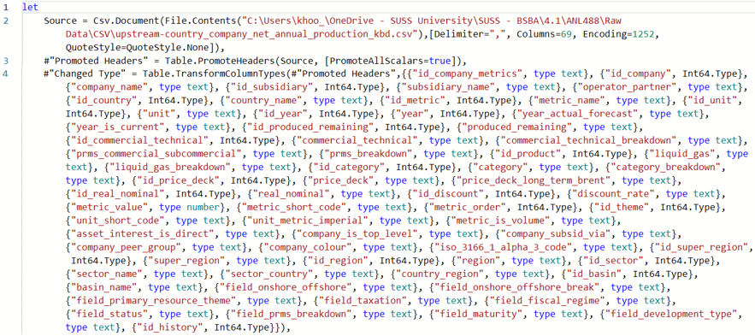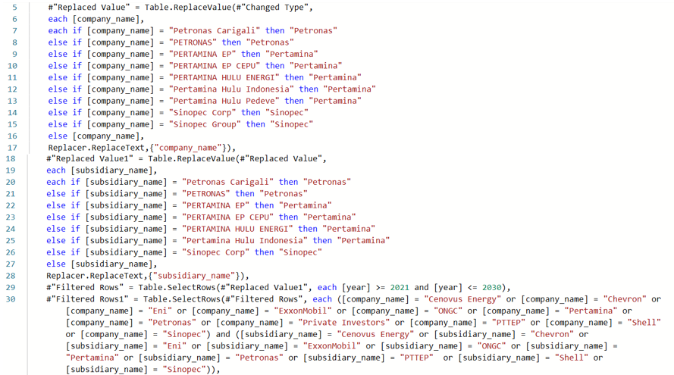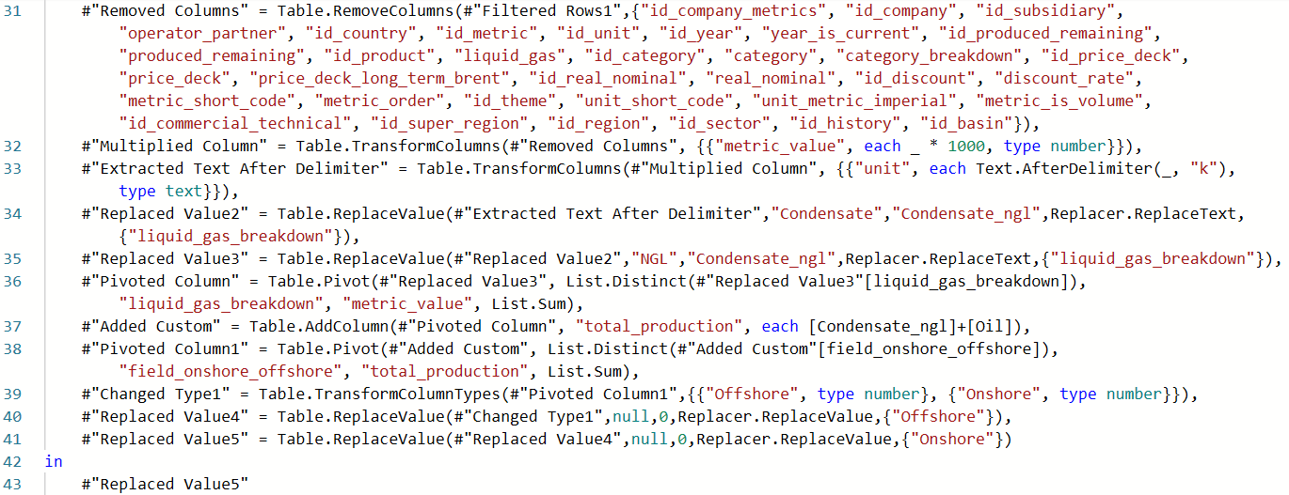

### Appendix B: Data preparation – Cenovus on Python

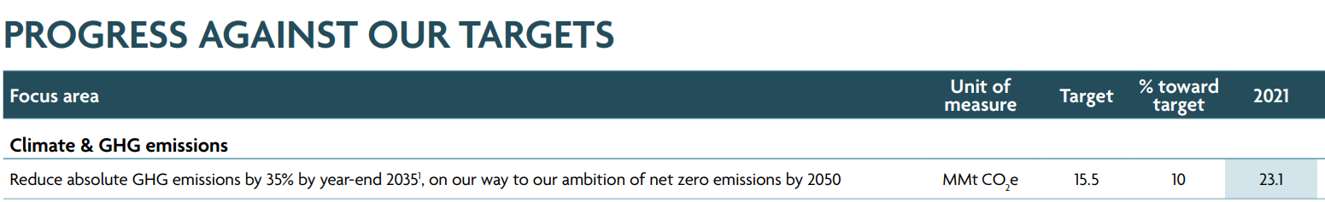

Figure B1: Cenovus 2021 GHG emissions (Cenovus Energy, 2022)

Table B1: 2021 Intensities and emissions calculations – Cenovus

|  |  |  |  |  |
| --- | --- | --- | --- | --- |
| Step | Assignment/Calculation | Oil | Gas | Total |
| 1 | Production (boe/d) | 0 | 9,539.0 | 9,539.0 |
| 2 | Emissions (kgCO2e/d) | 0 | 63,287,671.2 | 63,287,671.2 |
| 3 | Intensity (kgCO2e/boe) | 9,088.5 | 6,634.6 | - |
|  |  | Offshore | Onshore | Total |
| 4 | Production (boe/d) | 9,539.0 | 0 | 9,539.0 |
| 5 | Emissions (kgCO2e/d) | 63,287,671.2 | 0 | 63,287,671.2 |
| 6 | Intensity (kgCO2e/boe) | 6,634.6 | 2,189.4 | - |

The 2021 emissions were obtained from Cenovus’ sustainability report and then assumed to be fully from the gas and offshore production since there is no oil and onshore production according to the dataset. The intensities were then calculated using the 1:0.73 and 1:0.33 ratios.

Table B2: Target calculations – Cenovus

|  |  |  |  |
| --- | --- | --- | --- |
|  | Oil | Gas | Total |
| 2021 Production (boe/d) | 0 | 9,539.0 | 9,539.0 |
| 2030 Emissions (kgCO2e/d) |  |  | 41,095,890.4 |
| 2030 Forecasted production (boe/d) | 4,745.9 | 3,272.5 | 8,018.4 |
| 2030 Proportioned emissions target (kgCO2e/d) |  |  | 34,544,846.2 |

With the emission target set at 15.5 MMt CO2e by 2035, the 2030 emissions target was assumed to be 15.0 MMt CO2e. It was then converted to 41,095,890.4 kgCO2e/d and proportioned to 41,095,890.4 / (9,539.0 / 8,018.4) ≈ 34,544,846.2 kgCO2e/d ≈ 34.5M kgCO2e/d.

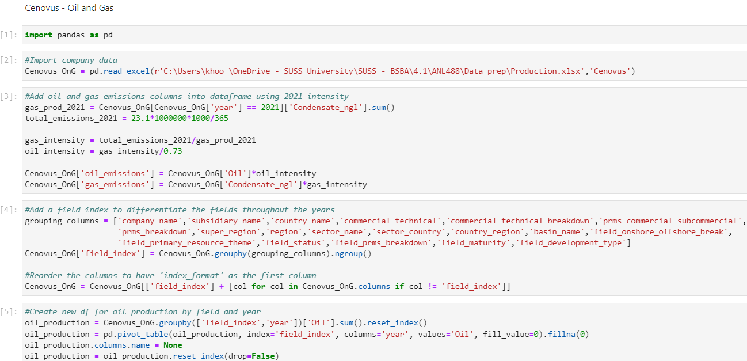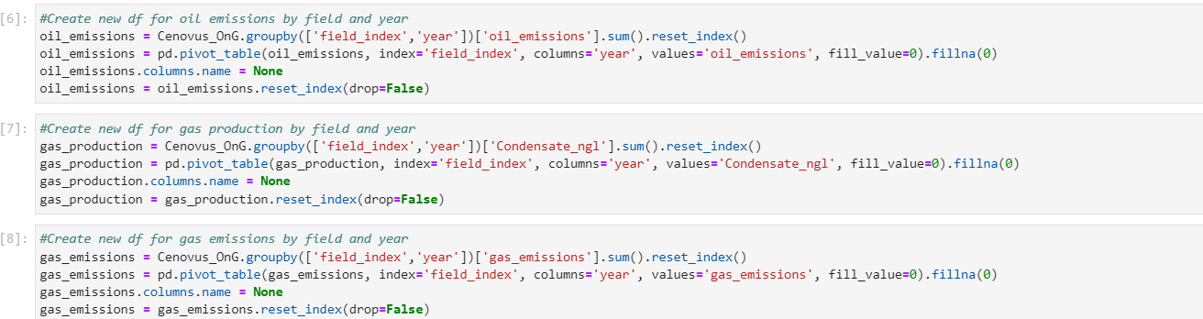

Figure B2: Data preparation Python codes on Cenovus O&G model

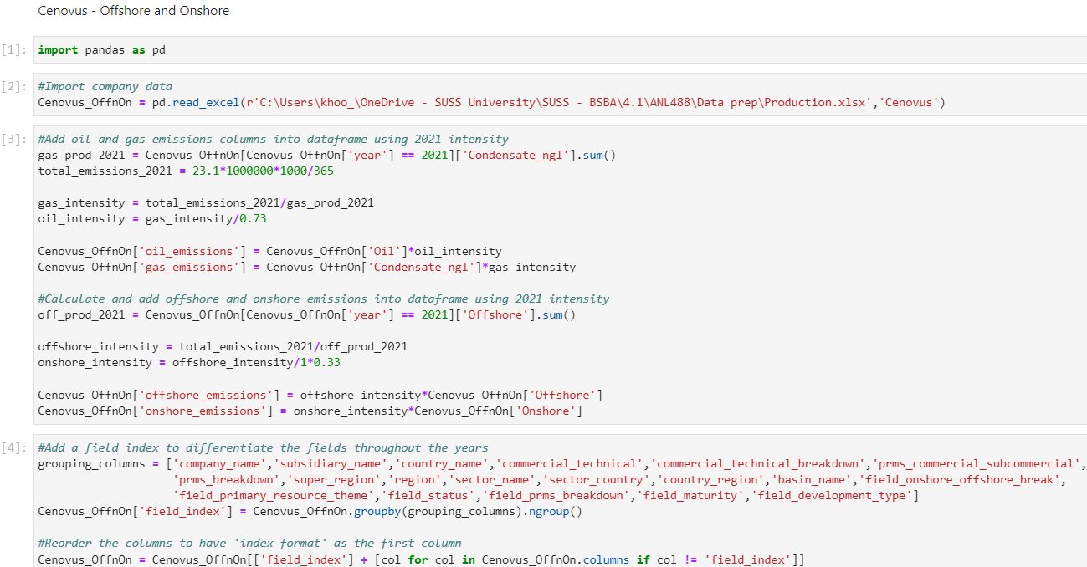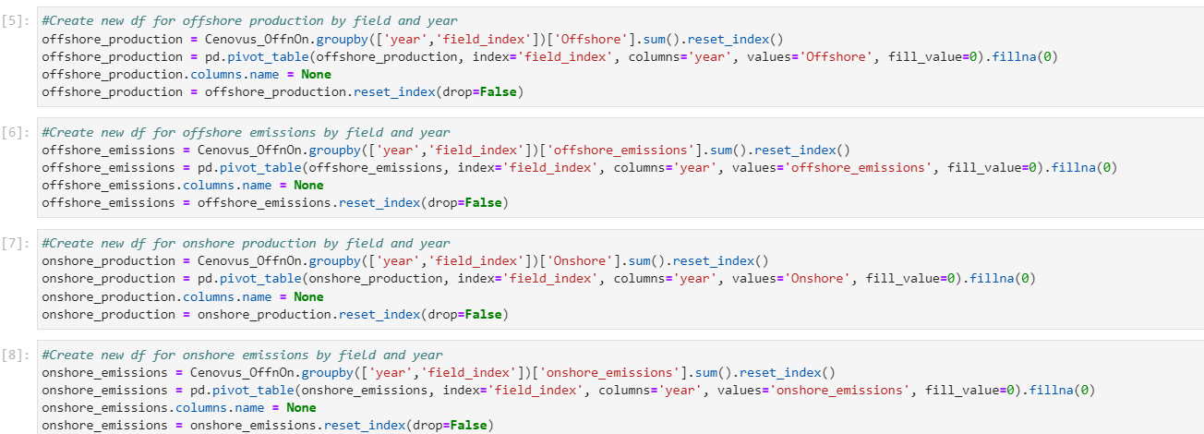

Figure B3: Data preparation Python codes on Cenovus offshore and onshore model

### Appendix C: Data preparation – Chevron on Python

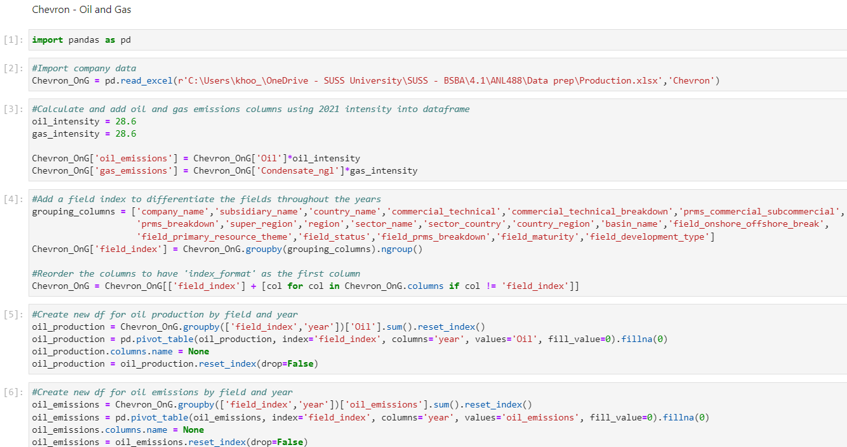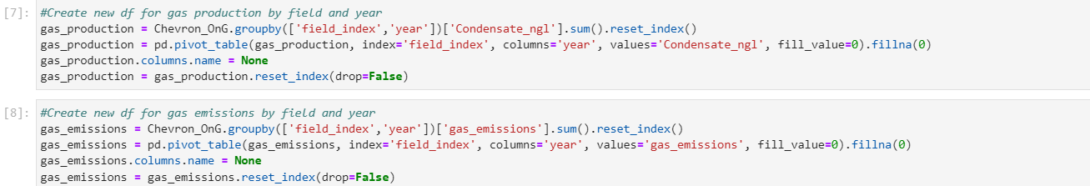

Figure C1: Data preparation Python codes on Chevron O&G model

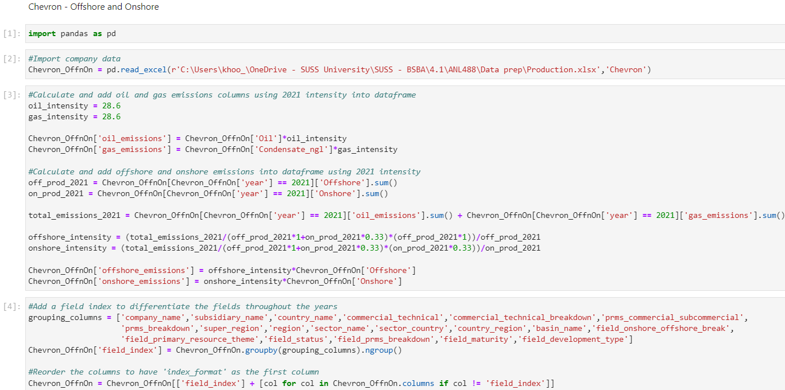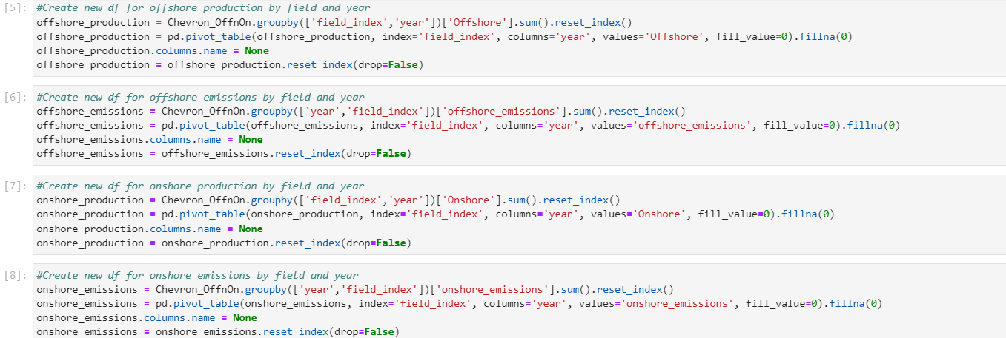

Figure C2: Data preparation Python codes on Chevron offshore and onshore model

### Appendix D: Data preparation – Eni on Python

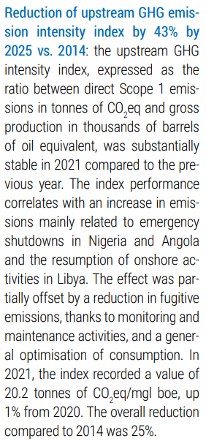

Figure D1: Eni 2021 GHG intensity and 2025 target (Eni, 2022)

Table D1: 2021 Intensities and emissions calculations – Eni

|  |  |  |  |  |
| --- | --- | --- | --- | --- |
| Step | Assignment/Calculation | Oil | Gas | Total |
| 1 | Production (boe/d) | 0 | 1,368.5 | 1,368.5 |
| 2 | Intensity (kgCO2e/boe) | 27,671.2 | 20,200.0 | - |
| 3 | Emissions (kgCO2e/d) | 0 | 27,643,700.0 | 27,643,700.0 |
|  |  | Offshore | Onshore | Total |
| 4 | Production (boe/d) | 1,368.5 | 0 | 1,368.5 |
| 5 | Intensity (kgCO2e/boe) | 20,200.0 | 6,666.0 | - |
| 6 | Emissions (kgCO2e/d) | 27,643,700.0 | 0 | 27,643,700.0 |

The 2021 intensity obtained from Eni’s sustainability report was assumed to be fully from the gas and offshore production since there is no oil and onshore production according to the dataset. The oil and onshore intensities were then calculated using the 1:0.73 and 1:0.33 ratios.

Table D2: Target calculations – Eni

|  |  |  |  |
| --- | --- | --- | --- |
|  | Oil | Gas | Total |
| 2021 Production (boe/d) | 0 | 1,368.5 | 1,368.5 |
| 2030 Emissions (kgCO2e/d) |  |  | 18,429,133.3 |
| 2030 Forecasted production (boe/d) | 0 | 14,494.2 | 14,494.2 |
| 2030 Proportioned emissions target (kgCO2e/d) |  |  | 195,188,829.3 |

With the intensity target set at a 43% reduction by 2025 compared to 2014, the 2030 emissions target was assumed to be a 50% reduction. 2021’s intensity was a 25% reduction from 2014 thus, 2014’s intensity was calculated to be 20,200.0 / 75% ≈ 26,933.3 kgCO2e/boe. The 2030 intensity target would then be 26,933.3 × 50% ≈ 13,466.7 kgCO2e/boe. Assuming the same 2021 production, the 2030 emissions target was calculated to be 13,466.7 × 1,368.5 ≈ 18,429,133.3 kgCO2e/d and proportioned to 18,429,133 / (1,368.5 / 14,494.2) ≈ 195,188,829.3 kgCO2e/d ≈ 195.2M kgCO2e/d.

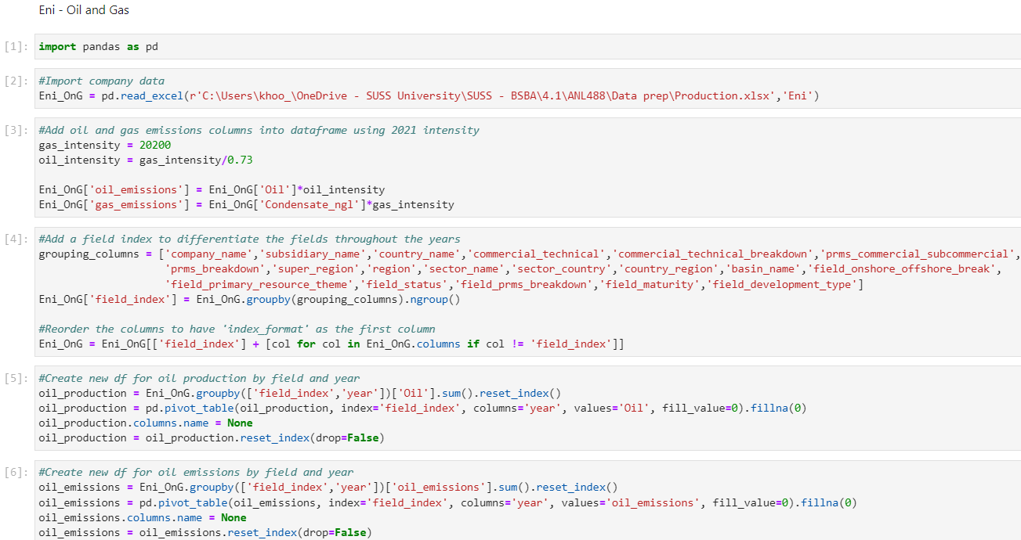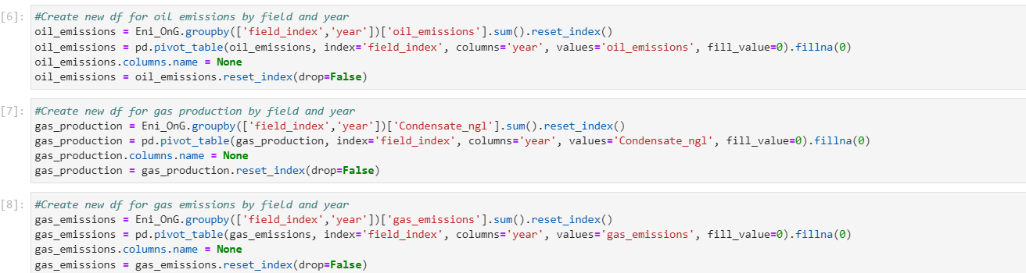

Figure D2: Data preparation Python codes on Eni O&G model

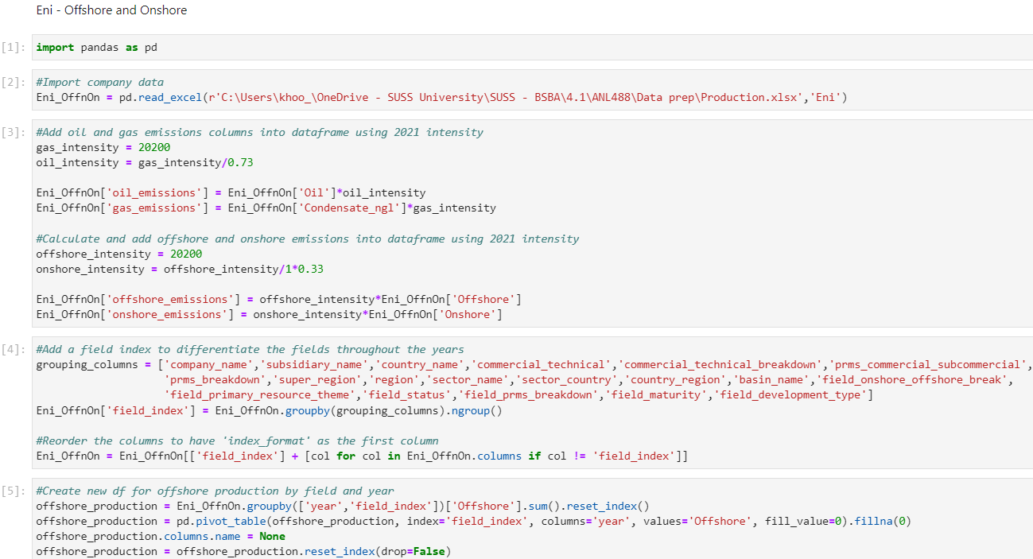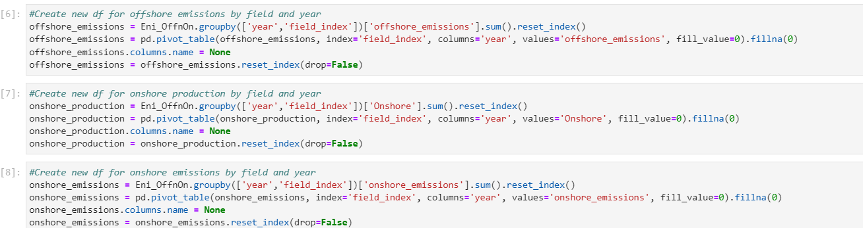

Figure D3: Data preparation Python codes on Eni offshore and onshore model

### Appendix E: Data preparation – ExxonMobil on Python

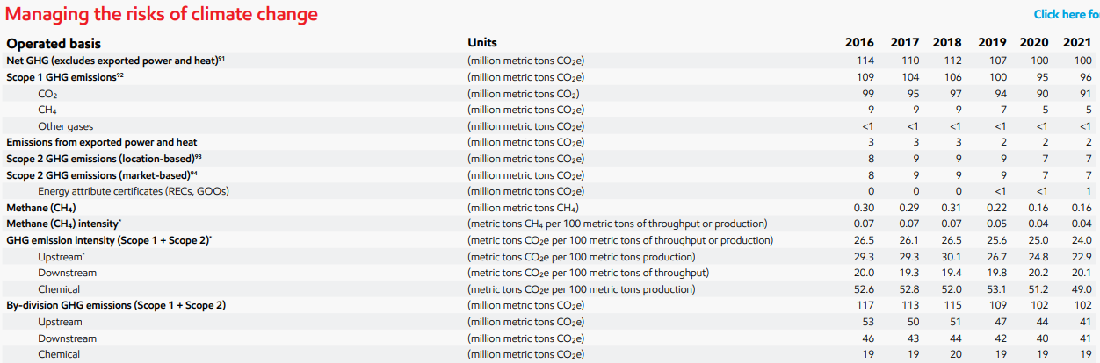

Figure E1: ExxonMobil 2021 GHG emissions (ExxonMobil, 2023)

Table E1: 2021 Intensities and emissions calculations – ExxonMobil

|  |  |  |  |  |
| --- | --- | --- | --- | --- |
| Step | Assignment/Calculation | Oil | Gas | Total |
| 1 | Production (boe/d) | 134,757.0 | 0 | 134,757.0 |
| 2 | Emissions (kgCO2e/d) | 112,328,767.1 | 0 | 112,328,767.1 |
| 3 | Intensity (kgCO2e/boe) | 833.6 | 608.5 | - |
|  |  | Offshore | Onshore | Total |
| 4 | Production (boe/d) | 37,350.0 | 97,407.0 | 134,757.0 |
| 5 | Emissions (kgCO2e/d) | 60,371,553.5 | 51,957,213.7 | 112,328,767.1 |
| 6 | Intensity (kgCO2e/boe) | 1,616.4 | 533.4 | - |

The 2021 upstream emissions were obtained from ExxonMobil’s 2023 progress report to be 41.0 million tons CO2e and then assumed to be fully from the oil production since there is no gas production according to the dataset. The oil, offshore, and onshore intensities were then calculated using the 1:0.73 and 1:0.33 ratios.

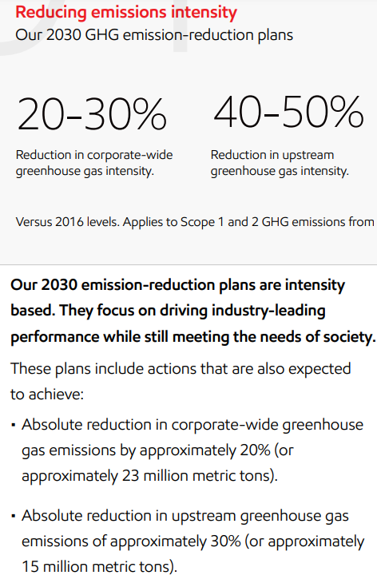

Figure E2: ExxonMobil 2030 GHG emissions target (ExxonMobil, 2023)

Table E2: Target calculations – ExxonMobil

|  |  |  |  |
| --- | --- | --- | --- |
|  | Oil | Gas | Total |
| 2021 Production (boe/d) | 134,757.0 | 0 | 134,757.0 |
| 2030 Emissions (kgCO2e/d) |  |  | 43,561,643.8 |
| 2030 Forecasted production (boe/d) | 24,625.0 | 956.3 | 25,581.3 |
| 2030 Proportioned emissions target (kgCO2e/d) |  |  | 8,269,413.1 |

It is mentioned in ExxonMobil’s 2023 progress report, as seen in Figure E2, that it aims to reduce upstream intensities to reduce 30% of upstream GHG emissions. 2016’s emissions can be seen from Figure E1 to be 53 million tons CO2e thus, resulting in the 30% reduction to be 43,561,643.8 kgCO2e/d. The 2030 emissions target was then further proportioned to 43,561,643.8 / (134,757.0 / 25,581.3) ≈ 8,269,413.1 kgCO2e/d ≈ 8.3M kgCO2e/d.

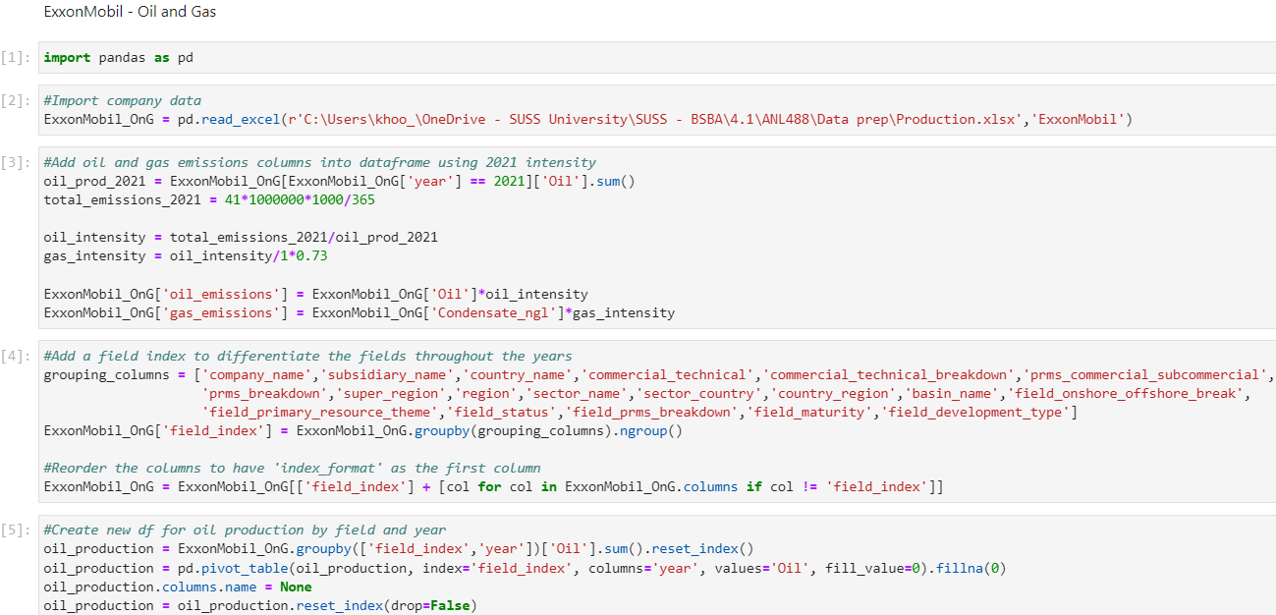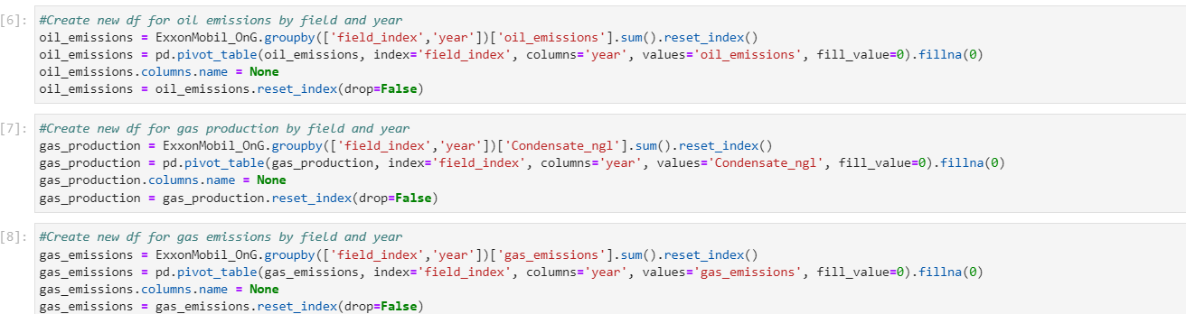

Figure E3: Data preparation Python codes on ExxonMobil O&G model

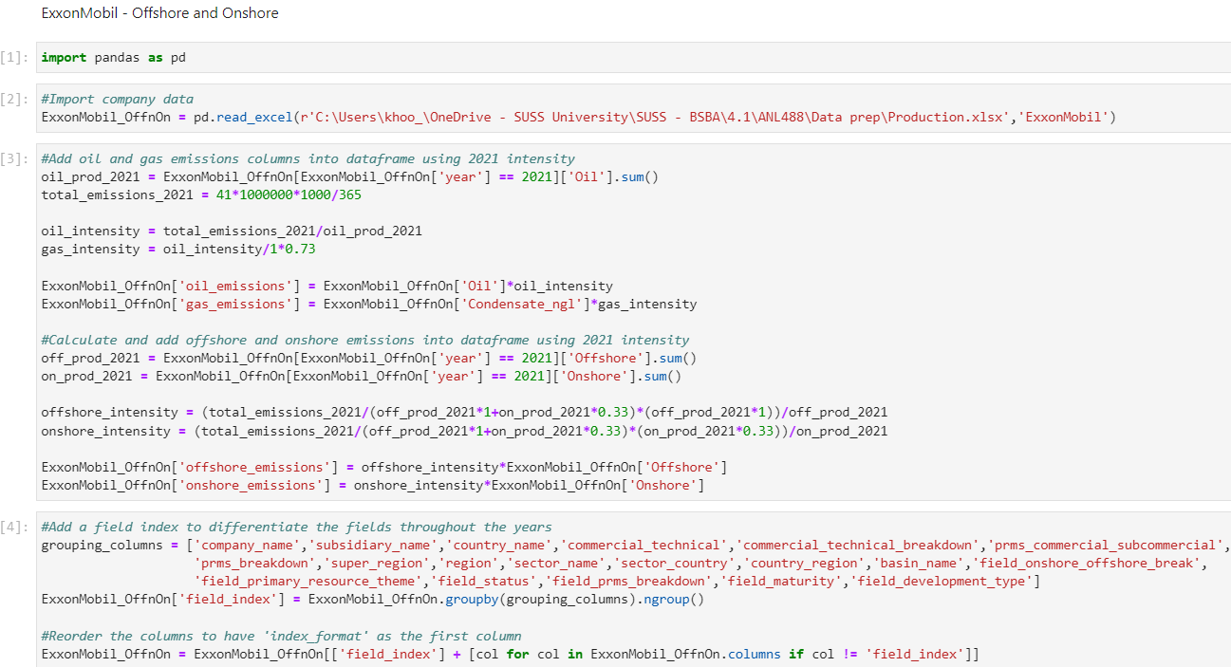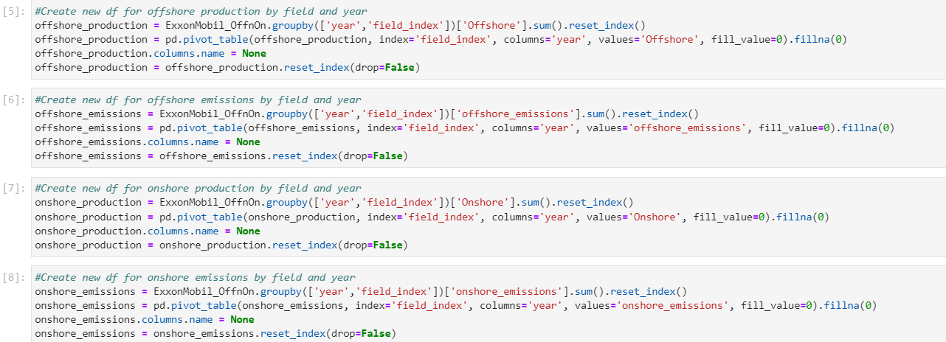

Figure E4: Data preparation Python codes on ExxonMobil offshore and onshore model

### Appendix F: Data preparation – Shell on Python

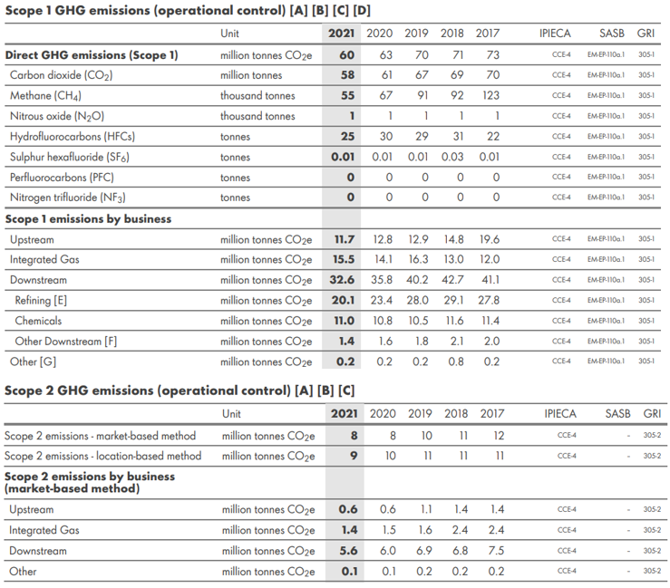

Figure F1: Shell 2021 GHG emissions (Shell, 2022)

Table F1: 2021 Intensities and emissions calculations – Shell

|  |  |  |  |  |
| --- | --- | --- | --- | --- |
| Step | Assignment/Calculation | Oil | Gas | Total |
| 1 | Production (boe/d) | 71,387.0 | 7,450.0 | 78,837.0 |
| 2 | Emissions (kgCO2e/d) | 31,313,094.0 | 2,385,536.1 | 33,698,630.1 |
| 3 | Intensity (kgCO2e/boe) | 438.6 | 320.2 | - |
|  |  | Offshore | Onshore | Total |
| 4 | Production (boe/d) | 78,837.0 | 0 | 78,837.0 |
| 5 | Emissions (kgCO2e/d) | 33,698,630.1 | 0 | 33,698,630.1 |
| 6 | Intensity (kgCO2e/boe) | 427.4 | 141.1 | - |

The 2021 upstream emissions were obtained from Shell’s 2021 sustainability report to be 11.7 + 0.6 million tons CO2e and then assumed to be fully from the offshore production since there is no onshore production according to the dataset. The oil, gas, and onshore intensities were then calculated using the 1:0.73 and 1:0.33 ratios.

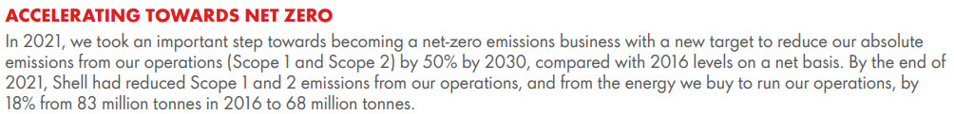

Figure F2: Shell 2030 emissions target (Shell, 2022)

Table F2: Target calculations – Shell

|  |  |  |  |
| --- | --- | --- | --- |
|  | Oil | Gas | Total |
| 2021 Production (boe/d) | 71,387.0 | 7,450.0 | 78,837.0 |
| 2030 Emissions (kgCO2e/d) |  |  | 20,566,075.7 |
| 2030 Forecasted production (boe/d) | 34,861.2 | 4,125.0 | 38,986.2 |
| 2030 Proportioned emissions target (kgCO2e/d) |  |  | 10,170,252.3 |

It is mentioned in Shell’s 2021 sustainability report as seen in Figure F2 that it aims to reduce its absolute emissions target by 50% by 2030 compared to 2016’s emissions at 83 million tons CO2e. Assuming the same proportions for the upstream GHG emissions to the total GHG emissions, 2030’s emissions target was calculated to be 50% × 83 × ((11.7 + 0.6) / 68) ≈ 7.5 million tons CO2e thus, resulting in the 50% reduction to be 20,566,075.7 kgCO2e/d. The 2030 emissions target was then further proportioned to 20,566,075.7 / (78,837.0 / 38,986.2) ≈ 10,170,252.3 kgCO2e/d ≈ 10.2M kgCO2e/d.

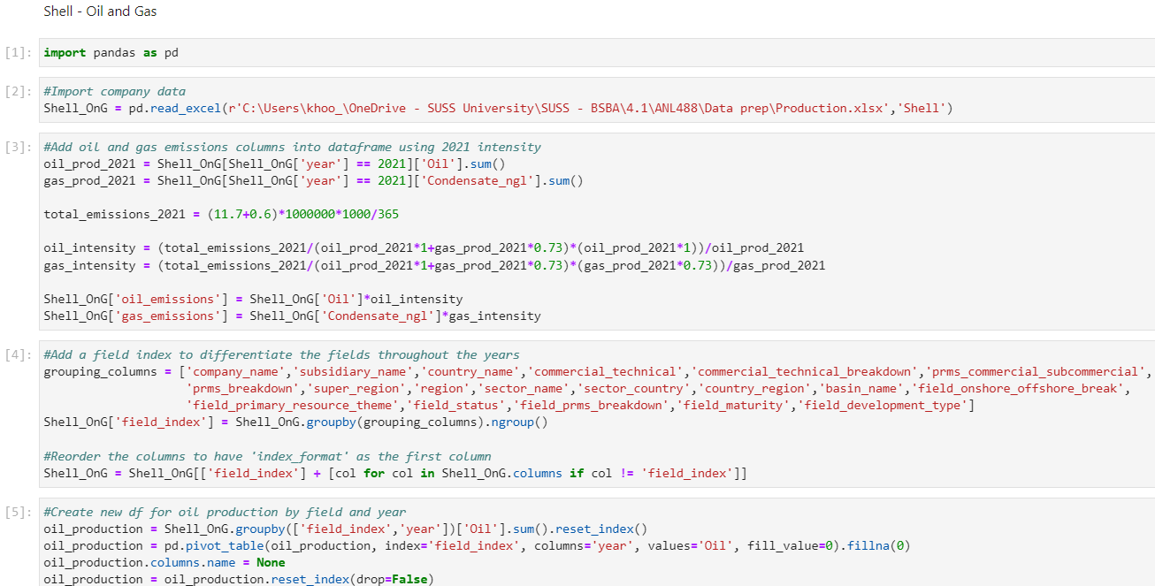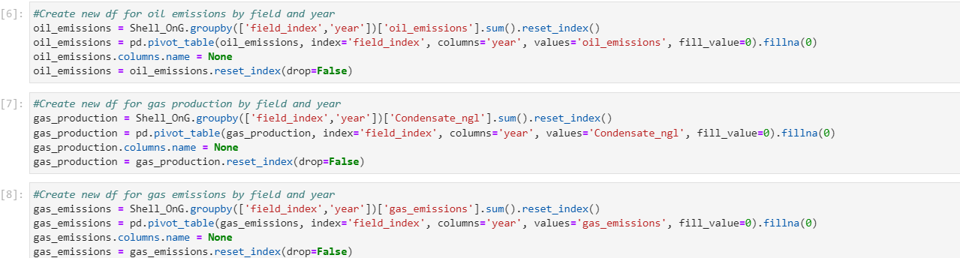

Figure F3: Data preparation Python codes on Shell O&G model

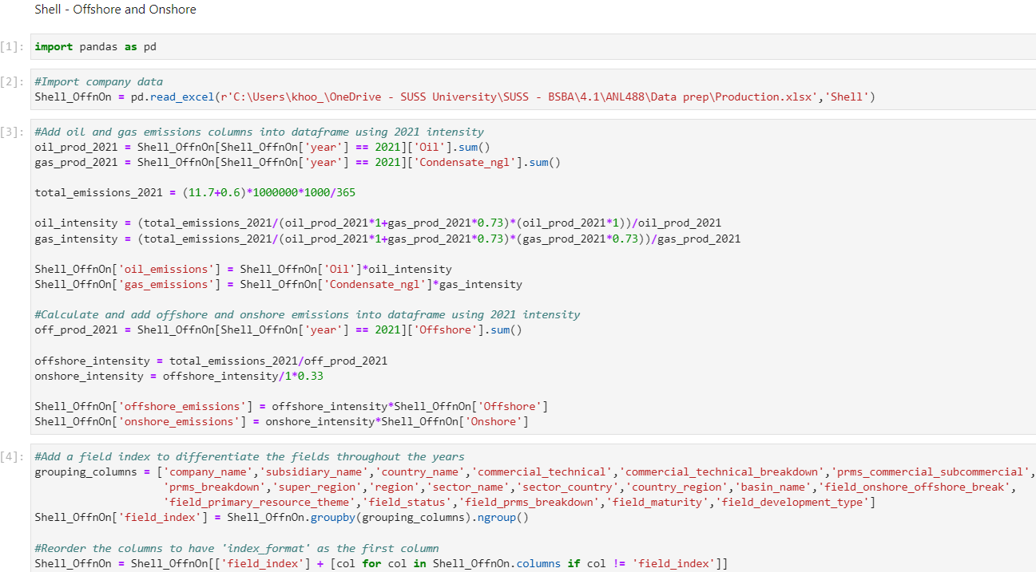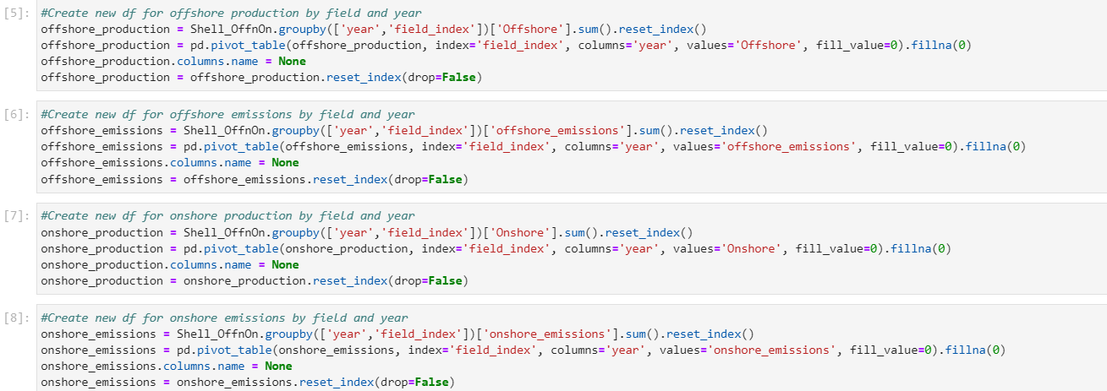

Figure F4: Data preparation Python codes on Shell offshore and onshore model

### Appendix G: Data preparation – ONGC on Python

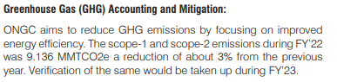

Figure G1: ONGC 2021 GHG emissions (ONGC, 2022)

Table G1: 2021 Intensities and emissions calculations – ONGC

|  |  |  |  |  |
| --- | --- | --- | --- | --- |
| Step | Assignment/Calculation | Oil | Gas | Total |
| 1 | Production (boe/d) | 386,848.0 | 27,710.0 | 414,558.0 |
| 2 | Emissions (kgCO2e/d) | 24,522,008.0 | 1,282,256.9 | 25,804,264.9 |
| 3 | Intensity (kgCO2e/boe) | 63.4 | 46.3 | - |
|  |  | Offshore | Onshore | Total |
| 4 | Production (boe/d) | 290,560.0 | 123,998.0 | 414,558.0 |
| 5 | Emissions (kgCO2e/d) | 22,618,867.3 | 3,185,397.6 | 25,804,264.9 |
| 6 | Intensity (kgCO2e/boe) | 77.8 | 25.7 | - |

The 2021 emissions were calculated to be 9.4 million tons CO2e as ONGC’s 2021-22 annual report stated a 3% reduction from 2021’s emissions to 2022’s 9.136 million tons CO2e. The O&G, offshore, and onshore intensities were then calculated using the 1:0.73 and 1:0.33 ratios.

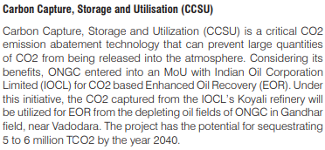

Figure G2: ONGC 2030 emissions target (ONGC, 2022)

Table G2: Target calculations – ONGC

|  |  |  |  |
| --- | --- | --- | --- |
|  | Oil | Gas | Total |
| 2021 Production (boe/d) | 386,848.0 | 27,710.0 | 414,558.0 |
| 2030 Emissions (kgCO2e/d) |  |  | 17,585,086.9 |
| 2030 Forecasted production (boe/d) | 301,136.8 | 4,417.2 | 305,554.0 |
| 2030 Proportioned emissions target (kgCO2e/d) |  |  | 12,961,259.0 |

ONGC intends to use CCS technologies to reduce up to 6 million tons CO2e by 2040. Using 2030 as the target year, 50% of the target, 3 million tons CO2e are to be reduced since 2021’s emissions instead. 9.4 – 3.0 = 6.4 million tons CO2e thus, resulting in the 50% reduction to be 17,585,086.9 kgCO2e/d. The 2030 emissions target was then further proportioned to 17,585,086.9 / (414,558.0 / 305,554.0) ≈ 12,961,259.0 kgCO2e/d ≈ 13.0M kgCO2e/d.

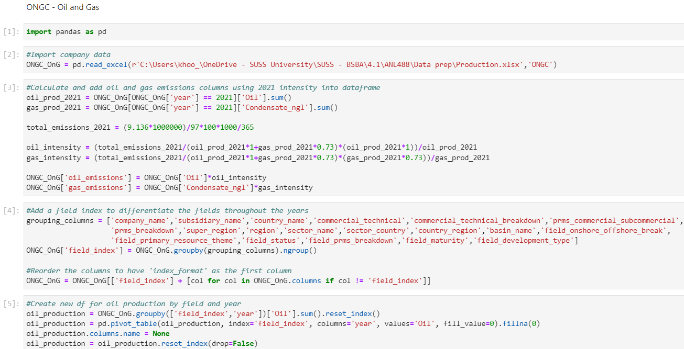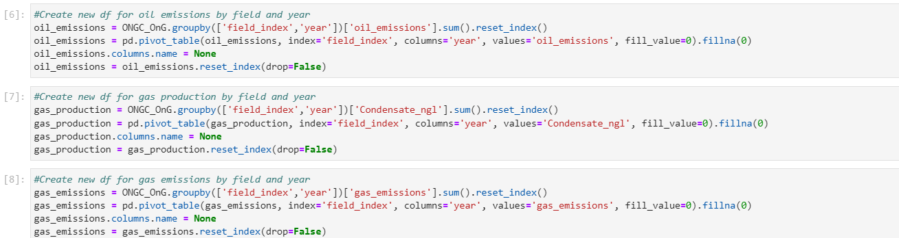

Figure G3: Data preparation Python codes on ONGC O&G model

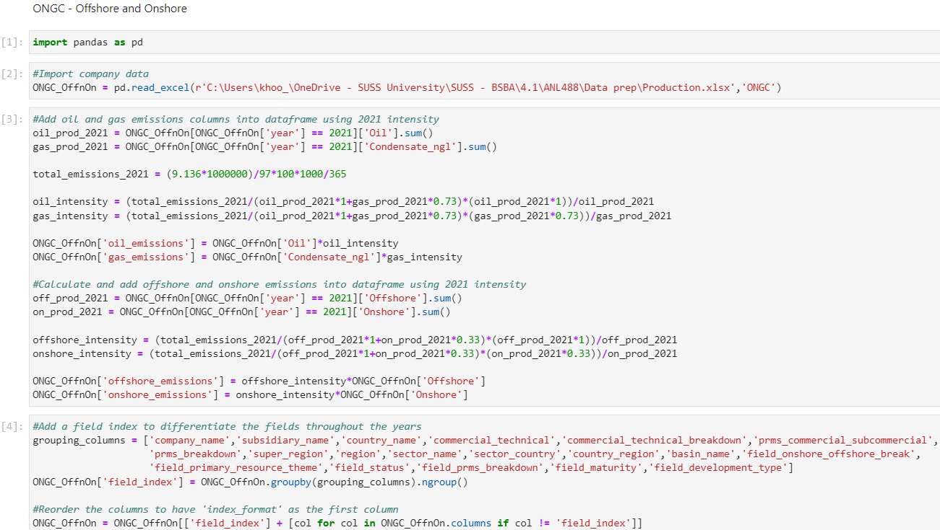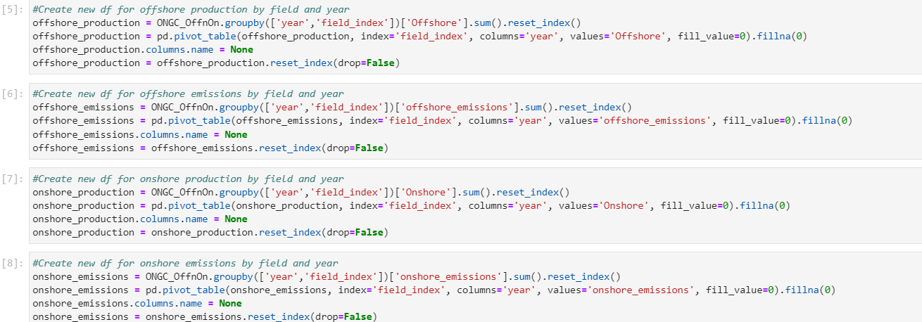

Figure G4: Data preparation Python codes on ONGC offshore and onshore model

### Appendix H: Data preparation – Pertamina on Python

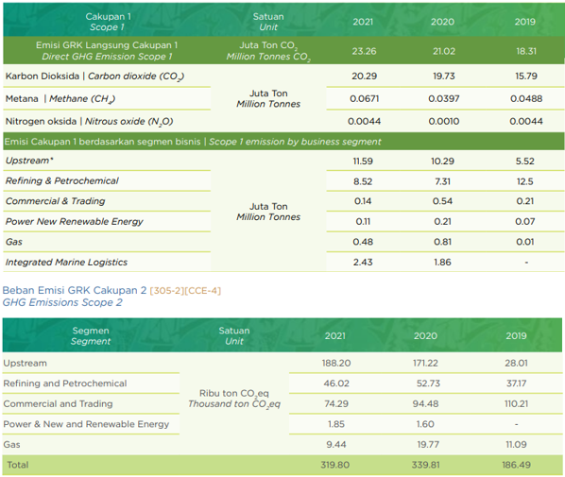

Figure H1: Pertamina 2021 GHG emissions (Pertamina, 2022)

Table H1: 2021 Intensities and emissions calculations – Pertamina

|  |  |  |  |  |
| --- | --- | --- | --- | --- |
| Step | Assignment/Calculation | Oil | Gas | Total |
| 1 | Production (boe/d) | 256,339.4 | 20,892.4 | 277,231.8 |
| 2 | Emissions (kgCO2e/d) | 30,456,941.7 | 1,812,099.4 | 32,269,041.1 |
| 3 | Intensity (kgCO2e/boe) | 118.8 | 86.7 | - |
|  |  | Offshore | Onshore | Total |
| 4 | Production (boe/d) | 81,539.1 | 195,692.7 | 277,231.8 |
| 5 | Emissions (kgCO2e/d) | 18,007,326.4 | 14,261,714.7 | 32,269,041.1 |
| 6 | Intensity (kgCO2e/boe) | 220.8 | 72.9 | - |

The 2021 upstream emissions were calculated to be 11.59 + (188.2 / 1000) ≈ 11.8 million tons CO2e, as seen in Figure H1 above from Pertamina’s 2021 sustainability report. The O&G, offshore, and onshore intensities were then calculated using the 1:0.73 and 1:0.33 ratios.

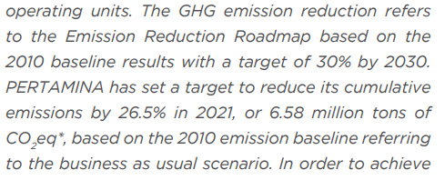

Figure H2: Pertamina 2030 emissions target (Pertamina, 2022)

Table H2: Target calculations – Pertamina

|  |  |  |  |
| --- | --- | --- | --- |
|  | Oil | Gas | Total |
| 2021 Production (boe/d) | 256,339.4 | 20,892.4 | 277,231.8 |
| 2030 Emissions (kgCO2e/d) |  |  | 47,619,539.9 |
| 2030 Forecasted production (boe/d) | 186,943.3 | 6,069.4 | 193,012.7 |
| 2030 Proportioned emissions target (kgCO2e/d) |  |  | 33,153,401.0 |

Pertamina stated its intentions to reduce emissions by 30% from 2010 to 2030, as seen in Figure H2 above. With 6.58 million tons CO2e being a 26.5% reduction from 2010 to 2021, 2010’s emissions were calculated to be 6.58 / 26.5% ≈ 24.8 million tons CO2e. The 2030 emissions target was thus calculated to be 70% × 24.8 ≈ 17.4 million tons CO2e, resulting in the 30% reduction to be 47,619,539.9 kgCO2e/d. The 2030 emissions target was then further proportioned to 47,619,539.9 / (277,231.8 / 193,012.7) ≈ 33,153,401.0 kgCO2e/d ≈ 33.2M kgCO2e/d.

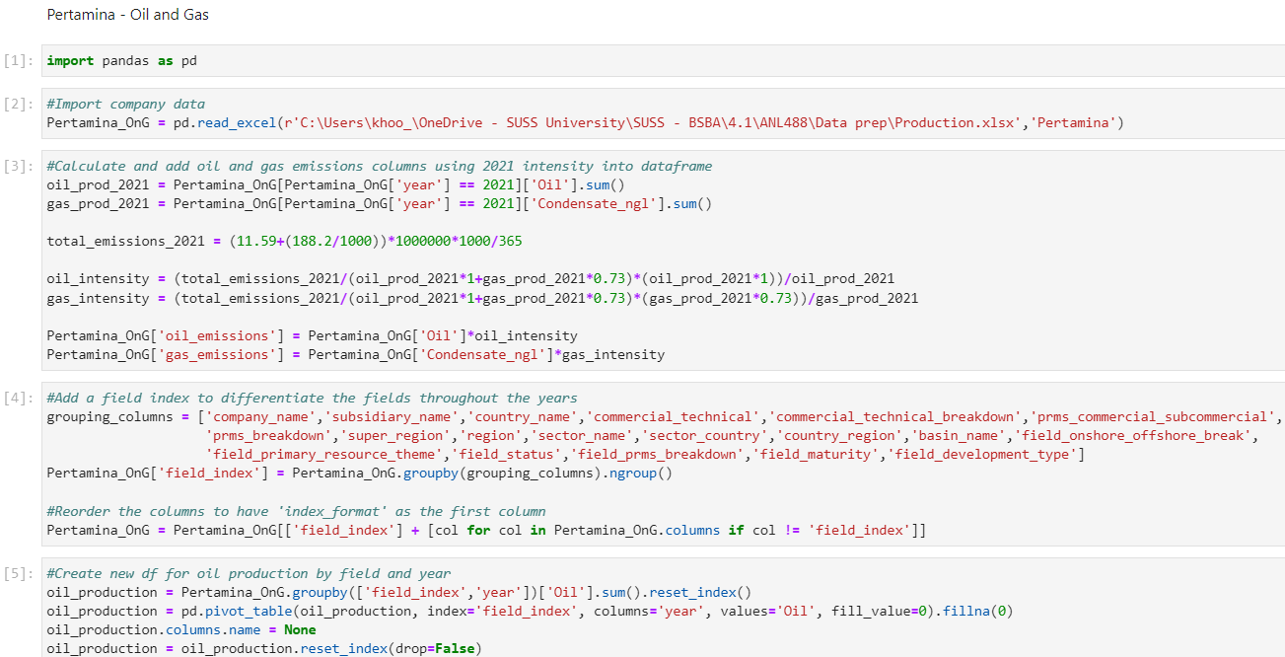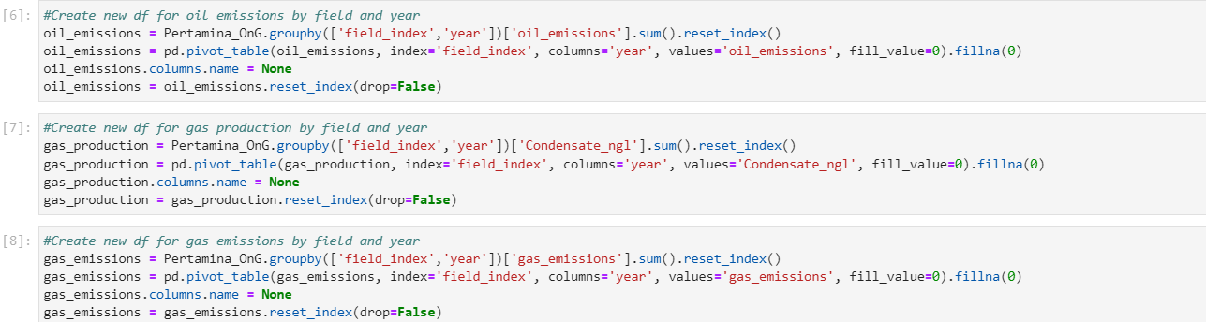

Figure H3: Data preparation Python codes on Pertamina O&G model

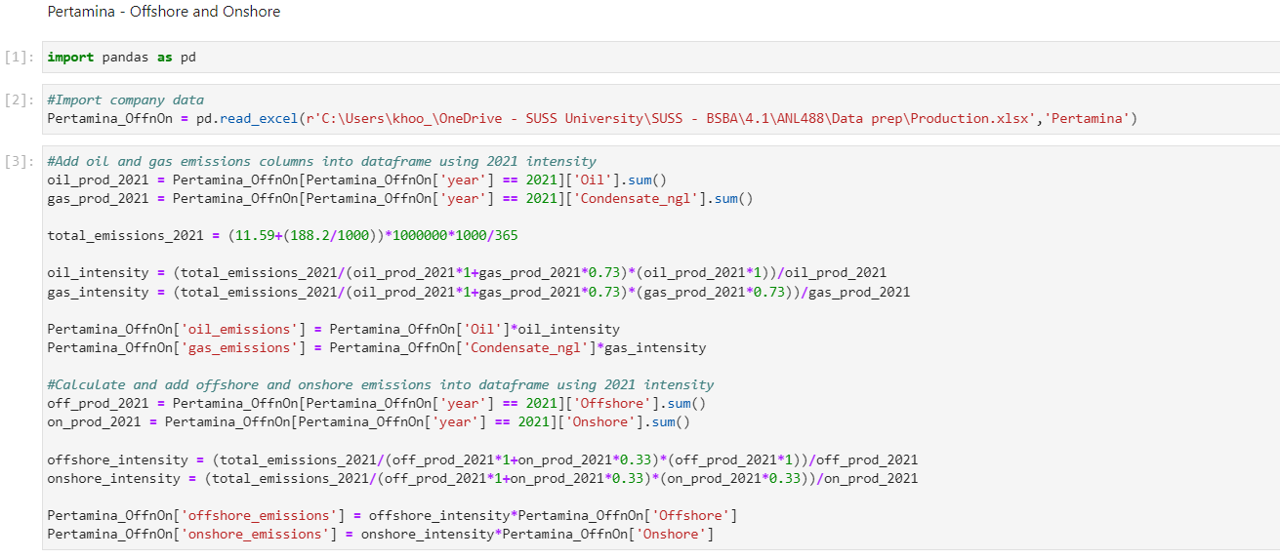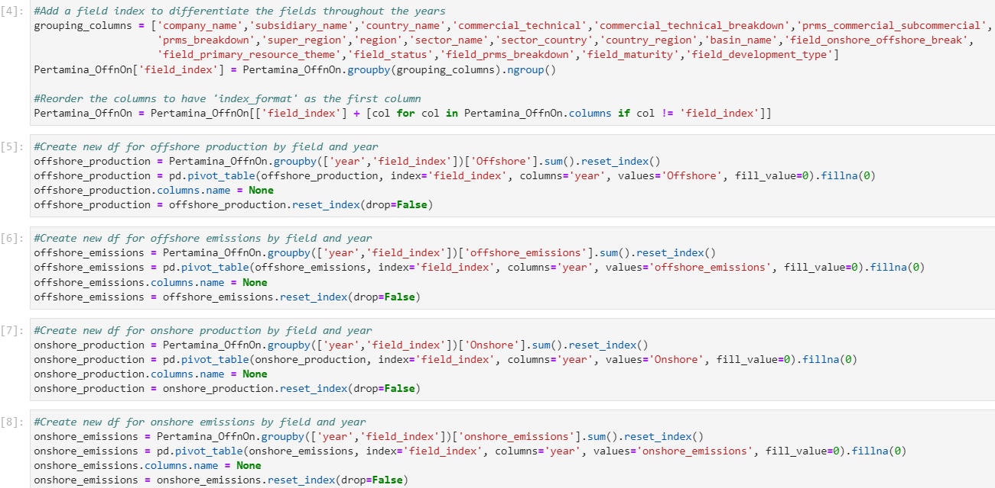

Figure H4: Data preparation Python codes on Pertamina offshore and onshore model

### Appendix I: Data preparation – Petronas on Python

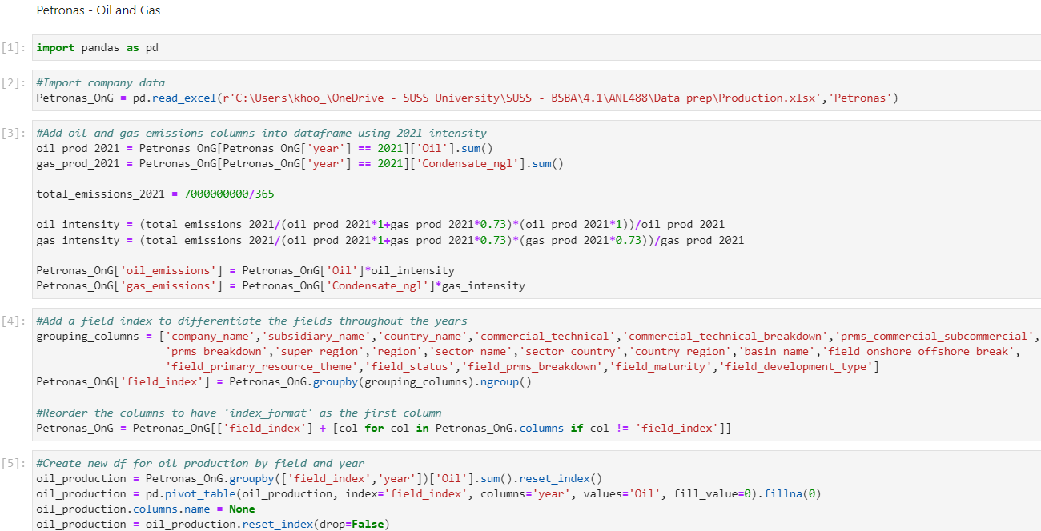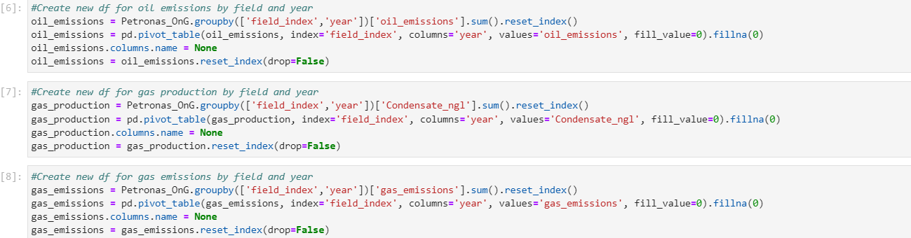

Figure I1: Data preparation Python codes on Petronas O&G model

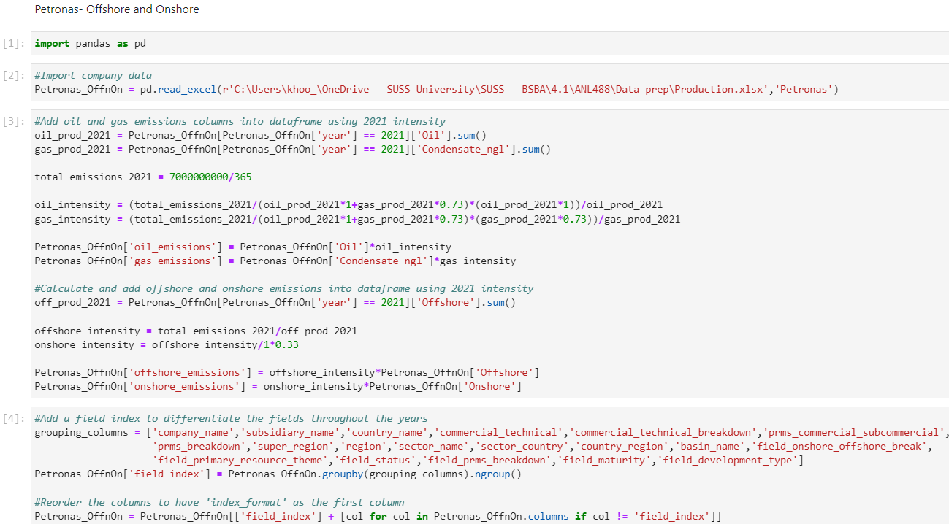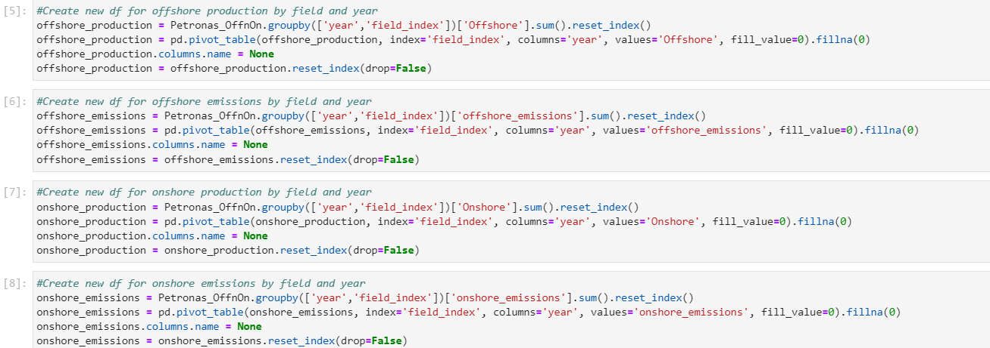

Figure I2: Data preparation Python codes on Petronas offshore and onshore model

### Appendix J: Data preparation – PTTEP on Python

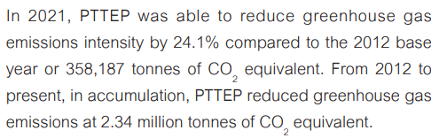

Figure J1: PTTEP 2021 GHG emissions (PTTEP, 2022)

Table J1: 2021 Intensities and emissions calculations – PTTEP

|  |  |  |  |  |
| --- | --- | --- | --- | --- |
| Step | Assignment/Calculation | Oil | Gas | Total |
| 1 | Production (boe/d) | 47,997.8 | 29,155.7 | 77,153.5 |
| 2 | Emissions (kgCO2e/d) | 2,141,144.3 | 949,447.7 | 3,090,592.1 |
| 3 | Intensity (kgCO2e/boe) | 44.6 | 32.6 | - |
|  |  | Offshore | Onshore | Total |
| 4 | Production (boe/d) | 52,348.5 | 24,805.0 | 77,153.5 |
| 5 | Emissions (kgCO2e/d) | 2,672,670.9 | 417,921.2 | 3,090,592.1 |
| 6 | Intensity (kgCO2e/boe) | 51.1 | 16.8 | - |

With 358,187.0 tons CO2e being a 24.1% reduction from 2012 to 2021, as seen in Figure J1 above from PTTEP’s 2021 sustainability report, 2021’s emissions were calculated to be 358,187 / 24.1 × 75.9 ≈ 1,128,066.1 tons CO2e and then converted to 3,090,592.1 kgCO2e/d. The O&G, offshore, and onshore intensities were then calculated using the 1:0.73 and 1:0.33 ratios.

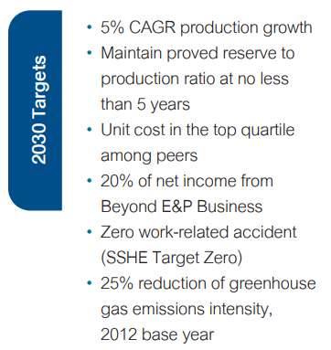

Figure J2: PTTEP 2030 emissions target (PTTEP, 2022)

Table J2: Target calculations – PTTEP

|  |  |  |  |
| --- | --- | --- | --- |
|  | Oil | Gas | Total |
| 2021 Production (boe/d) | 47,997.8 | 29,155.7 | 77,153.5 |
| 2030 Emissions (kgCO2e/d) |  |  | 3,053,944.8 |
| 2030 Forecasted production (boe/d) | 37,540.9 | 30,127.5 | 67,668.4 |
| 2030 Proportioned emissions target (kgCO2e/d) |  |  | 2,678,498.4 |

PTTEP stated its target to reduce emissions by 25% from 2012 to 2030, as seen in Figure J2 above. With 358,187.0 tons CO2e being a 24.1% reduction from 2012 to 2021, 2012’s emissions were calculated to be 358,187.0 / 24.1% ≈ 1,486,253.1 tons CO2e. The 2030 emissions target was thus calculated to be 75% × 1,486,253.1 ≈ 1,114,689.8 tons CO2e, resulting in the 25% reduction to be 47,619,539.9 kgCO2e/d. The 2030 emissions target was then further proportioned to 3,053,944.8 / (77,153.5 / 67,668.4) ≈ 2,678,498.4 kgCO2e/d ≈ 2.7M kgCO2e/d.

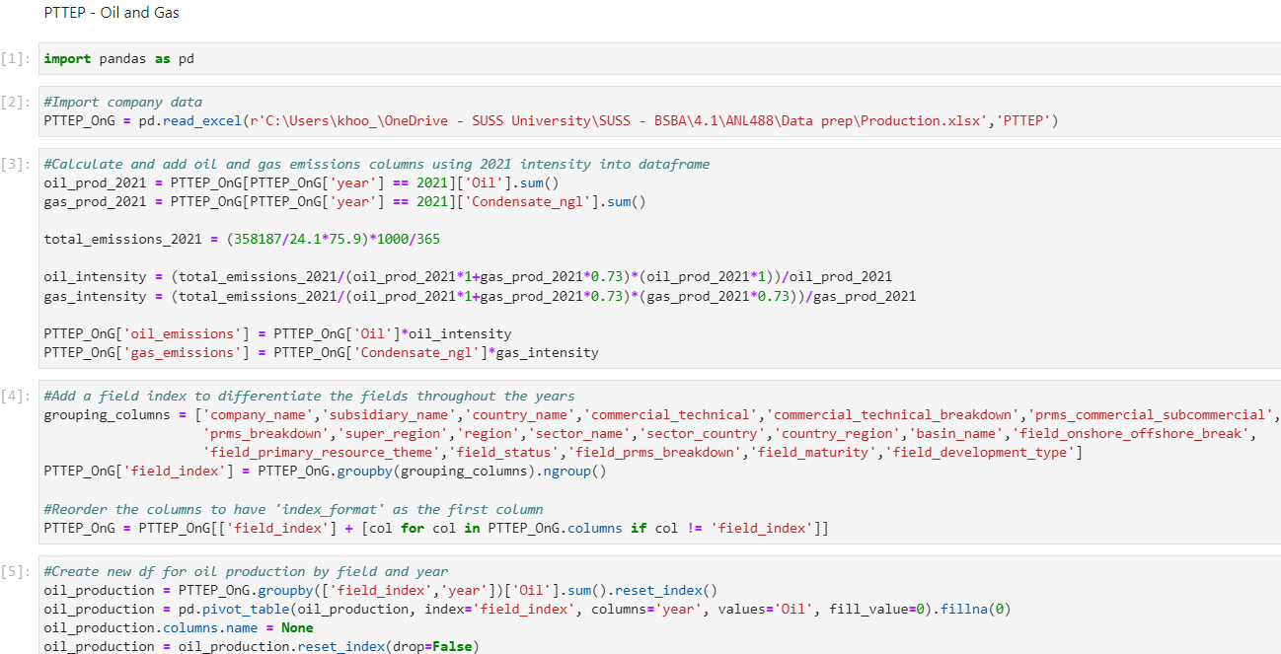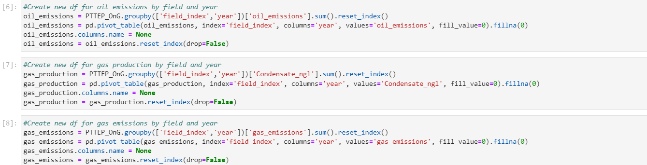

Figure J3: Data preparation Python codes on PTTEP O&G model

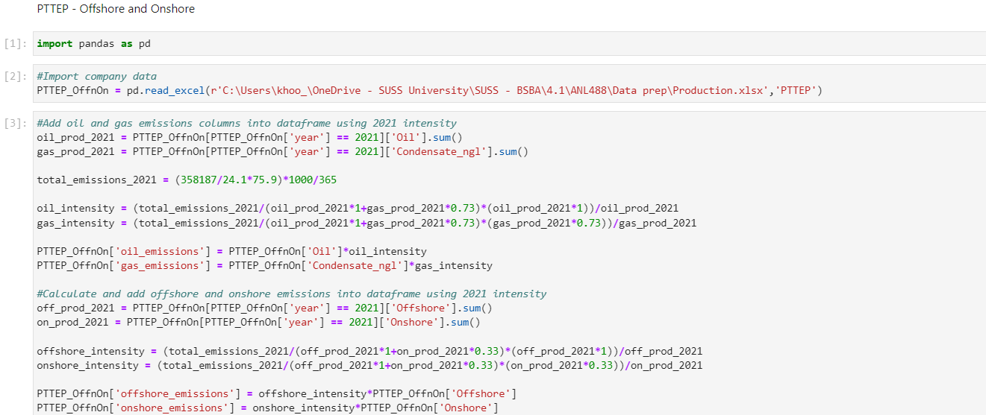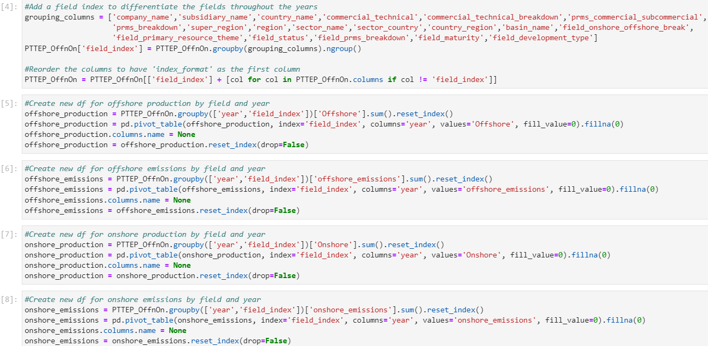

Figure J4: Data preparation Python codes on PTTEP offshore and onshore model

### Appendix K: Data preparation – Sinopec on Python

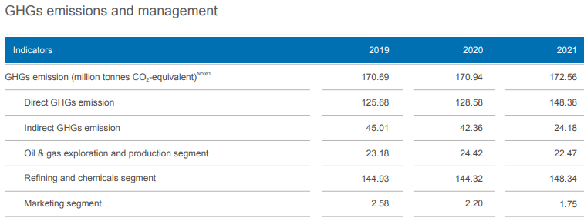

Figure K1: Sinopec 2021 GHG emissions (Sinopec, 2022)

Table K1: 2021 Intensities and emissions calculations – Sinopec

|  |  |  |  |  |
| --- | --- | --- | --- | --- |
| Step | Assignment/Calculation | Oil | Gas | Total |
| 1 | Production (boe/d) | 1,108,700.3 | 0 | 1,108,700.3 |
| 2 | Emissions (kgCO2e/d) | 61,561,643.8 | 0 | 61,561,643.8 |
| 3 | Intensity (kgCO2e/boe) | 55.5 | 40.5 | - |
|  |  | Offshore | Onshore | Total |
| 4 | Production (boe/d) | 6,701.5 | 1,101,998.8 | 1,108,700.3 |
| 5 | Emissions (kgCO2e/d) | 1,113,931.3 | 60,447,712.5 | 61,561,643.8 |
| 6 | Intensity (kgCO2e/boe) | 166.2 | 54.9 | - |

Sinopec’s 2021 upstream emissions were 22.47 million tons CO2e, as seen in Figure K1 above from Sinopec’s 2021 sustainability report, converted to 61,561,643.8 kgCO2e/d. With no gas production according to the dataset, the emissions are assumed to be fully from oil production. The gas, offshore, and onshore intensities were then calculated using the 1:0.73 and 1:0.33 ratios.

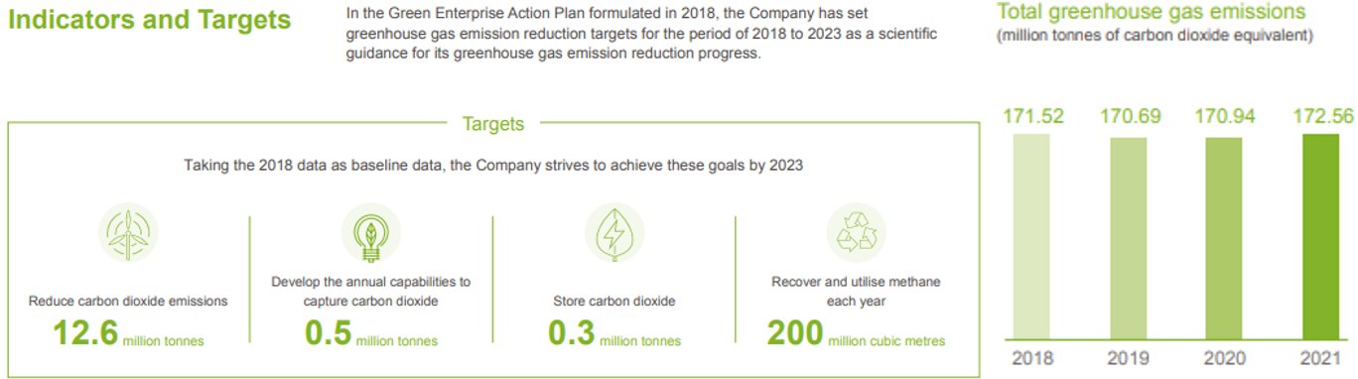

Figure K2: Sinopec 2030 emissions target (Sinopec, 2022)

Table K2: Target calculations – Sinopec

|  |  |  |  |
| --- | --- | --- | --- |
|  | Oil | Gas | Total |
| 2021 Production (boe/d) | 1,108,700.3 | 0 | 1,108,700.3 |
| 2030 Emissions (kgCO2e/d) |  |  | 56,695,505.6 |
| 2030 Forecasted production (boe/d) | 620,688.8 | 0 | 620,688.8 |
| 2030 Proportioned emissions target (kgCO2e/d) |  |  | 31,740,104.5 |

Sinopec stated its target to reduce emissions by 12.6 million tons CO2e from 2018 to 2030, as seen in Figure K2 above. The total GHG emissions target in 2030 is thus 171.5 – 12.6 = 158.9 million tons CO2e. Assuming the same proportion of upstream emissions to total emissions in 2021 and 2030, the 2030 upstream emissions target was thus calculated to be 158.9 × (22.5 / 172.6) ≈ 20.7 million tons CO2e, converted to 56,695,505.6 kgCO2e/d. The 2030 emissions target was then further proportioned to 56,695,505.6 / (1,108,700.3 / 620,688.8) ≈ 31,740,104.5 kgCO2e/d ≈ 31.7M kgCO2e/d.

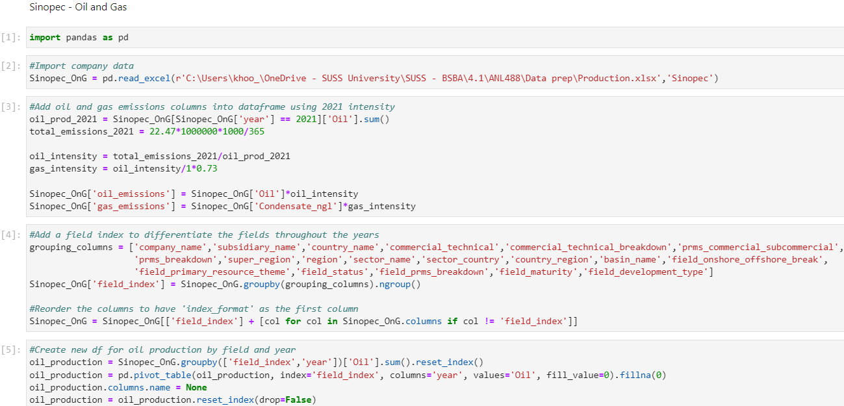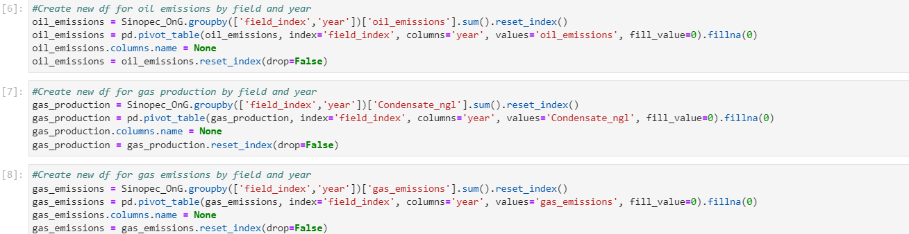

Figure K3: Data preparation Python codes on Sinopec O&G model

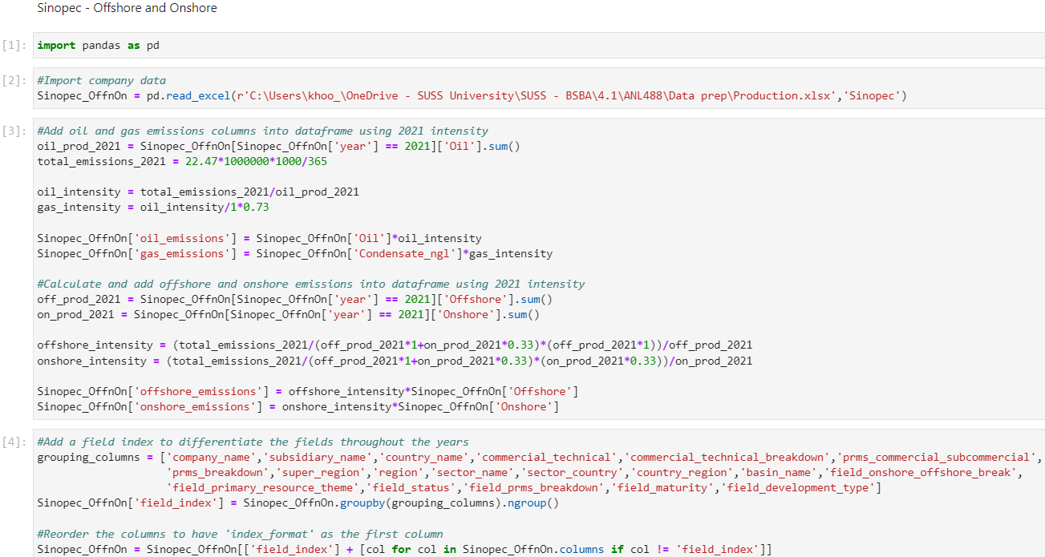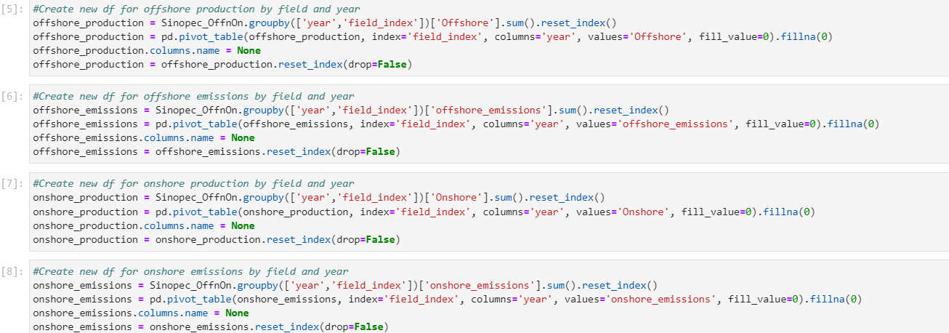

Figure K4: Data preparation Python codes on Sinopec offshore and onshore model

### Appendix L: Model construction and evaluation – Cenovus

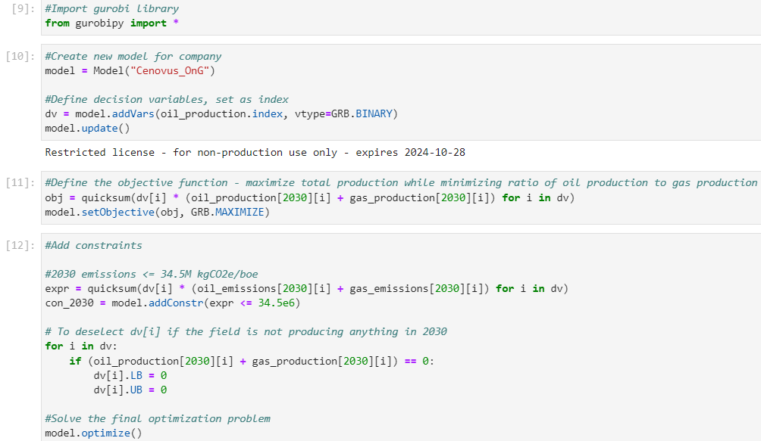 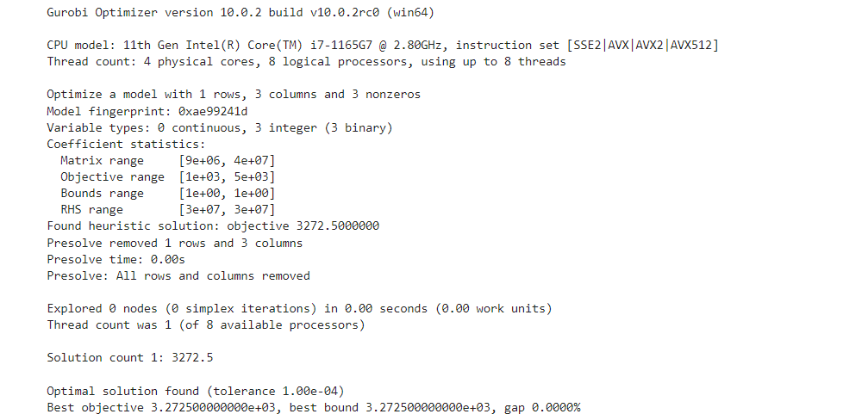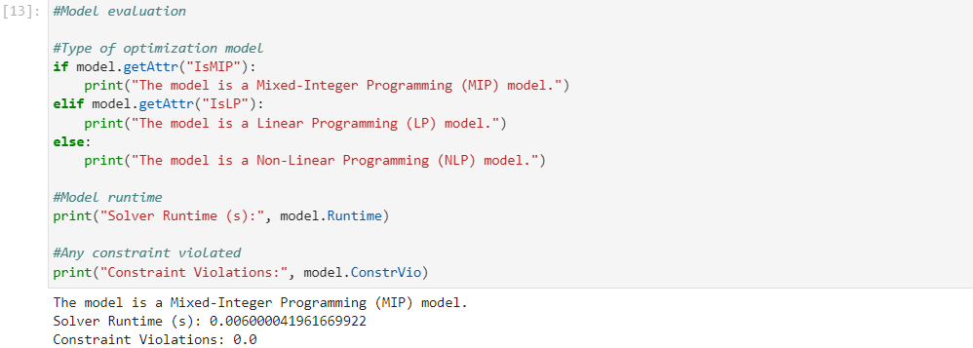

Figure L1: Cenovus O&G model construction and evaluation

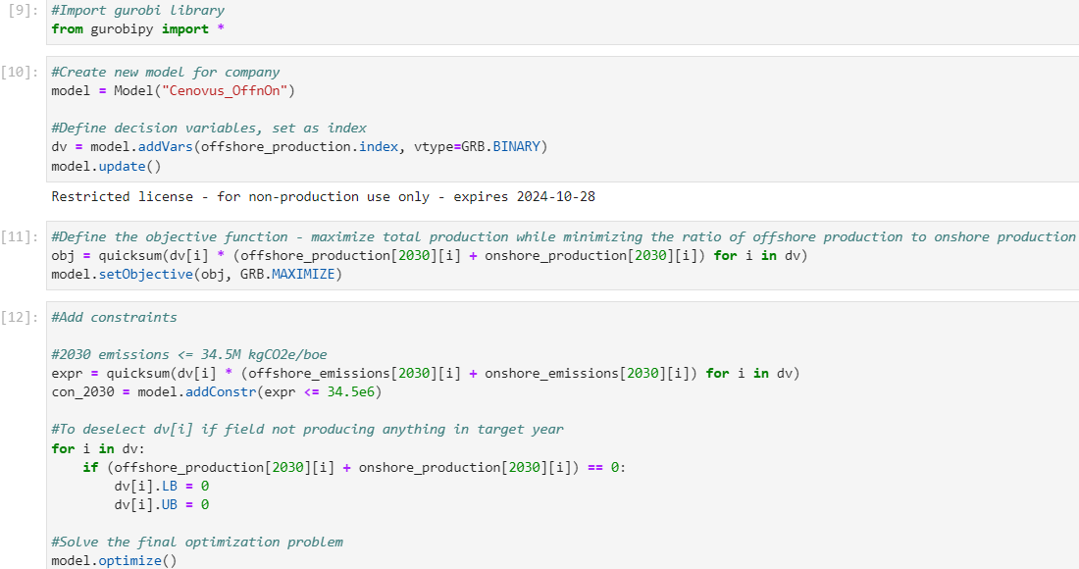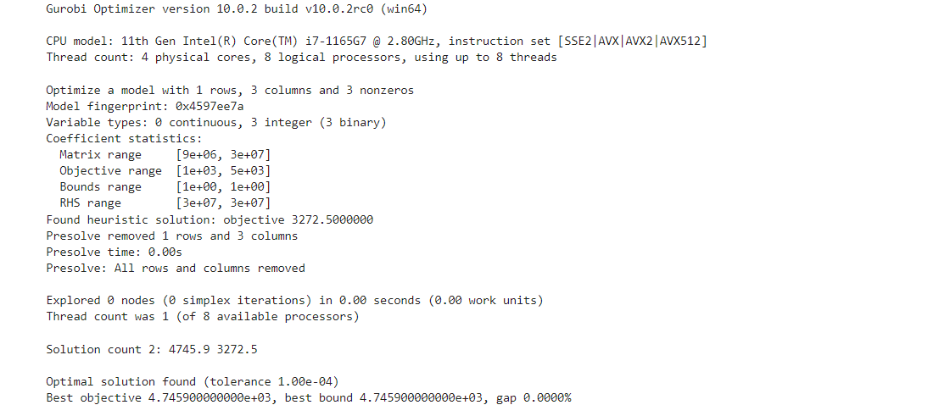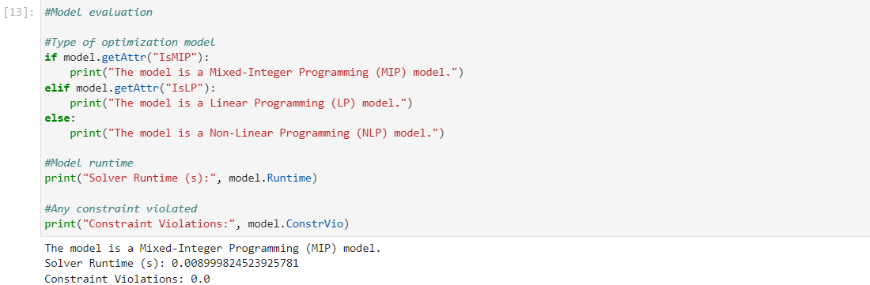

Figure L2: Cenovus offshore and onshore model construction and evaluation

### Appendix M: Model construction and evaluation – Chevron

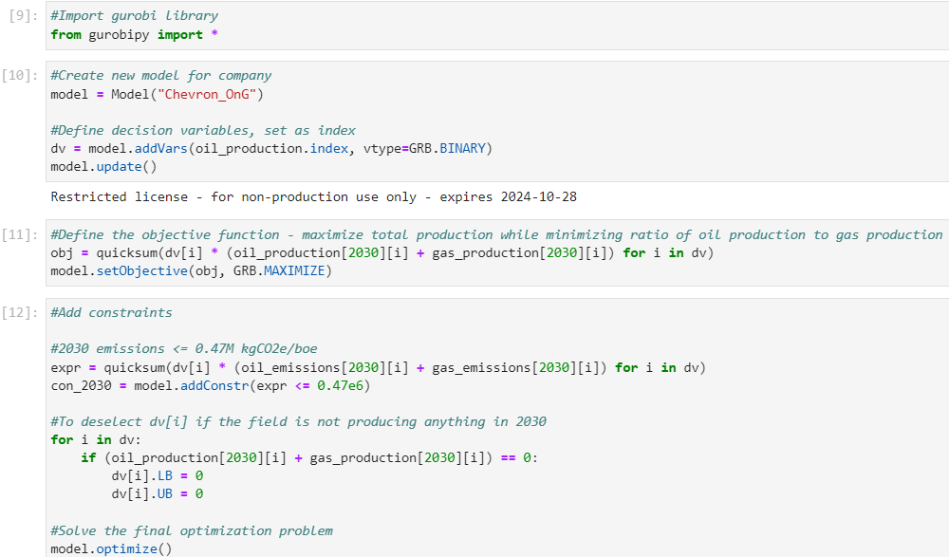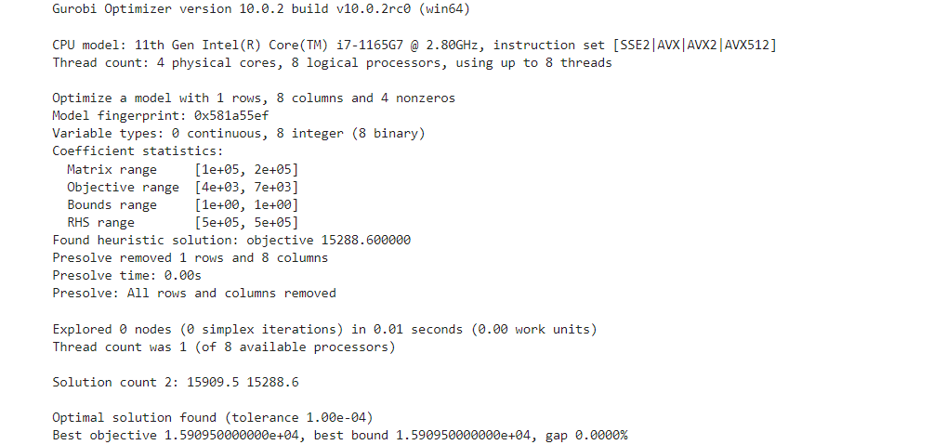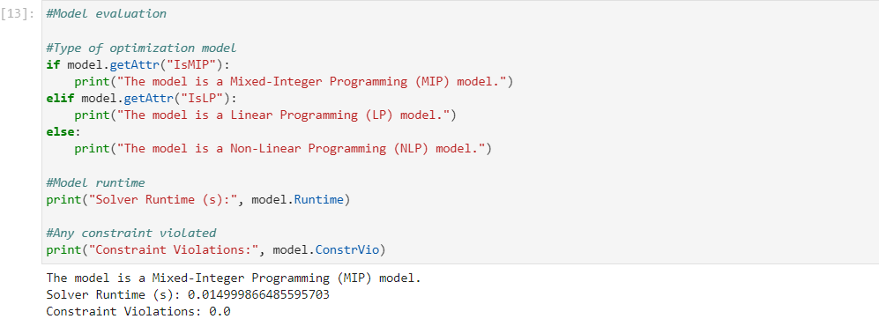

Figure M1: Chevron O&G model construction and evaluation

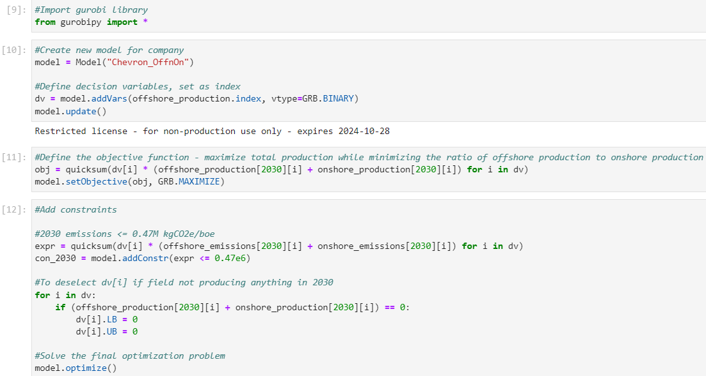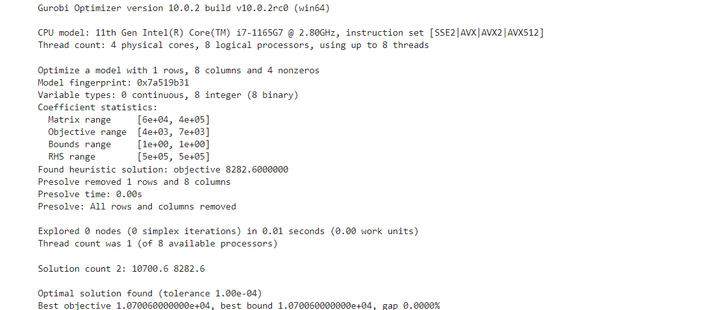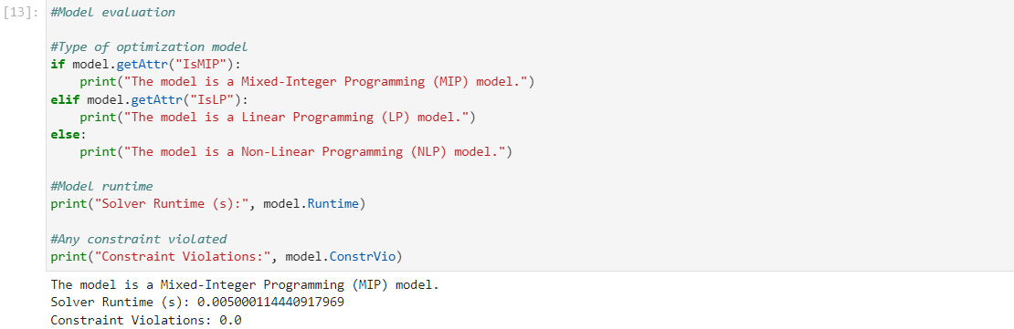

Figure M2: Chevron offshore and onshore model construction and evaluation

### Appendix N: Model construction and evaluation – Eni

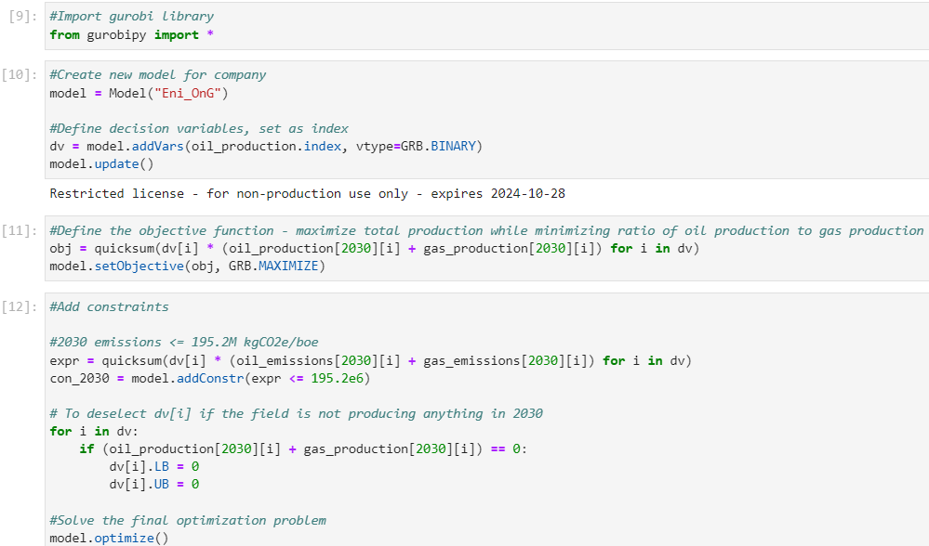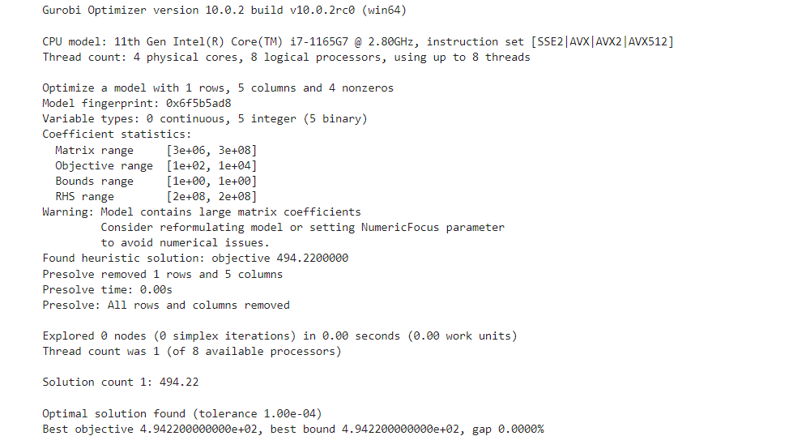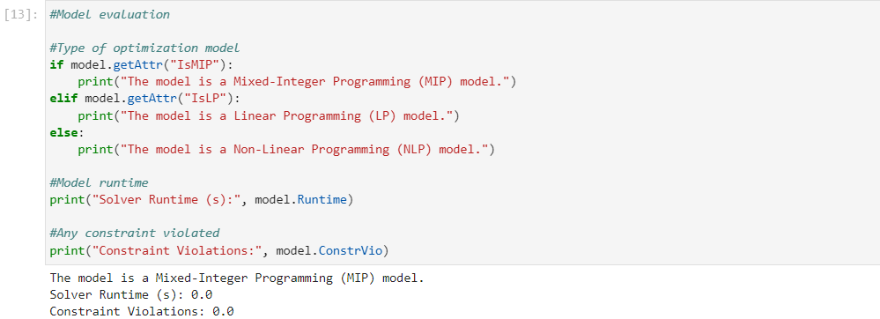

Figure N1: Eni O&G model construction and evaluation

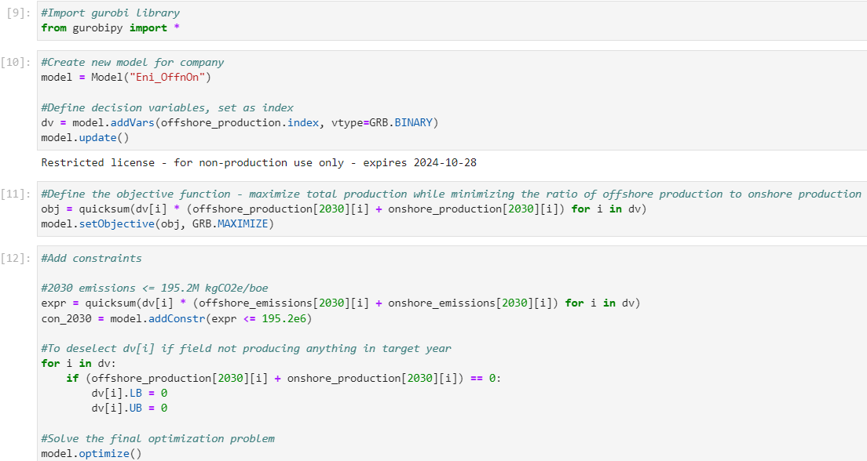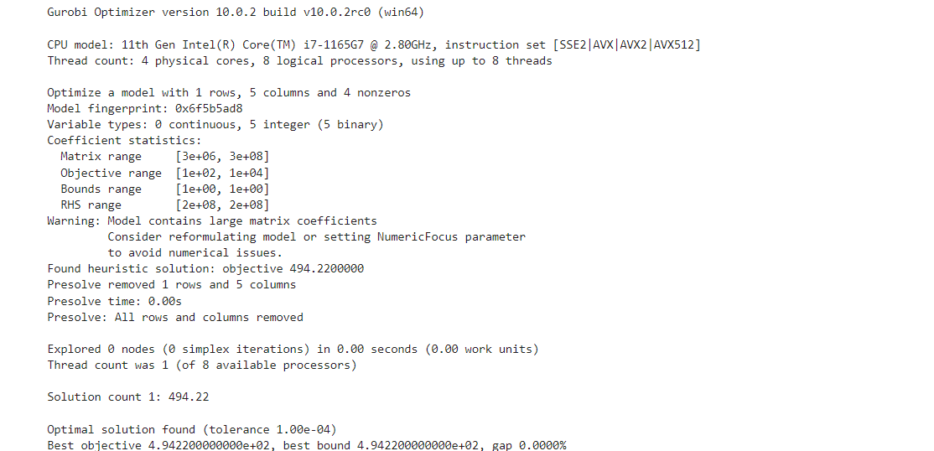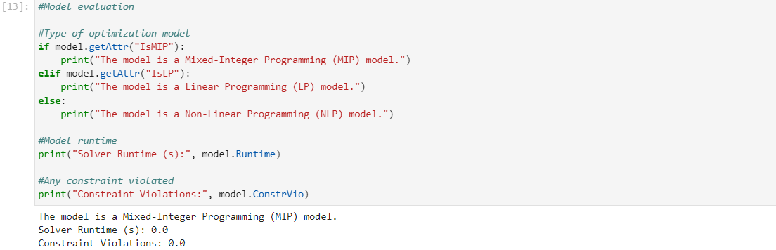

Figure N2: Eni offshore and onshore model construction and evaluation

### Appendix O: Model construction and evaluation – ExxonMobil

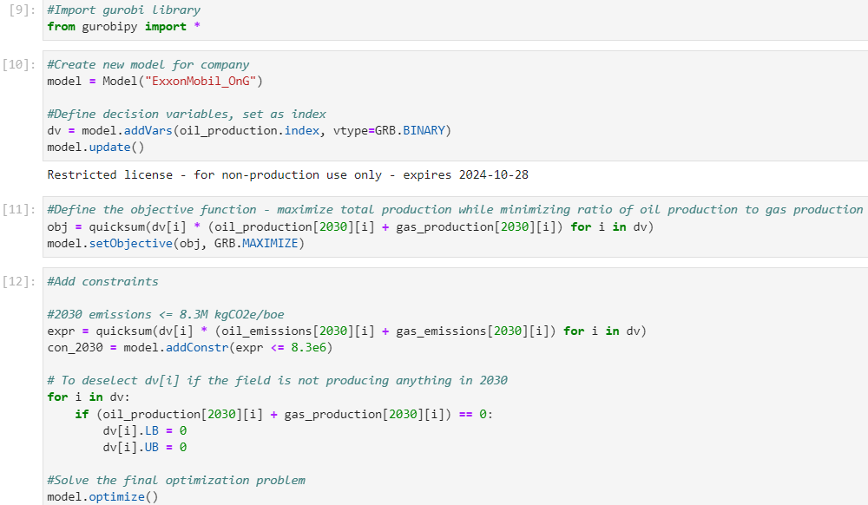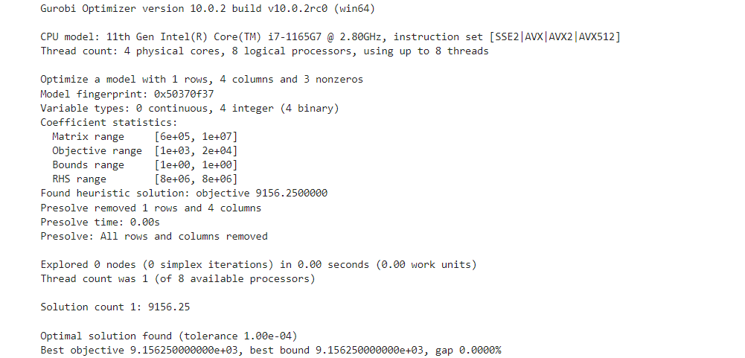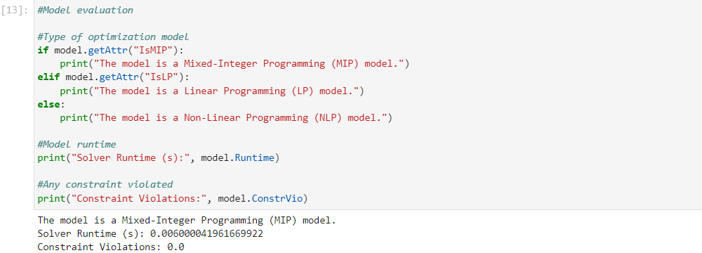

Figure O1: ExxonMobil O&G model construction and evaluation

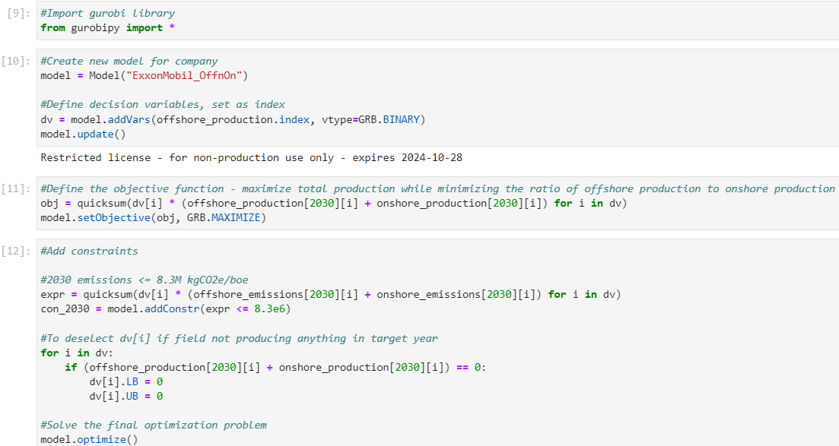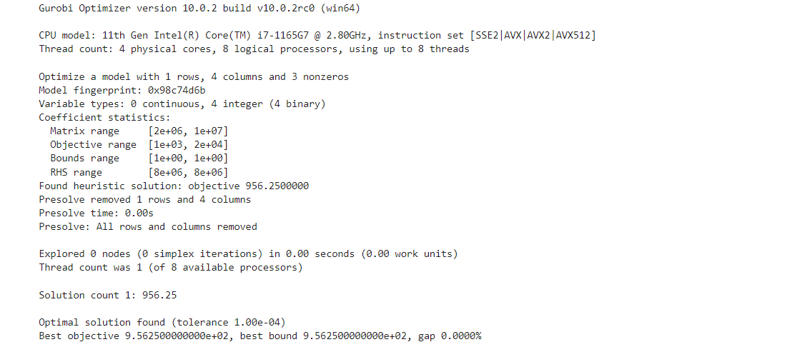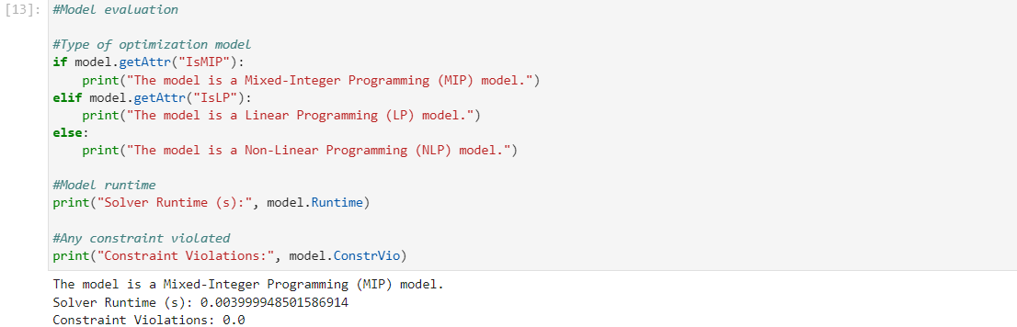

Figure O2: ExxonMobil offshore and onshore model construction and evaluation

### Appendix P: Model construction and evaluation – Shell

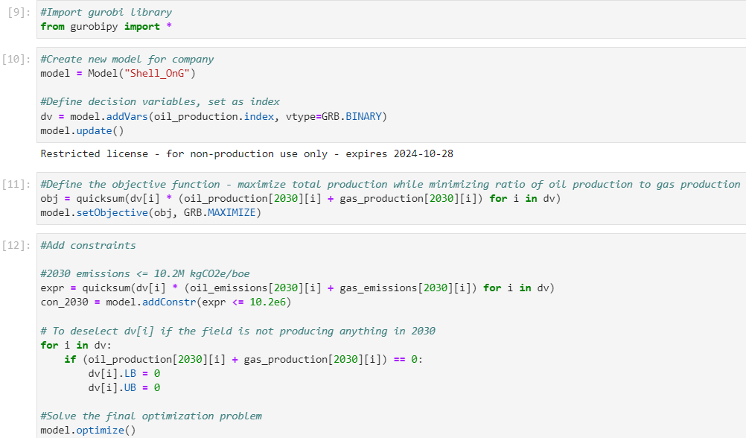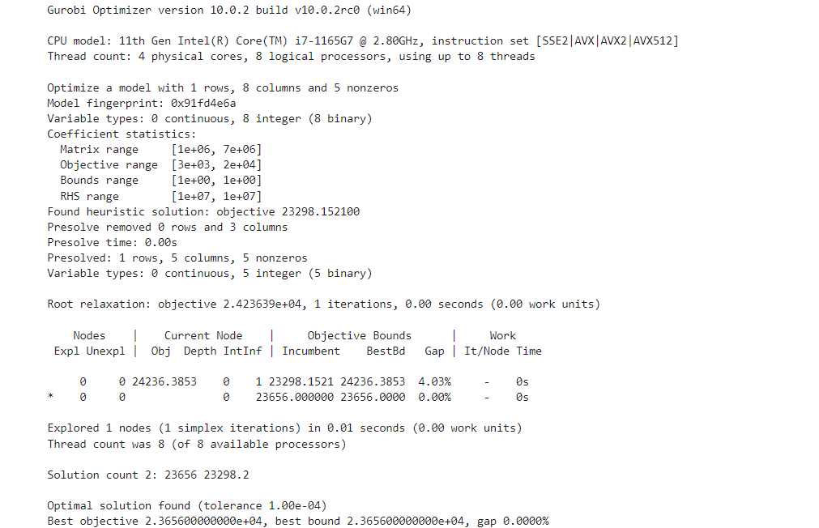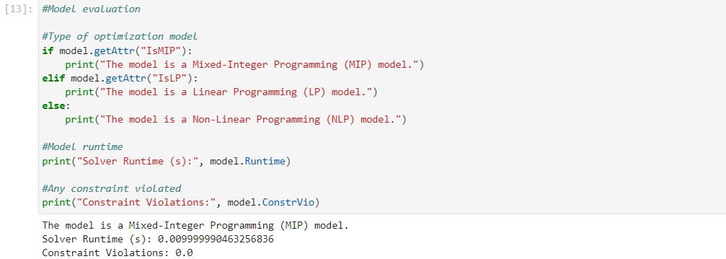

Figure P1: Shell O&G model construction and evaluation

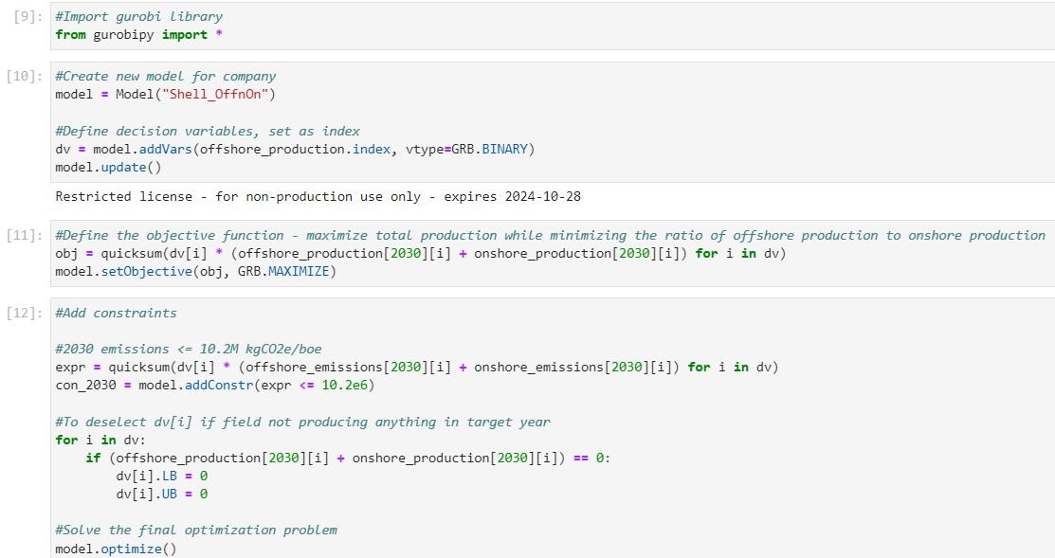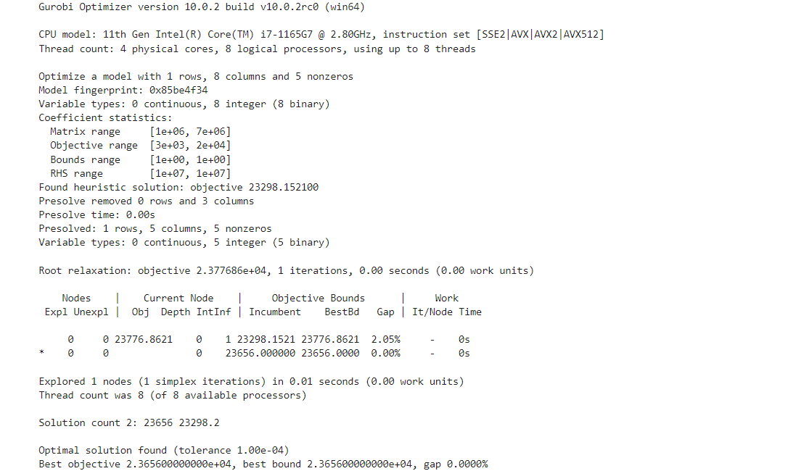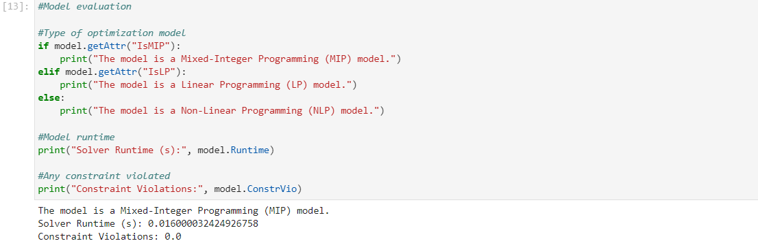

Figure P2: Shell offshore and onshore model construction and evaluation

### Appendix Q: Model construction and evaluation – ONGC

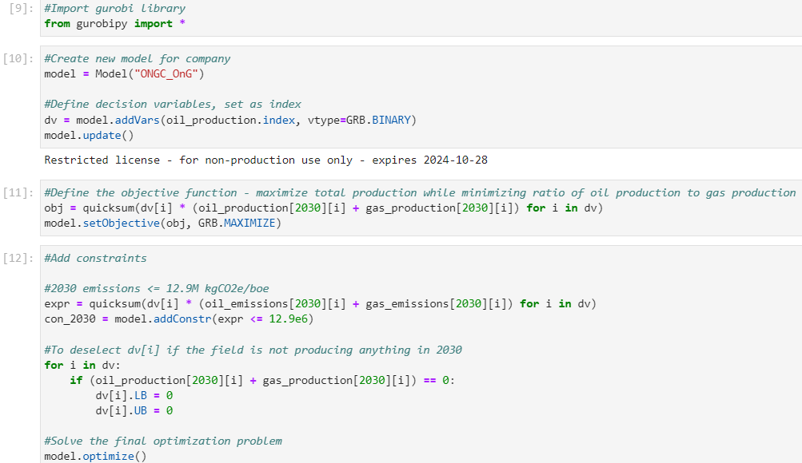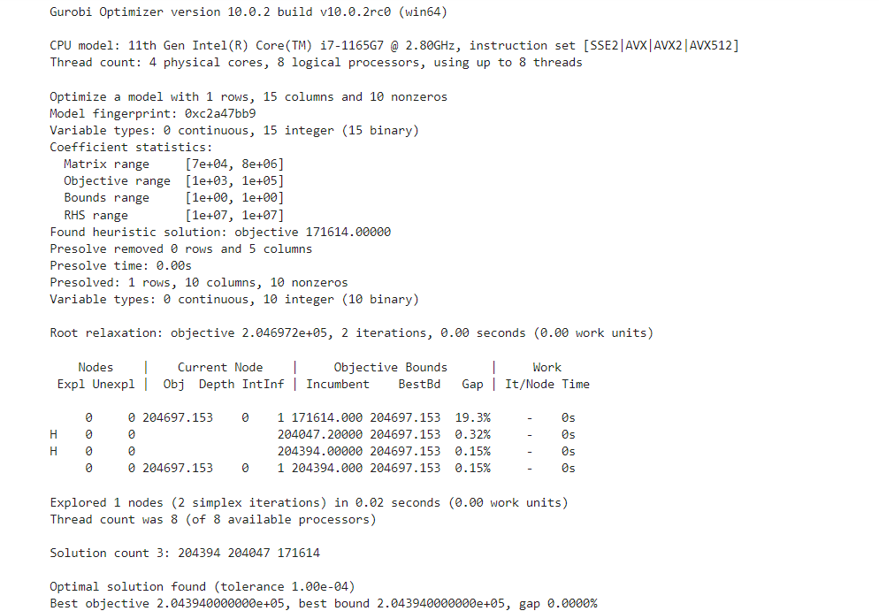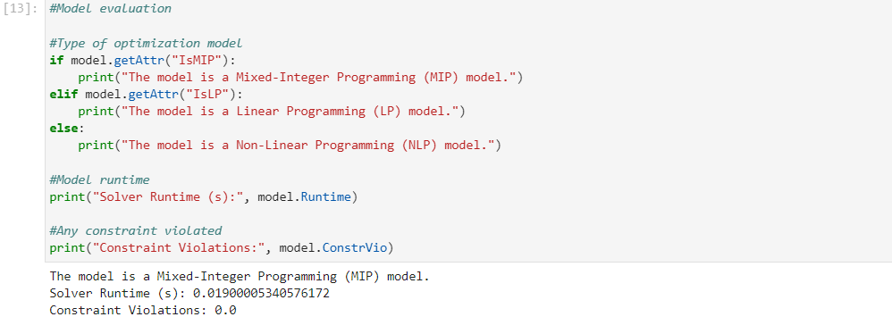

Figure Q1: ONGC O&G model construction and evaluation

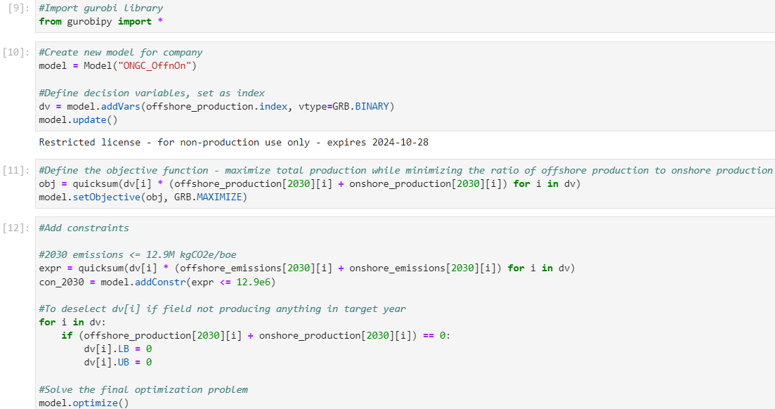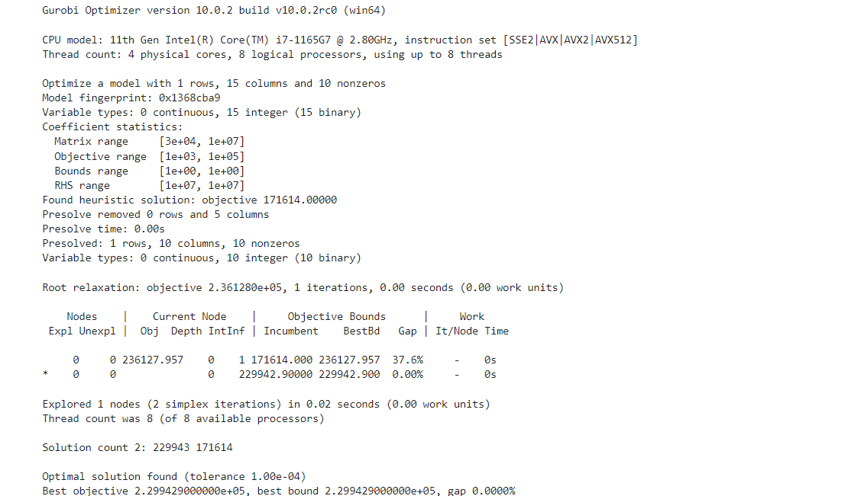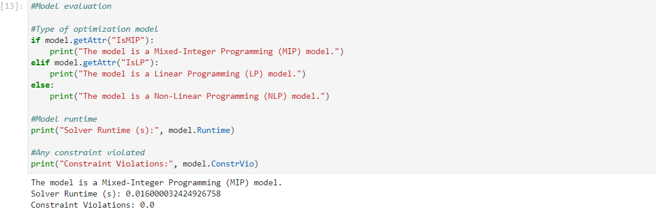

Figure Q2: ONGC offshore and onshore model construction and evaluation

### Appendix R: Model construction and evaluation – Pertamina

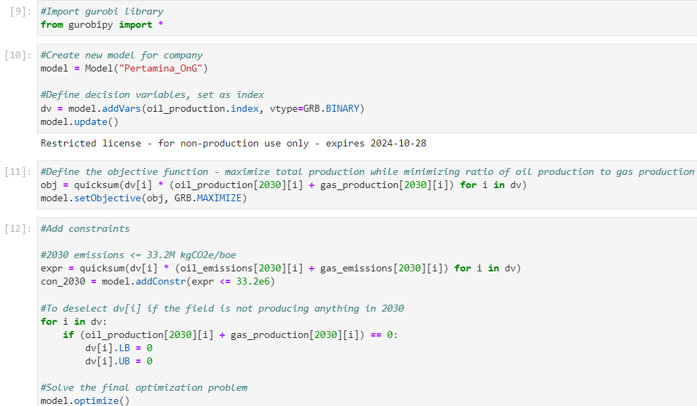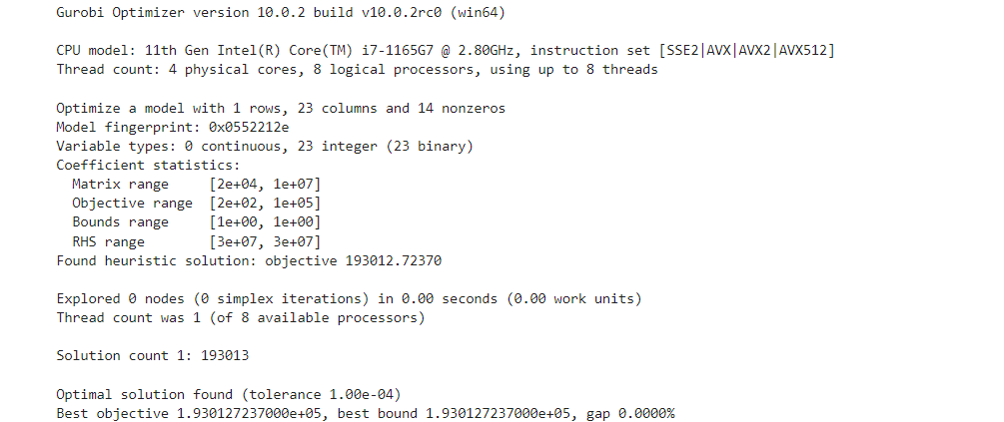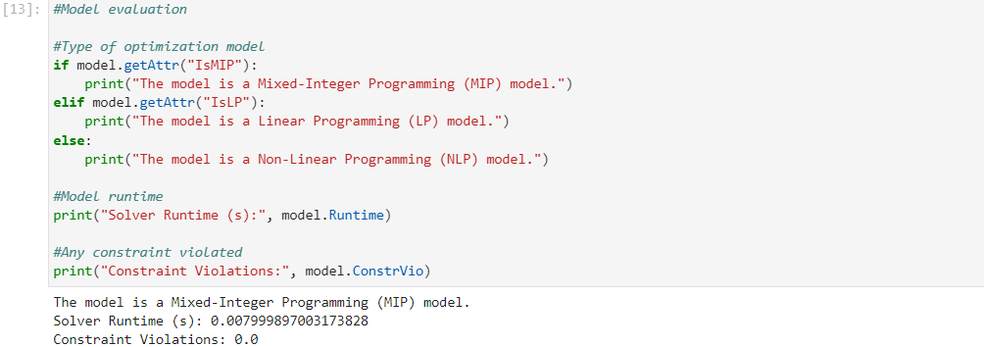

Figure R1: Pertamina O&G model construction and evaluation

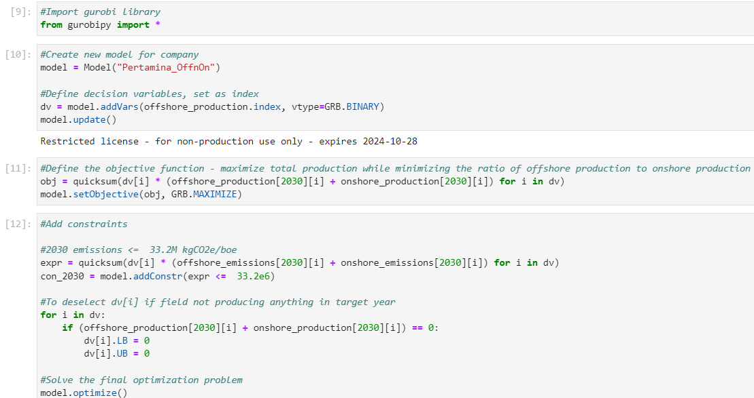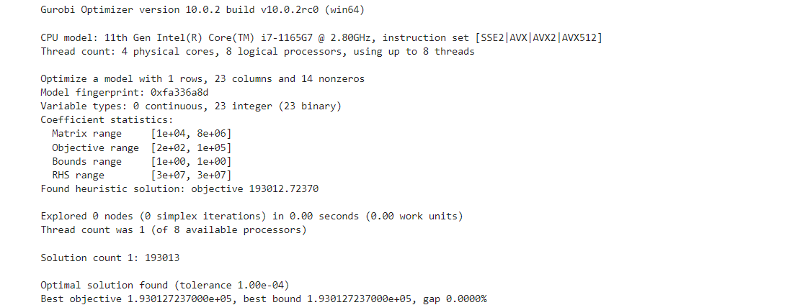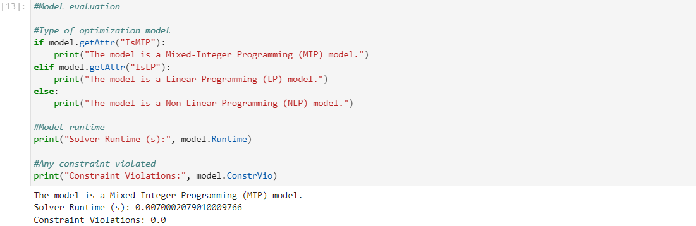

Figure R2: Pertamina offshore and onshore model construction and evaluation

### Appendix S: Model construction and evaluation – Petronas

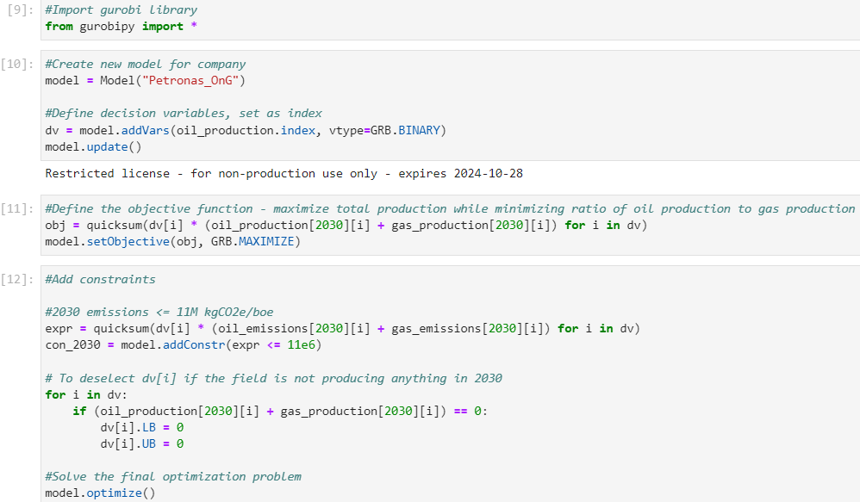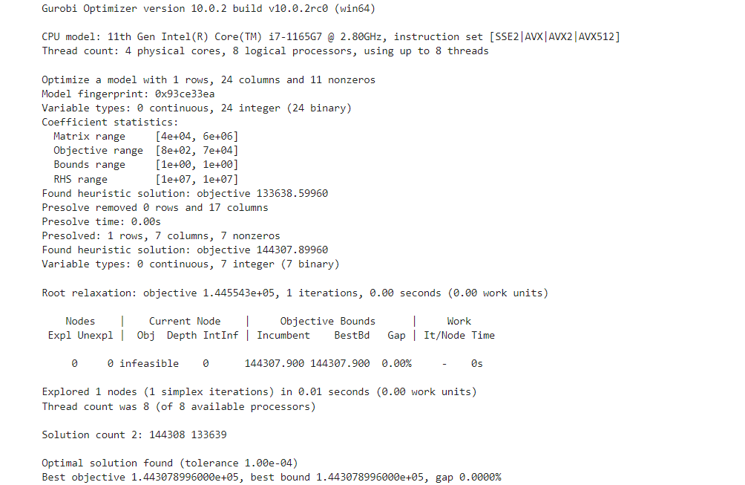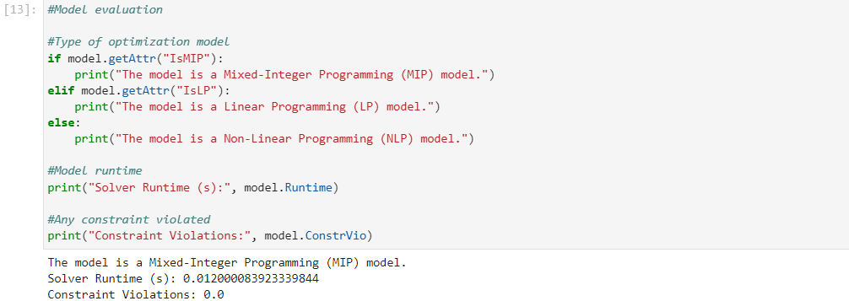

Figure S1: Petronas O&G model construction and evaluation

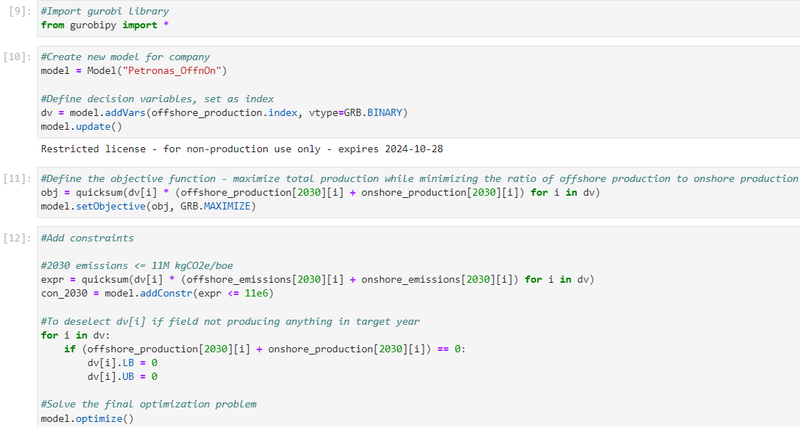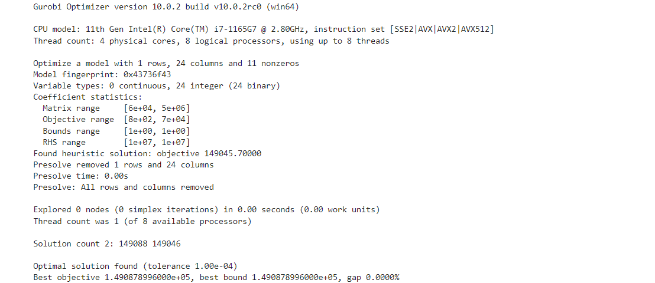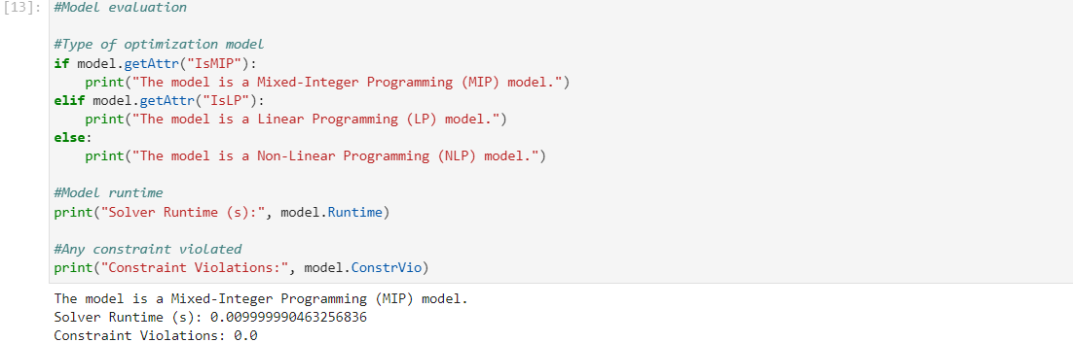

Figure S2: Petronas offshore and onshore model construction and evaluation

### Appendix T: Model construction and evaluation – PTTEP

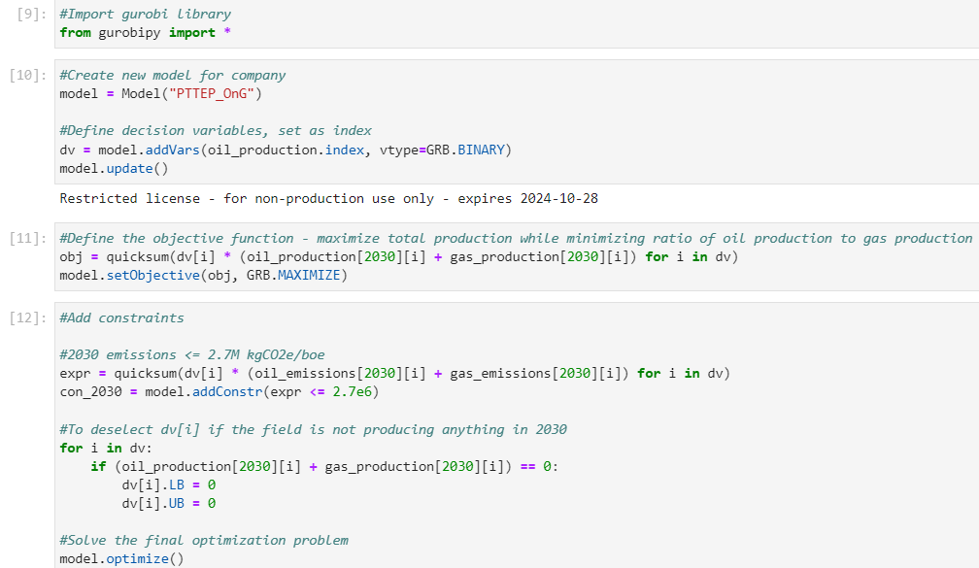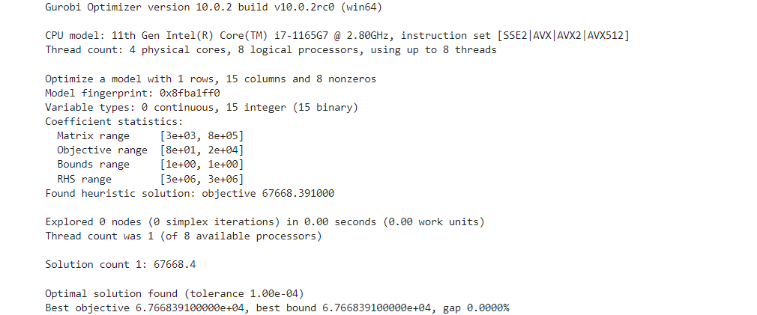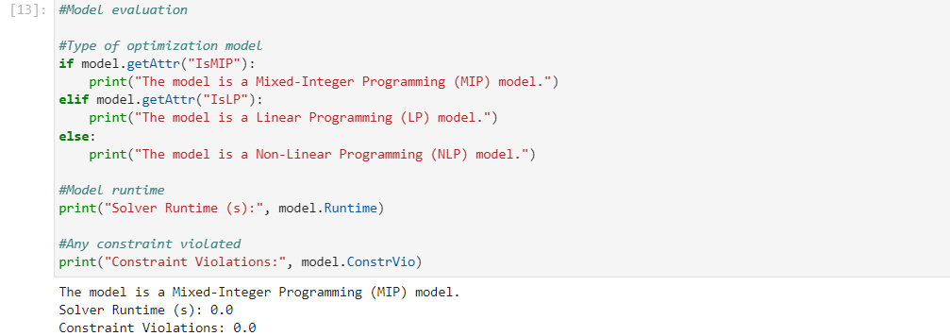

Figure T1: PTTEP O&G model construction and evaluation

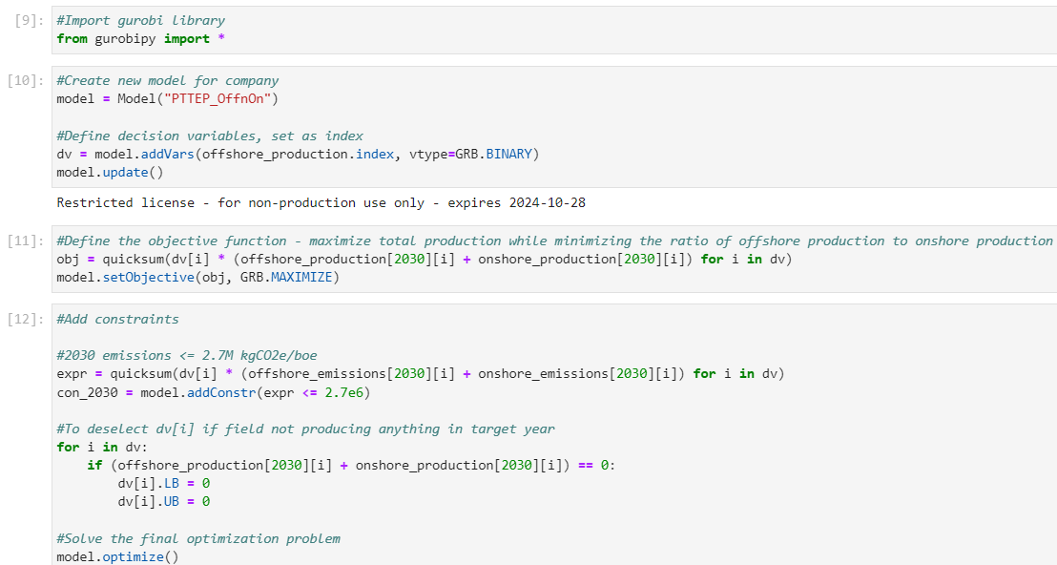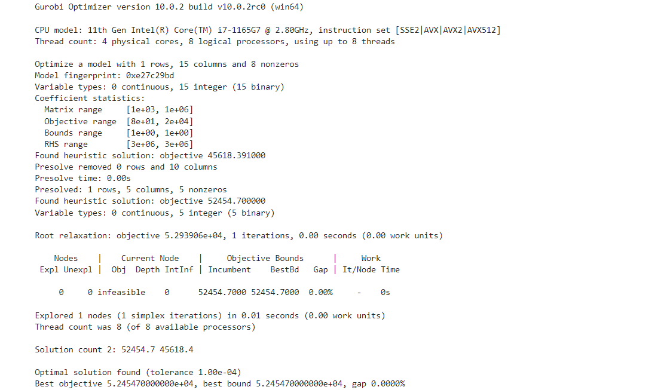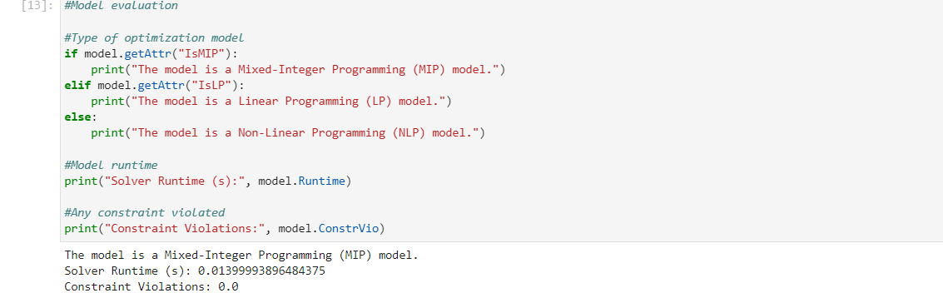

Figure T2: PTTEP offshore and onshore model construction and evaluation

### Appendix U: Model construction and evaluation – Sinopec

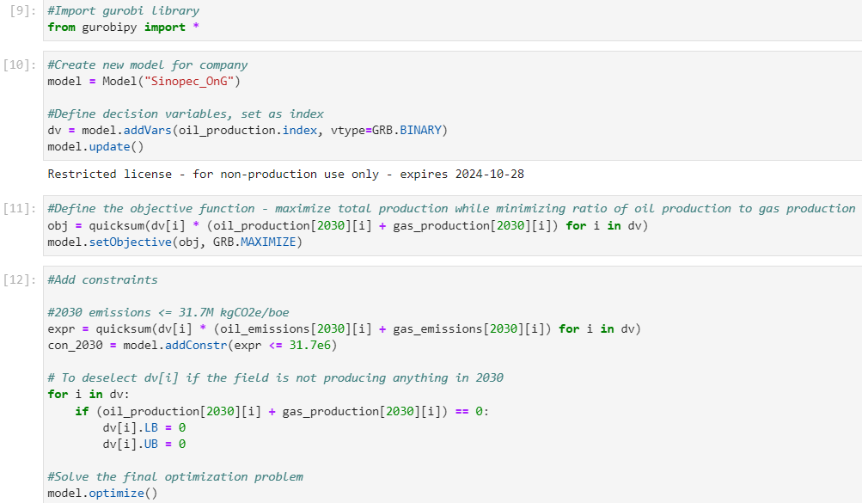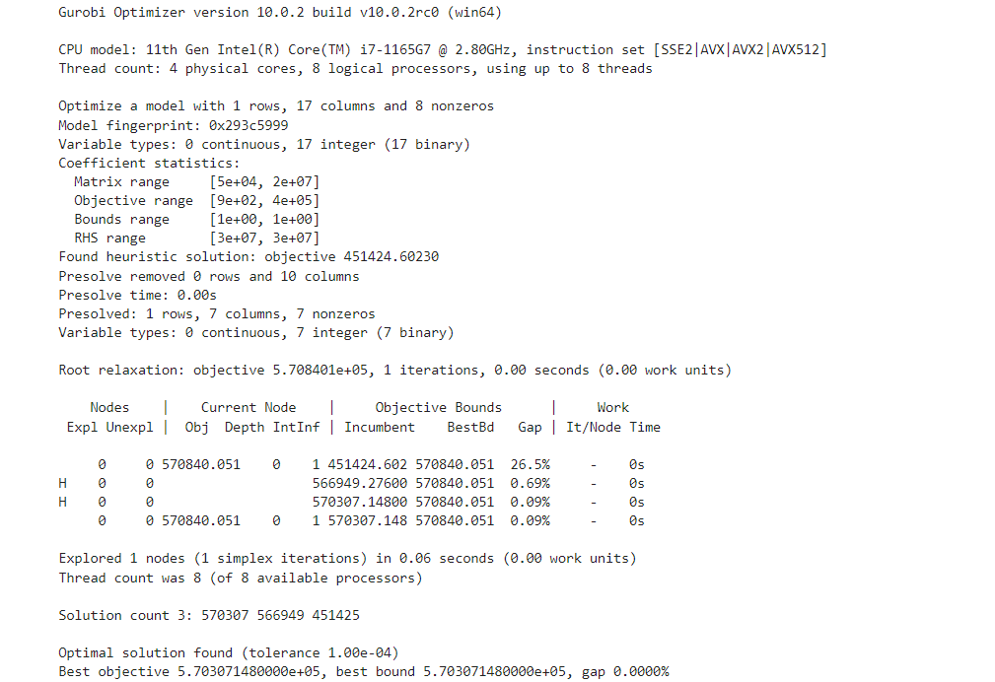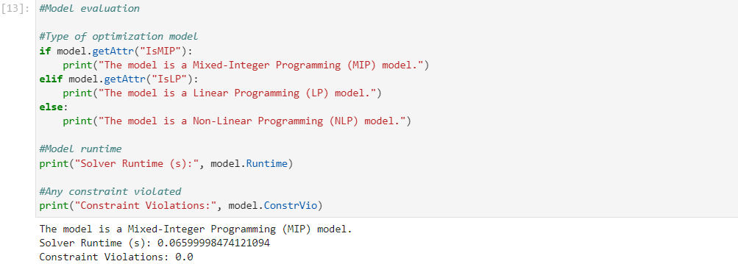

Figure U1: Sinopec O&G model construction and evaluation

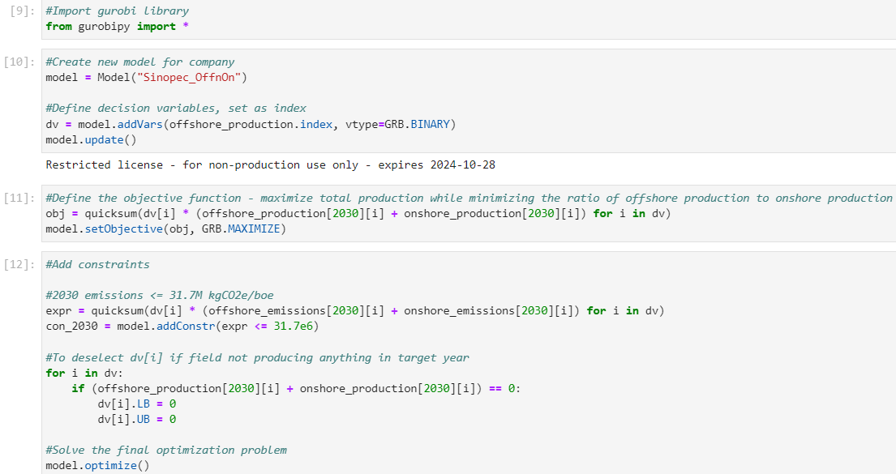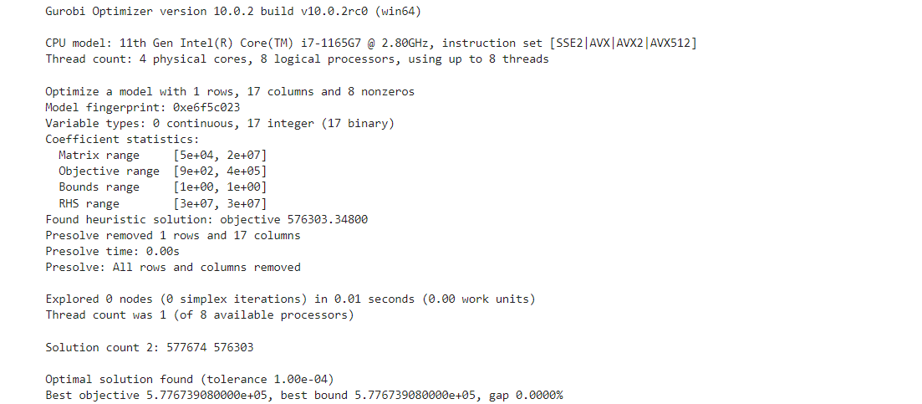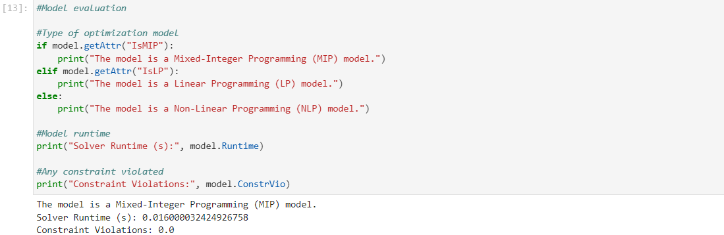

Figure U2: Sinopec offshore and onshore model construction and evaluation